Papers in the Biological Sciences

Handbook of Waterfowl Behavior, by Paul

Johnsgard

University of Nebraska - Lincoln Year 

Handbook of Waterfowl Behavior: Tribe
Mergini (Sea Ducks)

Paul A. Johnsgard
University of Nebraska-Lincoln, pjohnsga@unlserve.unl.edu

This paper is posted at DigitalCommons@University of Nebraska - Lincoln. http://digitalcommons.unl.edu/bioscihandwaterfowl/18

fastest of any in the pochard species; it is only a blur to the human eye. At times the bill appears to be thrown back to the vertical, but slow motion sequences (64 frames per second) suggest that the usual arc is less than 45 degrees. As in the other scaups, the bill is not tilted away from the vertical plane. In the lesser scaup Sneaking is exactly like that in the greater scaup and is easily overlooked. Males also Turn-the-back-of-the-head toward Inciting females in exactly the same manner as greater scaup males, with their head feathers similarly depressed to produce a remarkably low profile. Preening­ behind-the-wing is frequently performed by males, and often this display is performed mutually with females.
Copulatory behavior. The male precopulatory display consists of
Bill-dipping, Preening-dorsally, and Preening-behind-the-wing. As in the other scaups, the female may or may not respond with the same displays before assuming the receptive posture (Fig. 70E). After treading, the male, and usually also the female, swims in the Bill­ down posture (Fig. 70F). No doubt the male utters his Kinked-neck call as well, but I have never been close enough to hear this.

TRIBE MERGINI (SEA DUCKS)

As constituted here, the tribe Mergini includes all the species which Delacour and Mayr (1945) originally placed in the group. Delacour later (1959) removed the four species of eiders and placed them in a separate tribe, Somateriini, between the dabbling ducks and pochards. This was done apparently as a result of Humphrey's an­ atomical studies (1955, 1958), which suggested that the eiders might
be more closely related to Anas than to the othe:- "sea ducks." I have
discussed this problem elsewhere (Johnsgard, 1960f, 1964) and con­ cluded that the original inclusion of the eiders in the Mergini seems to fit the facts more adequately. Woolfenden (1961) has reached the same conclusion using anatomical evidence.
The tribe includes 20 species of which two are extinct. Except
for two Southern Hemisphere species, the group is of northern and arctic distribution. All species consume a high proportion of animal material, although they are by no means all "sea" ducks. All dive extremely well, although the manner of diving varies in that some species usually open their wings when diving and others never do. All the species except the isolated Southern Hemisphere forms exhibit considerable sexual dimorphism in plumage, voice, and behavior, and

there is much sympatry of ranges. Some genera (Somateria, Polysticta, Clangula, Melanitta) normally nest on the ground, and those species which usually nest in the open (the eiders) tend to have cryptic and disruptively patterned female plumages. The other species tend to nest in crevices or holes in the ground (the harlequin), or in trees, and females of these species lack such cryptic coloration. Metallic coloration is restricted to male head plumage in most species, but there is a metallic-colored speculum in two genera (Polysticta and Histri­ onicus). The other species either have white wing-specula or lack any wing patterning. In inost species the male trachea varies in diameter, and the structure of the bulla is exceedingly variable (see Johnsgard, 196lc), ranging from a simple, almost rudimentary form (Melanitta), through an Anas-like left-sided and bony bulla (the eiders and the harlequin), to partially membranaceous bullae of very diverse shapes (the golde eyes and mergansers).
All species of sea ducks apparently require at least two years to
attain reproductive maturity. Pair bonds are renewed each year and courtship displays tend to be elaborate and very diverse. Partly because of the great morphological and behavioral diversity exhibited by the sea ducks, relationships within the group and to other groups are sometimes difficult to determine. Although Delacour (1959) believes that the tribe's closest affinities are with the perching ducks, evidence from hybridization, downy patterns, and behavior argue against this and suggest that the group probably was derived from pre-dabbling duck and pochard stock before these two groups diverged. Although the group is therefore of fairly ancient origin, it contains some of the most highly specialized species in the Anatidae.
Behaviorally, male courtship patterns are so diverse and elaborate
as to be almost useless for taxonomic purposes, although a few rather general patterns are typical of most species. These include a display Shake (the "Upward-stretch" of Myres, 1959) and perhaps also a ritualized Wing-Happing. Females of most species studied exhibit an Inciting display, but this varies so much in form from one species to another and is so highly ritualized in some species as to be almost unrecognizable. The most valuable behavioral evidence for the homo­ geneity of the group is to be found in the precopulatory behavior. In all species studied the female assumes a Prone posture, soliciting copulation, often after mutual Drinking between the pair. Before the male mounts he performs a varying number of movements and pos-

tures which usually include Drinking, Bill-dipping, Bathing, Preen­ ing-dorsally or Preening-behind-the-wing, and the Upward-stretch or Shake. These movements are firmly linked into definite sequences in some species, while in others they appear to occur in random order. Postcopulatory displays in several species include a ritualized retreat from the female ("Steaming") while Turning-the-back-of-the-head or lateral Head-turning.

EIDERS

Behaviorally the eiders have very little in common with the dabbling ducks, which the females resemble superficially. The Incit­ ing of female eiders is not so highly ritualized as in typical dabbling ducks, but rather alternates overt threats with chin-lifting and neck­ stretching, as in some pochards. Male courtship displays have nothing in common with those of dabbling ducks, but the Shake or Upward­ stretch of eiders is much like that of seaters. The lateral Head-turning movements of eiders are also much like those of goldeneyes and are used in similar situations. Precopulatory displays are distinctly similar to those of Melanitta and Bucephala, and postcopulatory behavior is also much like that of Bucephala. Female eiders nest on the ground, often in very exposed places, and at times in colonial fashion. Strong sexual dimorphism is present in all species, but metallic coloration is restricted to the wing speculum of one species. Males of all species have a remarkable green pigmentation on the head, as well as dark abdomens and white coloration on the wings or elsewhere.

Common Eider (Somateria mollissima)

The common eider and the two following species differ in several ways from Steller's eider, which probably belongs in a separate genus. The females of these species have a more distinctively disruptive plumage, the downy young lack dorsal spotting, and the males have a unique blackish eclipse plumage which is entirely unlike the plumage of females. Juveniles and females of the common eider have a vertically barred brownish plumage very similar to that of the spectacled eider. The males in nuptial plumage have a distinctive head pattern, but in their bqdy and wing coloration they are more like the king eider than like the spectacled eider. The eclipse plumage of adult males is almost entirely black, except for the white wing­ coverts and tertials, which are usually almost hidden from view.

Immature males in eclipse are more female-like, with distinct breast barring, and the juvenile plumage of eid(trs is also distinctly female­ like. Downy common eiders are an almost uniform grayish brown, with tan eye-stripes and throats.
The tracheal anatomy of this and the other species of Somateria
is of interest because of its distinctly Anas-like features, namely the uniform-diameter tracheal tube and the rounded, left-sided, and osseous tracheal bulla, which is mallardlike in shape. This similarity
was a major point in Humphrey's argument (1958) that the eiders should be placed near the dabbling ducks. Countering this argument, however, is the fact that the harlequin has an equally Anas-like tracheal bulla, as apparently also had the Labrador duck. Further­ more, unlike the bronchi of the dabbling ducks, those of this and the other species of Som:ateria are enlarged, as are those of many of the sea ducks (see Johnsgard, l96lc). Finally, the cooing sounds uttered by male eiders are unlike those uttered by any of the dabbling ducks, perhaps because the notes are apparently produced (as are some goose calls) by inspiration rather than expiration.
General behavior. Eiders are strictly maritime birds, often feeding in shallow water for mollusks, which they crush with their strong bills or swallow whole. They are heavy-bodied birds, distinctive in Hight for their rapid wing beats and almost perfectly straight course, and lacking the agility of the smaller Steller's eider. Lateral Head­ shaking is the only preflight movement which has been observed.
Agonistic and sexual behavior: female. D. F. McKinney has
studied several races of common eiders, and his observations on the European and Pacific races have recently (1961) been published. The Inciting behavior is only slightly ritualized, and consists of overt threatening movements with neck outstretched over the water alter­ nated with chin-lifting and neck-stretching toward the preferred male.
Repeated one-syllable notes accompany the display (Fig. 72A, B).
This has little in common with the Inciting of dabbling ducks; it is more like that of some pochards. Females also have a gog-gog call, and they perform rudimentary versions of such major male displays as Neck-stretching and the various "Cooing Movements."
Agonistic and sexual behavior: male. Male displays of the Euro­
pean eider are numerous, but three movements with associated vocali­ zations constitute the primary sexual displays. The first is a tossing of the bill almost to the vertical (Fig. 71C, D). This display, also

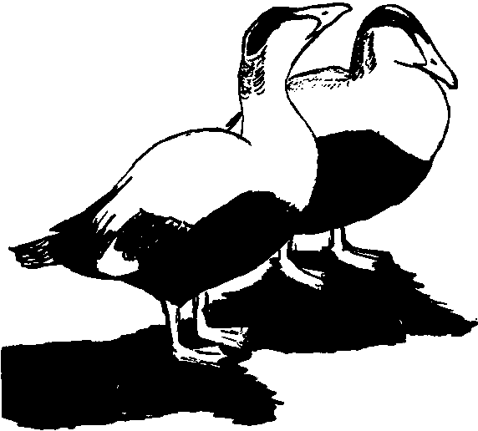
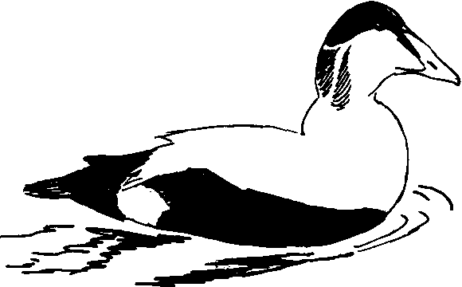A D

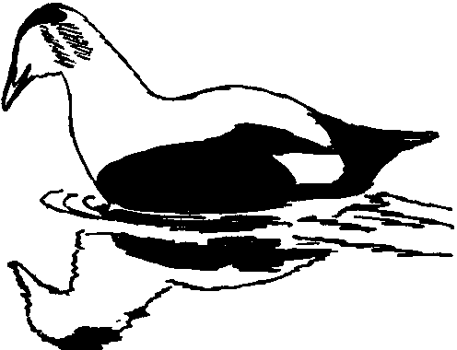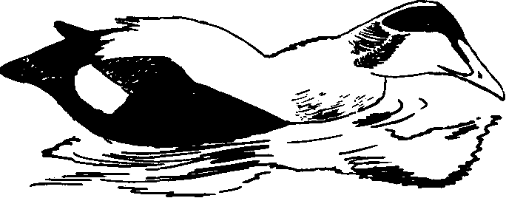

B E

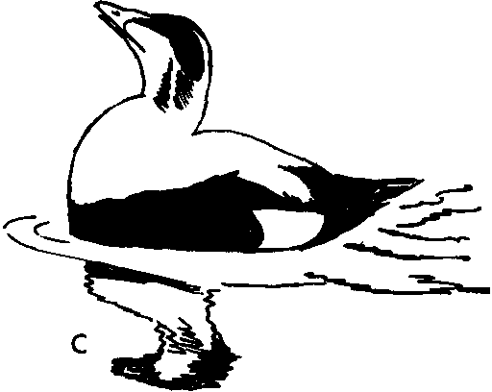
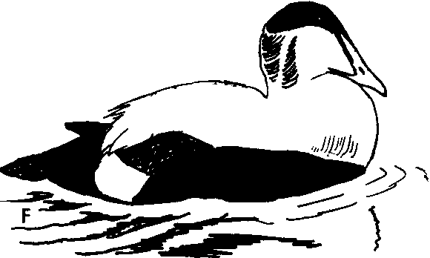Figure 71. European Eider
A. Chin-lifting by male eider. Compare with Fig. 72A.
B, C. "Double Cooing Movement" by male eider. The Neck-jerking dis­ play (Cooing Movement 2) in B is followed immediately by the Bill-toss (Cooing Movement I).
D-F. Male eider performing Reaching display (Cooing Movement 3)
consisting of Neck-stretching (D), reaching forward (E), and
rapidly returning the head to a resting position (F).

called "Cooing Movement 1" (Hoogerheide, 1950; McKinney, 1961), has an ah-hoo' call associated with it. "Cooing Movement 2" is a jerking of the head diagonally upward and forward, as if the bird were hitting a ball with his head as a soccer player might (Fig. 71B). This display is clearly homologous to the Neck-jerking display of spectacled eiders. When the display is performed alone, the call is a hoo, or ah-hoo', similar to that of the preceding display, but the Bill­ toss and Pushing movements are often linked into a "Double Cooing Movement," and sometimes Pushing both precedes and follows the Bill-toss, producing a "Triple Cooing Movement" and a hoo-ah­ hoo'-hoo" call. "Cooing Movement 3," which is homologous with the "Reaching" of the king eider (Myres, 1959a), consists of a neck­ stretching followed by a reaching forward of the bill until it almost
touches the water; then the head is brought back rapidly as the call, hoo-hooo', is uttered (Fig. 71D-F). Occasionally Neck-stretching occurs without being followed by a Reaching movement, and a silent and repeated Chin-lifting is used as a hostile display (Fig. 71A). Males sometimes also utter soft cooing notes without head movements, and this behavior has been termed "Roo calling." Males usually precede the Head-toss with lateral Head-turning, a display homo­
logous to but not so highly ritualized as lateral Head-turning in king eiders. Three clearly ritualized comfort movements occur during dis­ play-Bathing, Wing-Happing, and the "Upward-stretch" (Myres,
1959a). The Bathing is similar to a normal though very vigorous bathing, but it is usually followed by ritualized Wing-Happing. When Wing-Happing the male rises very erect in the water, with his bill pointed almost vertically, and Haps his wings strongly two or three times before settling in the water. The Upward-stretch is a ritualized form of the general shake, possibly differing from it in that the body rises higher out of the water and there is little if any shaking of the tail (which is a conspicuous feature of the Introductory Shake of dabbling ducks and pochards). Additional comfort movements such as head-rolling, head-shaking, and bill-dipping are frequent during courtship and are probably also ritualized. D. F. McKinney (1961) has studied the Pacific race of the common eider and found some qualitative and quantitative differences in its displays from those of the European race. In particular, Cooing Movement 2 (Neck-jerking) is absent in the Pacific race, as are the Compound Cooing Movements of which this display is a part. I have noted, however, that the Ameri-

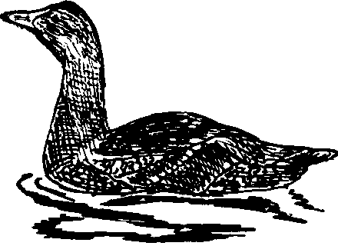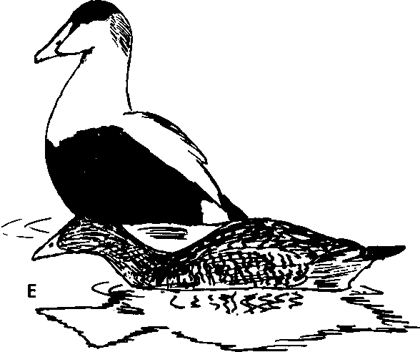A D 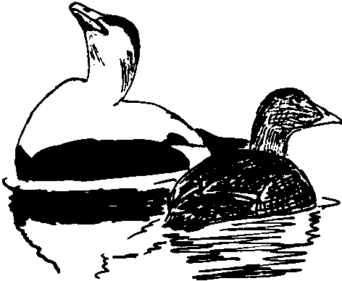

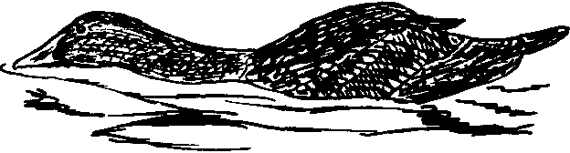

B

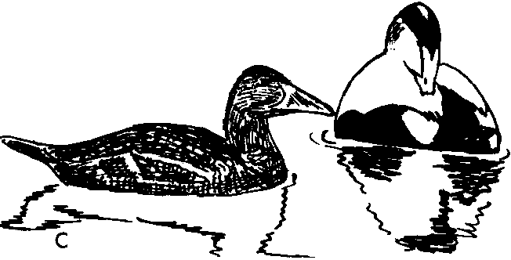

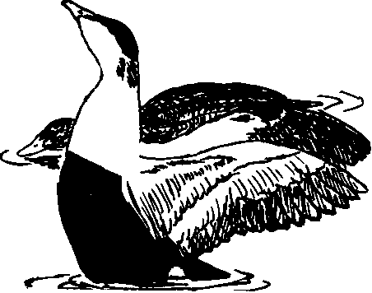Figure 72. European Eider
A, B. Inciting by female eider. Chin-lifting (A) is followed and alter­ nated with direct threatening movement. Compare with Inciting in Steller's eider (Fig. 76) and other sea ducks.
C-F. Precopulatory behavior.
C. Preening-dorsally by male.
D. Bill-toss (Cooing Movement I) by male; female starting to go Prone.
E. Male Upward-stretch; female nearly Prone.
F. Male Wing-flapping; female completely Prone.

can eider, found on the Atlantic coast, does possess these displays and thus is closer to the European race in its behavior patterns.
The precopulatory displays of the common eider are very interest­ ing, and provide additional evidence that the eiders belong in the tribe Mergini. Females assume the receptive, or "Prone," posture gradually, usually after Inciting. There is no obvious mutual pre­ copulatory behavior, and the male's behavior changes only slightly after the female has assumed the receptive posture. He continues to perform all his usual courtship displays, but in particular he tends to perform Neck-stretching, Bathing, Preening-dorsally, and the Up­ ward-stretch, but in no set sequence (Fig. 72D-F) (McKinney,
1961). Preening-dorsally (Fig. 72C) by the male is similar to the
corresponding display of pochards and, as in that group, possibly serves to initiate copulatory sequences. The male common eider differs from males of some of the following genera in having no single display which he always performs immediately before mounting. He performs no Wing-Hicks or other displays during treading. As soon as he releases the female he performs a single Reaching display and swims directly away from her while performing lateral Head-turning movements. The female then normally begins to bathe.

King Eider (Somateria spectahilis)

To judge from hybrid records and behavior, the king eider is probably more closely related to the common eider than to the spectacled eider. The downy young of all three species are very similar except for the facial patterning. The juvenile and female plumages differ somewhat from those of the other Somateria species, in that the body feathers tend to have U-shaped dark brown markings rather than vertical barring, producing a rather mallardlike effect. The nuptial plumage of the male is distinctive in that the upper-wing coverts are more extensively black and the head has bluish in addi­ tion to greenish pigmentation, and the fatty base of the bill is much enlarged. The blackish eclipse plumage unique to the larger eiders is also present in this species. The tracheal structure is very similar to that of the common eider, and the bulla is only slightly smaller than in that species. King eiders are sympatric with common and spectacled eiders, and wild hybrids have been reported with the former.
General behavior. King eiders range slightly farther north than do common eiders, although the breeding ranges of the two species

overlap. Both species dive well and consume great quantities of mol­
lusks. No preflight movements have been observed.
Agonistic and sexual behavior: female. Female king eiders are very similar to common eiders in their displays. Inciting takes the same form as in that species, and consists of a little-ritualized alterna­ tion of threatening movements and chin-lifting. The gog-gog-gog . . . calling of this species sounds like a hammer hitting a hollow wooden wall. As in the common eider, females sometimes perform incomplete versions of several male displays, such as Reaching, Pushing, Bathing, the Upward-stretch, and Wing-flapping.
Agonistic and sexual behavior: male. The king eider surpasses even
the common eider in ritualizing comfort movements into displays. When Wing-flapping, for example, males often face the female as they rise almost vertically in the water and twice flap their wings strongly (Figs. 73F, 74A). Head-rolling (rubbing the cheeks and crown on the shoulders) is very frequent in king eiders and is certainly ritual­ ized; it or Wing-flapping frequently follows Bathing. Like the spectacled eider, the king eider has a conspicuous Pushing display which is, however, usually repeated several times (Fig. 74B-D). A tremulous hooo note is uttered with each Pushing movement. The second major male display is Reaching, first named by Myres (l959a), which is performed in a manner very similar to Cooing Movement 3 of the common eider (Fig. 73A-E). The call, however, is very dif­ ferent-a tremulous and fading hoo-oo-oo-oo ... The king eider usually follows this display with lateral Head-turning, which is typically a preliminary movement in the common eiders. Lateral Head-turning in the king eider (Fig. 74E, F) is even more highly exaggerated than in the common eider; the head swings ponderously through a 180 degree arc. Lateral Head-turning is usually accompanied by Neck-stretching, but Neck-stretching is also occasionally performed independently. Male king eiders also sometimes perform slight Chin­ lifting movements, as do male common eiders. Although such displays as Preening-dorsally and Bathing are occasionally seen in courting parties, these are probably more properly regarded as precopulatory displays.
Copulatory behavior. The precopulatory behavior is much like
that of the common eider, with the female gradually assuming a Prone posture, often interrupting it to make slight Inciting move­ ments. Before mounting, the male performs an extended series of

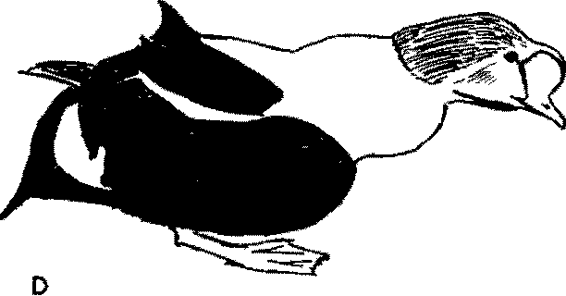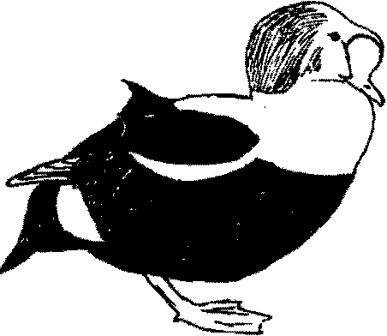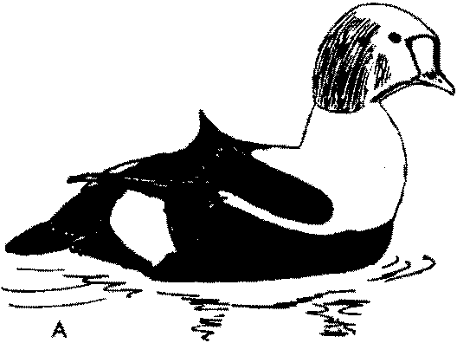

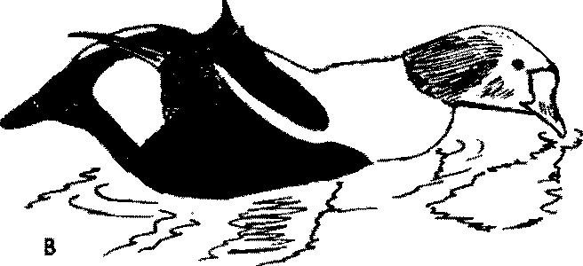E

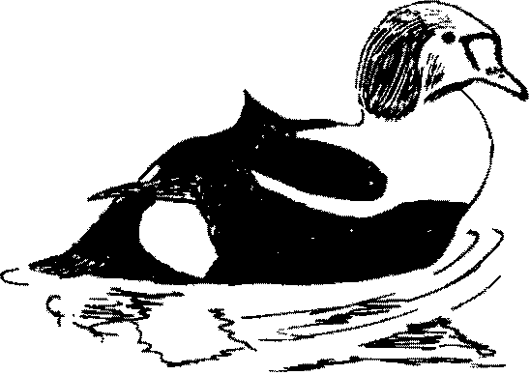

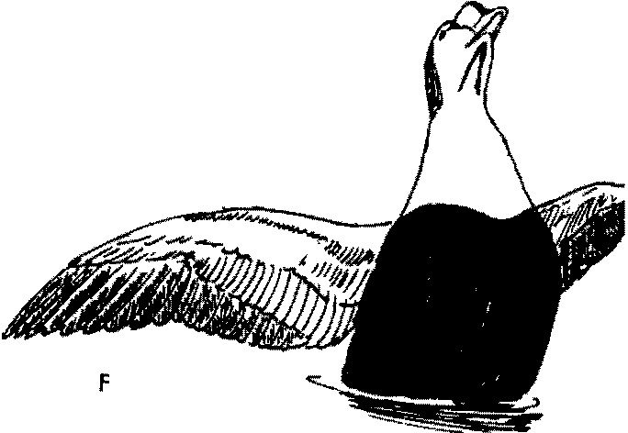Figure 73. King Eider
A-C. Male king eider performing Reaching display. Neck-stretching (A)
is followed by reaching forward (B), and finally bringing the head rapidly back. Compare with European eider (Fig. 71).
D, E. Reaching on land. Note bulge in neck region.
F. Display Wing-flapping. Note extremely upright body posture and ex­
hibition of V-mark on throat.

A 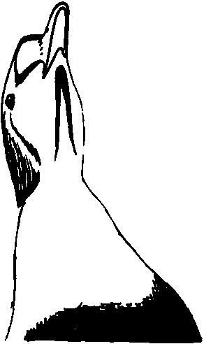 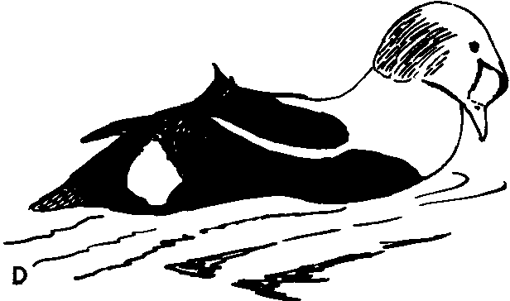

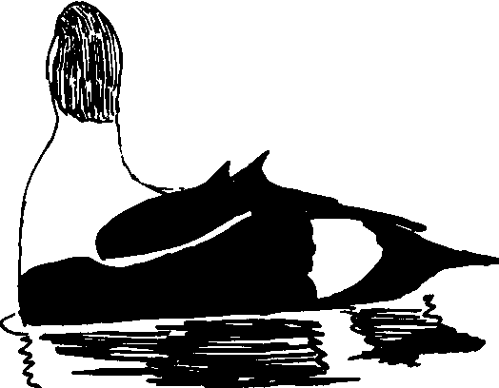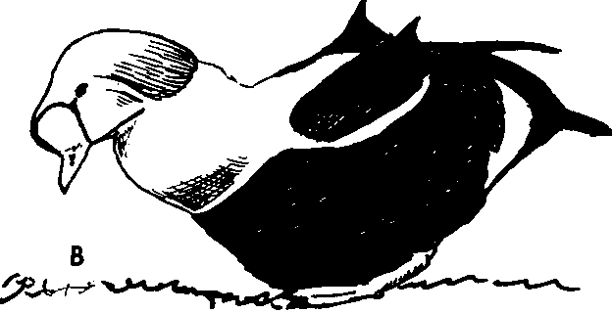 E 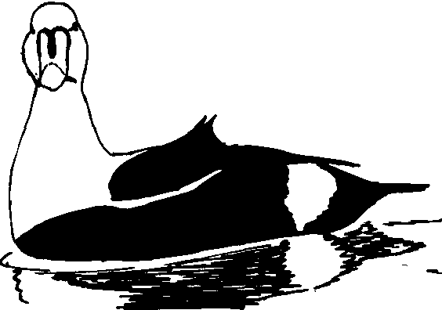

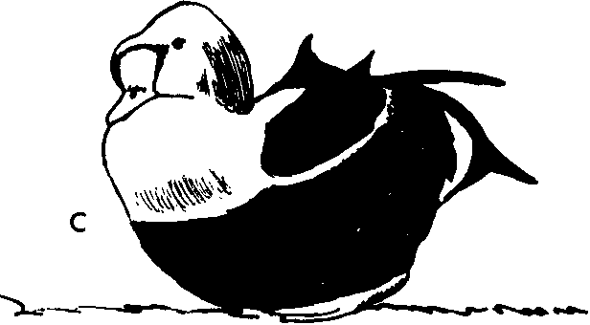F

Figure 74. King Eider
A. Display Wing-Happing by male king eider, showing throat markings.
B, C. Male performing Pushing display on land. Compare with Fig. 7IB. D. Male performing Pushing on water.
E, F. Male performing lateral Head-turning.

display movements, including both Pushing and Reaching, and in addition such displays as Bathing, Head-rolling, Wing-Happing, and the Upward-stretch. Mounting apparently is frequently preceded by Wing-Happing. After treading, the male appears to retain his hold on the female's nape for a second or two, although no true Rotations are produced. As the male releases the female, he performs a single Reaching display, then swims away fairly rapidly while Head-turning. The female then bathes.

Spectacled Eider (Somateria foscheri)

The spectacled eider would appear from its plumage to be a close relative of the common eider, and doubtless it belongs in the genus Somateria, but in a few behavioral respects it also resembles Steller's eider (Johnsgard, 1964). The downy young has a slightly lighter face pattern than does the common eider duckling, but the two are other­ wise similar. Juvenile birds and females are also similar to female common eiders, possessing the same type of vertical barring on the Hanks. Males in nuptial plumage have a wing pattern and body plumage much like those of the common eider, although the head pattern is distinctive. As in the other large eiders, there is a blackish eclipse plumage quite unlike the female plumage. The tracheal structure is also similar to that of the common eider (Humphrey,
1958). Although the species is sympatric with both other species of
Somateria, no hybrids are known.
General behavior. Judging from my experience with this species at lgiak Bay, Alaska, it is much like the other large eiders in its general behavior. I observed that it commonly foraged by diving under the water, opening its wings as it submerged, and it has also been observed to feed by tipping-up. Before taking Hight both sexes fre­ quently shake the head laterally, and they sometimes also perform the general shake in this situation.
Agonistic and sexual behavior: female. I observed that females
perform the same type of Inciting behavior which is found in the other two species of Somateria, and which is quite distinct from that of Polysticta. I heard what was doubtlessly the call corresponding to the gog-gog-gog . . . calls of king and common eiders, but distances were too great for me to judge similarities with these other species. I observed no other female displays.

Subfamily Anatinae 265
Agonistic and sexual behavior: male. Virtually the only informa­ tion available on the behavior of this species is based on my observa­ tions-often made from rather great distances-of wild birds at Igiak Bay. The spectacled eider differs from the two preceding species in that the Upward-stretch is important in pair formation; in addi­ tion, the form of this display is much as it is in Steller's eider, with the bill directed down toward the water as it is shaken. Wing-flapping is not so highly ritualized as in the king and common eiders (Fig.
75A); there is no distinct pause before flapping and no orientation
toward the female. The primary male courtship display is one I have called Rearing, since it is clearly homologous to the Rearing of Steller's eider. This is usually performed a few seconds after the Upward-stretch, and consists of a rapid jerk upward and backward of the head and neck, bringing the black chest into prominence (Fig.
75C). Although this independent Rearing occurs frequently, it also occurs as the final phase of a display I have termed the Head-forward
-Rearing posture, which closely corresponds to Reaching in the king eider and to Cooing Movement 3 in the common eider. In this sequence the neck is first stretched vertically (Fig. 75D); then the head is swung forward (Fig. 75E) and quickly retracted (Fig. 75F), producing a Rearing of the body that is not nearly so marked as during independent Rearing. A very weak ah-hoo' hardly audible beyond a few yards, accompanies this display. There are at least two other major male displays, which I have called the Bill-toss and Neck­ jerking. The Bill-toss corresponds to, and is certainly homologous to, Cooing Movement 1 of the common eider, while the Neck-jerk is obviously equivalent to Cooing Movement 2 of the common eider (Fig. 75B). These two displays are frequently linked into a combina­ tion I have called the Bill-toss-Neck-jerk, and although I have ob­ served independent Neck-jerking, I have not recorded Bill-tossing without Neck-jerking associated with it. Lateral Head-turning is in­ frequent and inconspicuous in this species.
Copulatory behavior. On the basis of limited observations, I would
judge that the precopulatory behavior of this species is much like that of the king and common eiders, with the male performing such displays as Bathing, Preening-behind-the-wing, Preening-dorsally, Pushing, and Wing-flapping. In the instances I observed, however, the male, like the male Steller's eider, performed the Upward-stretch only once, immediately before mounting. After treading, the male re-

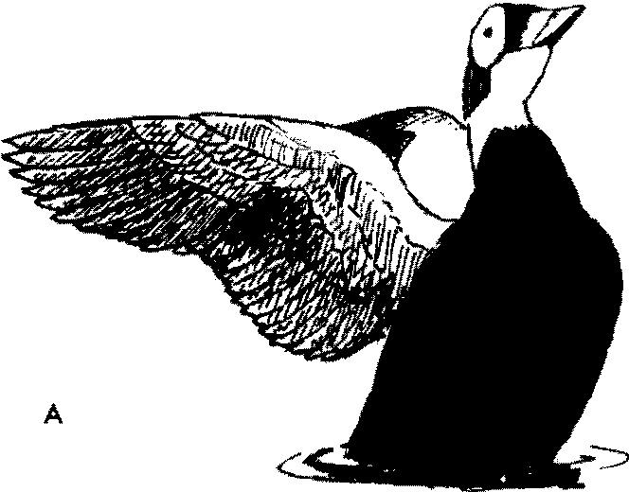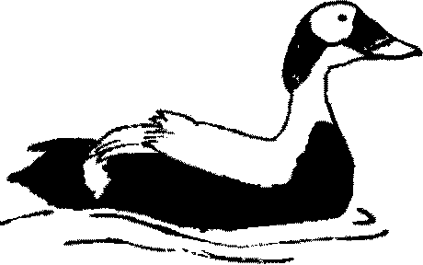D

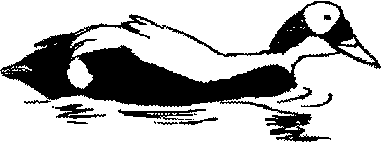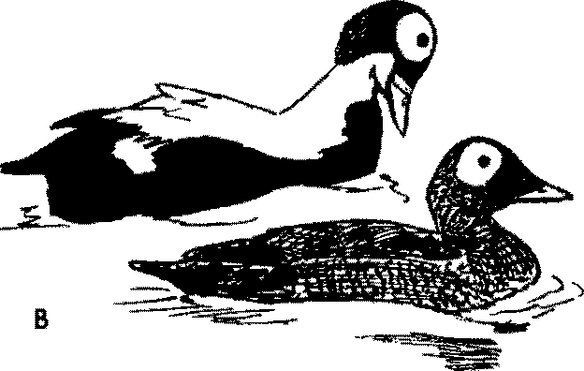 E

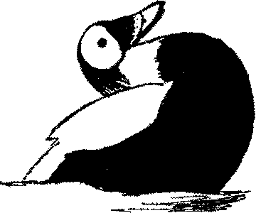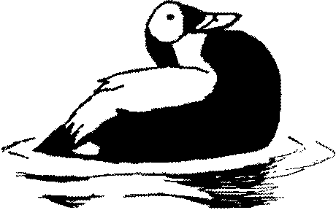c F

Figure 75. Spectacled Eider
A. Display Wing-Happing by male spectacled eider.
B. Neck-jerking by male spectacled eider.
C. Independent Rearing by male spectacled eider. Compare with Fig. 76C.
D-F. Head-forward-Rearing sequence.
D. Preliminary neck-stretching. Compare with Fig. 73A.
E. Head-forward phase. Compare with Fig. 73B. F. Rearing phase. Compare with Fig. 73C.

leased the female's nape, performed a single Head-forward-Rearing display, and finally made about four lateral Head-turning movements. The female bathed after copulation.

Steller's Eider (Polysticta stelleri)

Steller's eider is a somewhat more specialized form than the larger eiders, and has a soft-edged bill that approaches that of the extinct Labrador duck. The downy young are dark brown above, grayish brown below and, unlike the larger eiders, have light dorsal spots. Juveniles resemble females, which have a completely dark-brown barred body plumage except for a white eye-ring and a metallic-blue wing speculum. Adult males in nuptial plumage approach the larger eiders in their dark abdomen, curved and elongated tertials, and green head patches, but they are unique in their white head, cinnamon under parts, and ornate, elongated scapulars. The wing has a metallic­ blue speculum much like that of the harlequin duck.·There is an eclipse plumage which, unlike that of the larger eiders, is almost identical to the female plumage. The trachea of the male is slightly variable in diameter, and the syrinx has a small left-sided osseous bulla. No hybrids are known, and the species has a very restricted distribution along the Bering Sea.
General behavior. Steller's eiders are not so ungainly as the larger
eiders when on land or in Hight, but they do usually open their wings when diving. They feed to an even greater degree than the larger eiders on animal materials, and during the breeding season nearly ninety percent of their food is from this source (Kortright, 1943). Except during courtship the birds are very quiet, and even then only the female is especially vocal. Lateral Head-shaking in an alert posture is the only preflight signal.
Agonistic and sexual behavior: female. The Inciting of Steller's
eiders is more ritualized than that of the larger species, and consists of a slight lateral threatening movement followed by a rapid and exaggerated chin-lifting and an associated loud qua-haaa' that can be heard for a considerable distance. Females lack any call equivalent to the gog-gog call of the larger eiders, but they do often perform Bath­ ing and Upward-stretch movements which are similar to the corres­ ponding movements of the males. McKinney (MS) has heard a "rapid, rippling, gutteral call" uttered "constantly" by wild females,

but the captive birds I observed did not perform this call to my knowledge.
Agonisic and sexual behavior: male. Male Steller's eiders are
remarkably different from the larger eiders in their displays, and only the lateral Head-turning and Bathing movements suggest close affinities. Lateral Head-turning is performed in a much faster manner than in the larger eiders, which is not surprising considering the dif­ ference in body size. The Upward-stretch of Steller's eiders is like that of the preceding speciesin that the body is not raised high out of the water and the head is shaken with a vigorous downward move­ ment, so that it nearly touches the water (Fig. 75C). This type of Upward-stretch is also very similar to that of the black scoter. The major sexual display is a very rapid rearing up of the head and fore­ parts of the body well out of the water, bringing into momentary view the brown and blackish under parts (Fig. 75£). This display, which I have called Rearing, is performed silently, and the only note I have heard male Steller's eiders utter at all is a soft growling threat note. The courtship displays are frequently linked into a definite sequence. The male begins by assuming an "Alert" posture, with his neck stretched and his tail cocked diagonally. He then suddenly performs the Upward-stretch, and immediately begins Steaming rapidly toward the courted female while performing lateral Head-turn­ ing (Fig. 75A). As he approaches the female he quickly performs a single Rearing display (Fig. 75C), then veers and Steams rapidly away from her while still performing lateral Head-turning. A rapid and silent Chin-lifting is used as an aggressive display between males, a movement which brings into sudden view the black chin markings (Fig. 76D). Males also swim rapidly ahead of Inciting females and perform lateral Head-turning or Turn-the-back-of-the-head to them (Fig. 76B). The latter display does not occur in this context in Somateria, but it resembles the combination of Inciting and Turning­ the-back-of-the-head found in many other ducks.
Copulatory behavior. The behavior associated with copulation in
Steller's eiders is most interesting, and provides clear evidence of their relationships with the following genera such as Melanitta. The female assumes a Prone posture directly rather than gradually, although this posture is often preceded by Bill-dipping and Preening-dorsally on the part of the male and, sometimes, also the female. As soon as the female goes Prone, the male begins to perform vigorous Bill-dipping

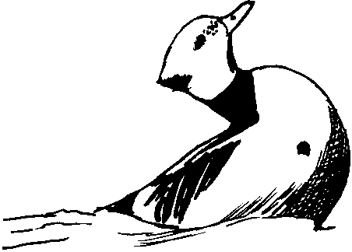

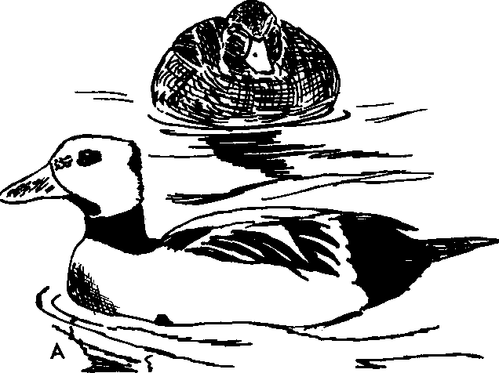0

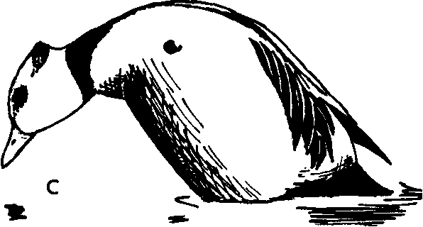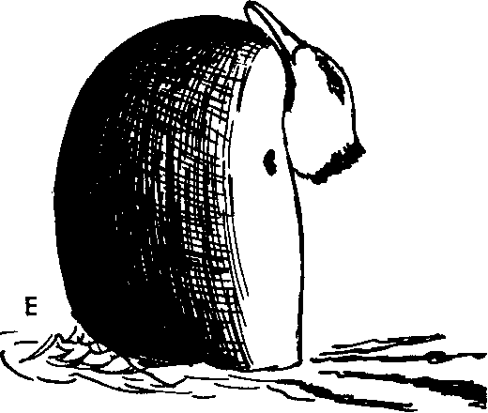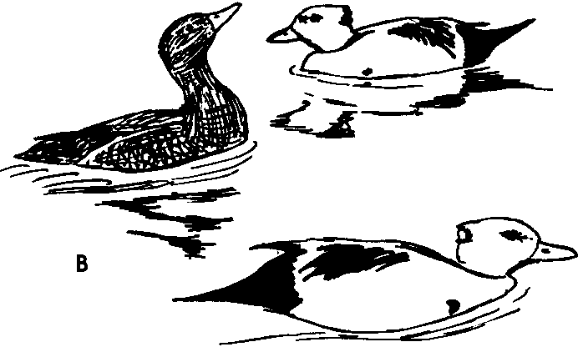

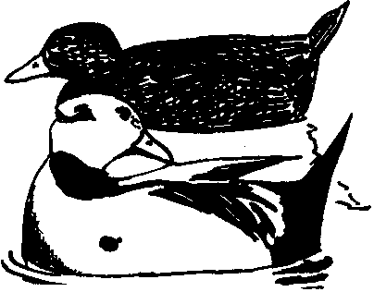F

Figure 76. Steller's Eider
A. Lateral Head-turning by male Steller's eider.
B. Female Steller's eider Inciting preferred male (right foreground)
against second male. The preferred male is performing Head­
turning.
C. Male performing Upward-stretch.
D. Aggressive Chin-lifting by male Steller's eider. This appears to be a modification or a low-intensity version of the Rearing display.
E. Rearing by male Steller's eider.
F. Precopulatory behavior. Preening-dorsally in the region of the ornamental scapulars on the side toward the female.

or Bathing movements, which are alternated regularly with Preening­ dorsally behind the ornamental tertials (Fig. 76F). This combination of Bathing and Preening-dorsally may be continued for a minute or more, but eventually the male follows Bathing with a single, sudden Upward-stretch, after which he "surfboards" to the female with astonishing speed, with his chest well out of the water, and mounts her immediately. As in the typical eiders, there is no Flick-of-the­ wings during treading. Before the male releases the female, the two birds Rotate almost a complete circle in the water. The male then immediately performs a single Rearing display, and finally Steams away, performing lateral Head-turning, and the female bathes. Several features of this copulatory behavior, such as the female's Prone posture, the male's combination of Bathing and Preening­ dorsally, and his ritualized Steaming to and from the female, all indicate affinities with the scoter-goldeneye group and show no evi­ dence of relationships with the dabbling ducks.

Labrador Duck (Camptorhynchus lahradorius)

The extinct Labrador duck is so little known that it is only tenta­ tively placed here and presumed to have been related to the seaters and perhaps also to Steller's eider. The downy plumage is unknown, but the female plumage was gray. Though weakly patterned, it was rather scoterlike. As in the white-winged seater, there was a large speculum formed by the secondaries and their coverts in both sexes. The male in breeding plumage was strongly marked with black and white in an eiderlike pattern, but the wings were entirely white except for the primaries. It is uncertain whether an eclipse plumage was present. The trachea of the male was described by Wilson (1829). As in the seaters, there was an expansion of the tracheal tube at the anterior end and two enlargements (rather than one as in scoters) near the middle of the tube. The bulla is described as having been large, "bony and round, puffing out from the left side." This asymmetrical and osseous bulla is unlike that of the seaters, and the only other sea ducks with such bullae are the eiders and the harlequin duck. This suggests that the Labrador duck might provide an evolu­ tionary link between the eiders and such other sea ducks as the harlequin and the seaters. Woolfenden (1961) has commented on the intermediate form of the Labrador duck's pectoral girdle between

those of Steller's eider and the harlequin. Humphrey and Butz (1958) have reviewed the anatomical features of the Labrador duck and con­ cluded that it was probably related to the scoter group.
Very little is known about the general or sexual behavior of the
Labrador duck, although it is known to have foraged at least partially on shellfish. Possibly the soft-edged bill of this species was related to specialized feeding requirements which were perhaps a factor in its extinction.

Harlequin Duck (Histrionicus histrionicus)

The genus Histrionicus does not really "fit" into any sequence of the sea ducks which might be devised. This may be in part due to the fact that it is a highly specialized bird which is adapted to mountain streams. The young are most like those of the scoters and the long­ tailed duck, having a dark back and crown and light cheeks and under parts. Juvenile males resemble females and have a plumage pattern much like that of scoters. The wing pattern is brown and lacks the metallic-colored speculum of the male. Adult males in nuptial plumage have a body coloration and pattern which is com­ pletely unique in the Anatidae. Unlike the other sea ducks except Steller's eider, the wings exhibit a metallic-blue speculum. There is a distinct eclipse plumage which closely resembles the female plumage. The trachea is of variable diameter, and unlike that of the scoters, has a completely osseous and left-sided bulla much like those of the eiders (see illustration in Johnsgard, 196Ic). The harlequin has a wide range in the Northern Hemisphere, and is sympatric with many other sea ducks. No hybrids are known.
General behavior. The harlequin, more than any of the other sea
ducks, is a bird of mountain streams. It is highly adapted to living in such habitats and, like the torrent duck and Salvadori's duck, swims with constant head-pumping motions. Like the eiders, scoters, and the long-tailed duck, it usually uses its wings when diving. Preflight movements have not been recorded.
Agonistic and sexual behavior: female. Myres (1959a) has ob­
served this species, and states that Head-nodding is the only female display he has seen, and that it is exactly like the Head-nodding of males. It is a somewhat elliptical movement, with the long axis of the ellipse parallel to the water, and with the bill held horizontally.

Several high-pitched notes have been attributed to the female, and
Sven-Axel Bengtson (pers. comm.) has recently observed a form of
Inciting similar to that of goldeneyes.
Agonistic and sexual behavior: male. Myres (l959a) believes that the Head-nodding described above is the only male display. It is accompanied by a high-pitched note, single or trilled, reminiscent of "a group of fighting mice." Bretherton (1896) has described a much more complex display, in which "the head is thrown far back with the bill pointed directly upward and widely open; then with a jerk the head is thrown forward and downward as the cry is uttered, and at the same time the wings are slightly expanded and drooped." This display has not been observed by any others to my knowledge. Little has been recorded concerning the behavior of Harlequins, but Neal G. Smith (pers. comm.) and Sven-Axel Bengtson (unpublished MS) have made recent observations of interest. Bengtson believes that Head-nodding is the primary male display, used in situations of court­ ship, slight disturbance, and early stages of threat display, varying somewhat in the vigor with which it is performed. Threat postures and aggressive rushes toward the opponent were also frequently observed. Bengtson mentions seeing a male shake his bill laterally in the water, a movement probably corresponding to the Water-twitch (Myres, 1959a) of seaters. Both Bengtson and Smith have observed wing-Happing by males as a possible display; Smith informed me that this movement was the most conspicuous male activity aside from Head-nodding. As in eiders, the wings were Happed only about two complete beats. In one case Smith observed that one of the males called, then the other ran across the water (without using his wings) for about four feet, stopped, and wing-Happed. Smith did not observe the Upward-stretch without wing-Happing, and Bengtson mentions this posture only in respect to copulatory behavior. Both observers have observed repeated series of wing-Happing; in one case Smith ob­ served a series of five wing-Haps. Females frequently called as the males wing-Happed, and in three cases females were observed to per­ form "bill-wetting" in response to this display. Smith described that call as very high-pitched, staccato, and not a whistle, but rather like the call of a least tern (Sterna albifrons). Males also called without special posturing, and followed such calls with lateral head-shakes (as do black seaters). Smith and Bengtson frequently observed male-to­ male threats and attacks over the surface, but no underwater attacks.

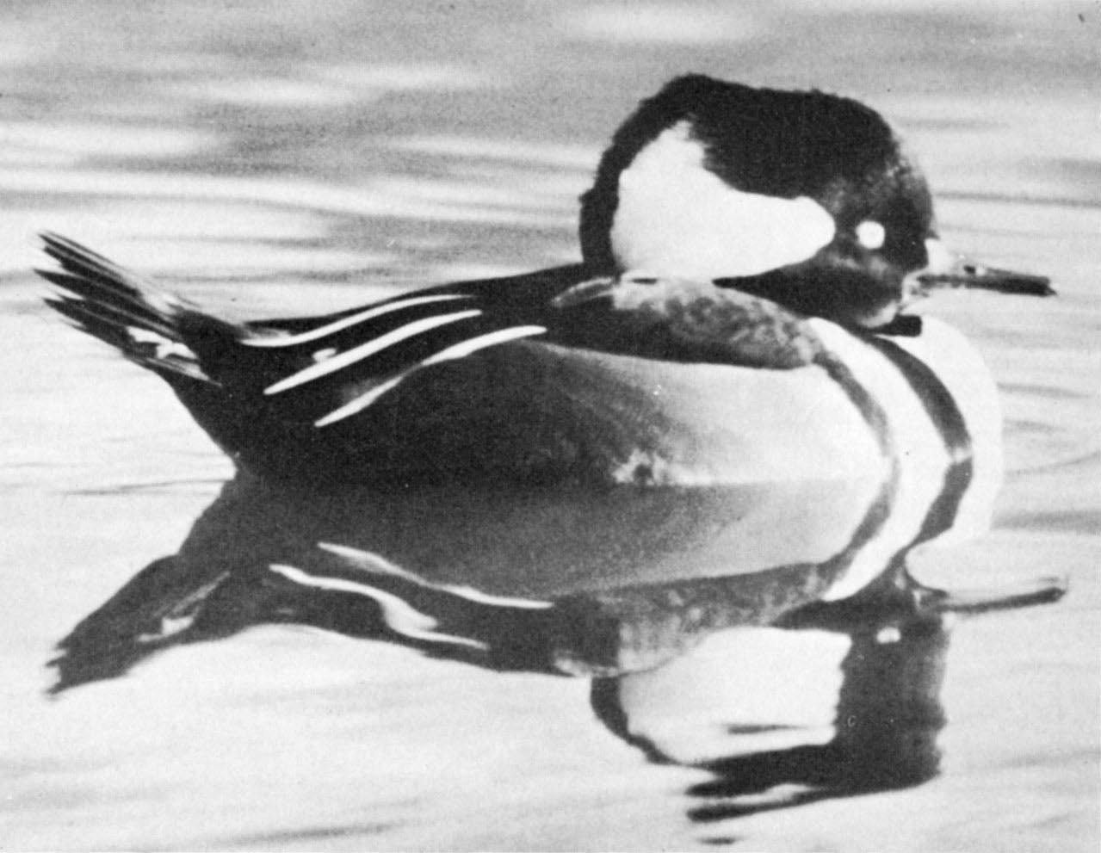
Hooded Merganser, male with crest down.

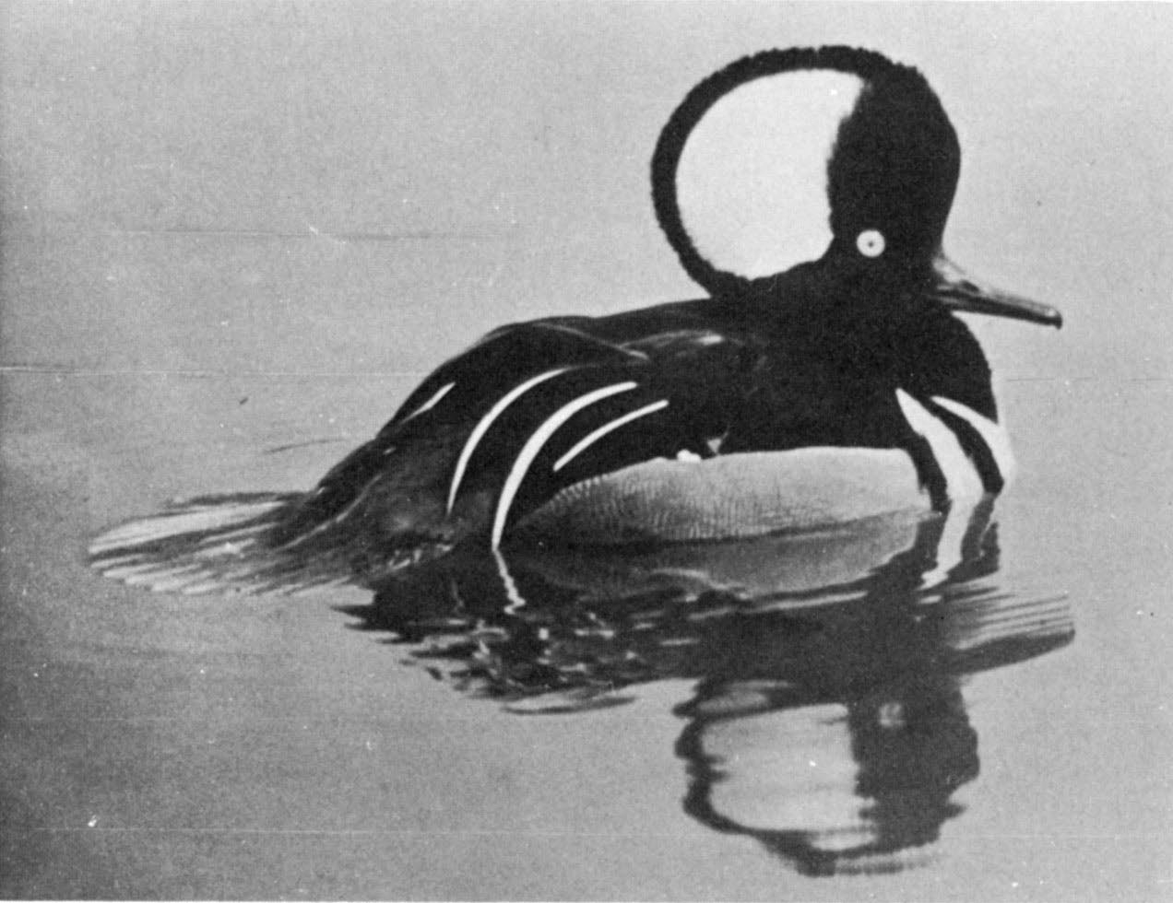

Hooded Merganser, male with crest raised.

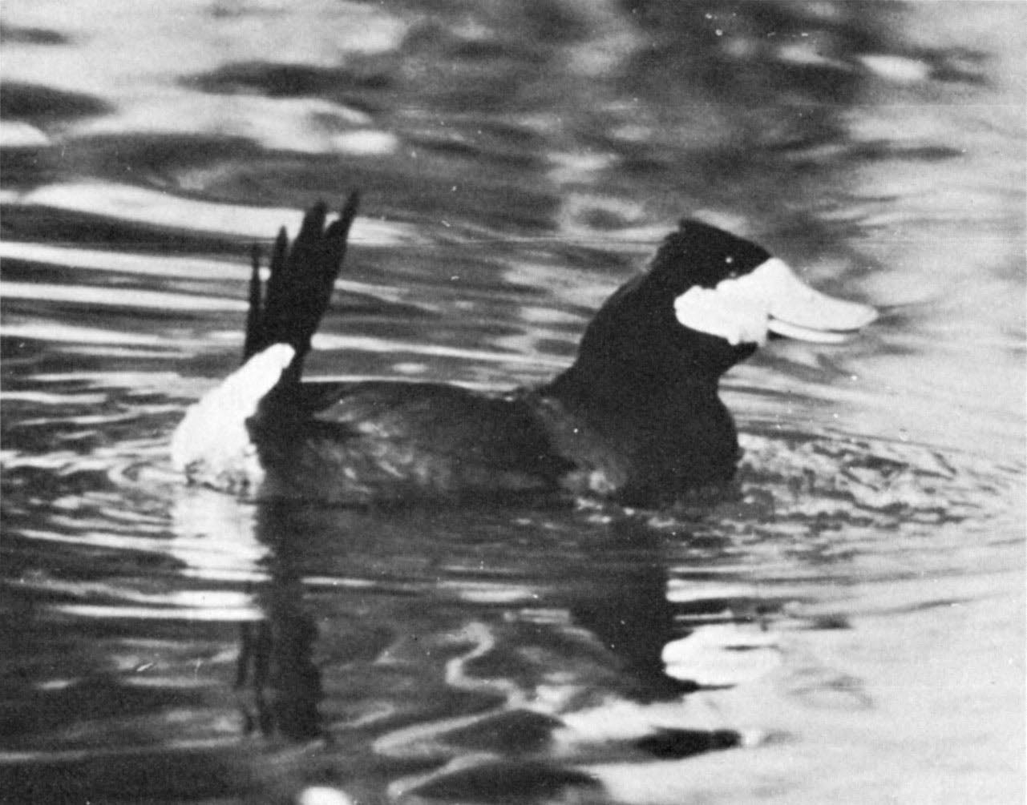
North American Ruddy Duck, Bubbling display.

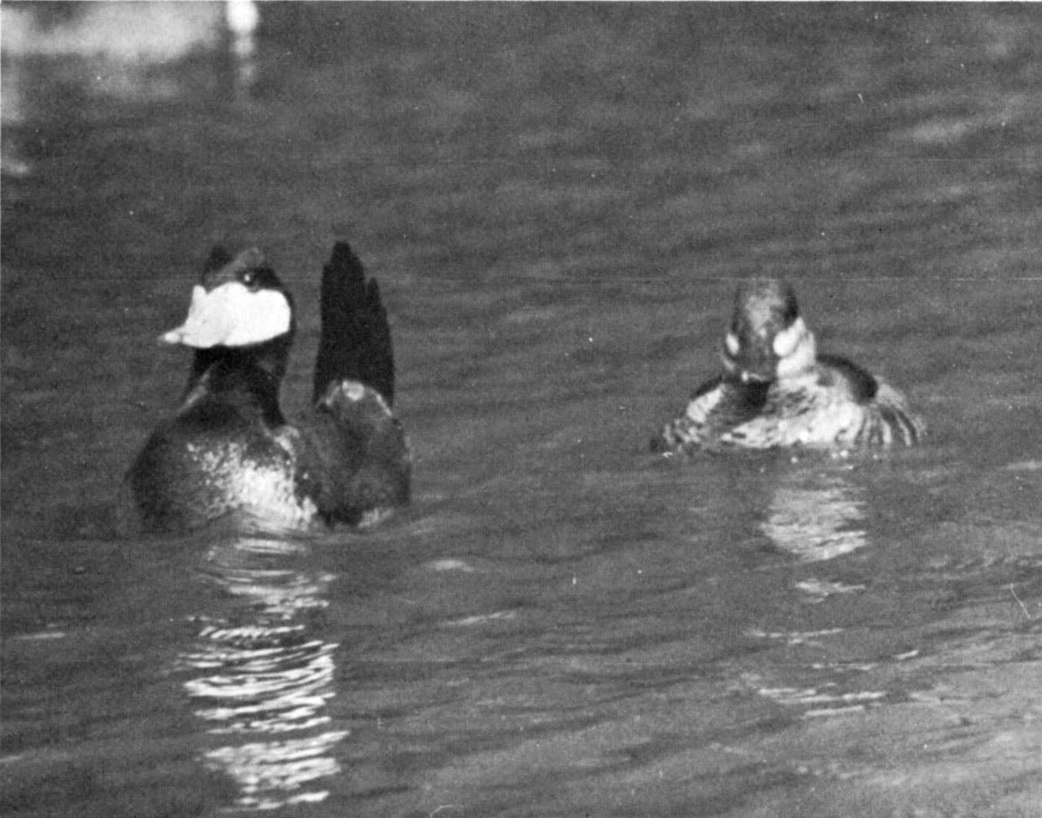

North American Ruddy Duck pair, Tail-cocking by male.

published observations regarding copulation in this species, which
appears to lack elaborate or stereotyped copulatory behavior. Neal G. Smith has observed several attempted copulations, all of which were disrupted by other birds. In the first observed instance the male was about ten feet from the female, who was not prone. He dipped his bill in the water, called with bill erect, then "skidded" rapidly over the water to the female, who escaped by diving. Later, four attempted copulations were seen. In these cases the female assumed a Prone posture which she sustained except during those times when the copu­ lation attempts were interrupted. In each case the male mounted her by suddenly "taxiing" over the water very rapidly. Smith's description of this approach clearly indicates that it is much like the rap1d "surf­ boarding" approach of Steller's eider. Each time the male mounted, however, another bird broke up the attempted copulation. No par­ ticular displays were observed immediately before the "taxi" to the female, but these could have been easily overlooked. Bengtson has observed 17 attempted and five completed copulations, and noted that copulations are initiated by mutual Head-nodding, which is usually followed by mutual "Bill-dipping" with lateral movements. The male is more likely to perform these latter movements, which consist of three to five dips in rapid succession. Bengtson states that the rush toward the female is identical to those occurring during courtship and agonistic behavior; the male skids toward the female with his bill wide open and uttering a mouselike squeaking sound. Mounting may be preceded by from five to 20 rushes before treading is achieved. In one precopulatory sequence a male preceded the rush with five "body­ ups" (Upward-stretches). In two instances Bengtson observed the female assume a Prone posture from ten to 20 seconds before tread­ ing. During copulation there are apparently no wing-flicking move­ ments, and there is little or no indication of postcopulatory Rotations. No distinctive postcopulatory postures or calls have been noted.

Long-tailed Duck (Clangula hyemalis)

The long-tailed duck, or old squaw, is probably a rather isolated species with no very close relatives. The downy young are much like those of the harlequin duck and the scoters, having unspotted brown­ ish backs and crowns, and white under parts and cheeks. Juveniles

resemble adult females, which, unlike those of other sea ducks, have distinct summer and winter plumages. The summer plumage is generally similar to the plumage of the female harlequin and is rather dark (including the down). The winter plumage is much lighter on the Hanks, breast, and head, and the winter down is also whitish. The males have an extraordinarily complex sequence and pattern of plumages, about which there has been much discussion and argument (Stresemann, 1948; Salomonsen, 1949). In nuptial plumage the male is predominantly white, with a black breast and back, a black ear patch, and a grayish color between the ear patch and bill. The tail is greatly elongated, and the dark central feathers may reach a length of almost ten inches. Most sexual display is done in this plumage, which is retained until about April, when the white feathers of the head and neck are replaced with black ones, the gray Hank feathers with white ones, and the long white scapular feathers with shorter tan feathers having dark central stripes. This plumage is assumed before the breeding period, but it is a duller plumage which appears to be a functional eclipse. Some of the white feathers behind the eye and the gray cheek feathers are retained, producing a white eye-ring of varying size in different birds. This plumage is held until July, when there is a further loss and/or fading of the longer scapulars and a molt of the tail. The loss of the wing feathers also occurs at this time. By September the tail and Hight feathers are again fully grown, and the brownish scapulars, and also the black head and neck feathers, are replaced with white ones. At this time the grayish cheek feathers, holdovers from the preceding winter's plumage, are also molted and replaced with white ones. These white cheeks are retained, however, for only a month or two before being replaced with the gray cheeks of the winter plumage.
The trachea of the male is of somewhat variable diameter, and
although the bulla is partially membranaceous it is distinct in shape from those of the other sea ducks (see illustration in Johnsgard,
1961c). The species occurs throughout the arctic zone and is sympatric
with most if not all the other northern sea ducks. Although wild hybrids have never been reported, a captive hybrid involving the chestnut teal has been alleged.
General behavior. The long-tail is an open-water bird and is
perhaps more northerly in its breeding distribution than any other

distances. Long-tails usually open their wings when diving, although in captivity at least this is sometimes not done. Lateral Head-shaking is the only preflight movement which has been noted.
Agonistic and sexual behavior: female. Myres (1959a) states that
Chin-lifting is the major female display, but it is rare compared with this display in female seaters. It is a rapid movement, involving only the bill, and the head remains on the shoulders. Presumably it is functionally equivalent to Inciting, but I have not personally ob­ served female display. Drury (1961) states that when tossing the head (presumably Chin-lifting) the female utters an urk; urk, urk, ang, ang, ang, goo or gut-gut-goo'ah-g6o'ah.
Agonistic and sexual behavior: male. Male long-tailed ducks have
several conspicuous displays, of which two are associated with calls. The most frequent call is the "Ah-har-lik" call (Myres, 1959a), which may be uttered without any head movement or with a rapid Bill-toss (Fig. 77A, B). The Ah-har-lik call is preceded by two preliminary notes, and the last syllable is loudest, thus: ugh, ugh, ah-oo-gah'. The second call is distinctly different and is associated with the "Rear-end display" (Myres, 1959a). This call can be written as a-oo, a-oo, a-oo'­ gah, with the penultimate syllable the loudest. The male begins this call with his head erect and his neck vertical; then he rapidly swings his head down over the water, with neck still extended, as he erects his tail to the vertical and kicks both feet slightly out of the water (Fig. 77C, E). Displays not mentioned by Myres include Neck­ stretching (Fig. 77D) and Turning-the-back-of-the-head (Fig. 77C, D). Neck-stretching is often followed by or combined with Turning­ the-back-of-the-head, and it resembles the erect, or "Sentinel," posture of seaters. Drury (1961) has also observed Short Flights by males. Unlike the seaters, these birds apparently do not engage in under­ water attacks on one another. Except during display, the male's head feathers are not raised, and the forehead profile is low and sloping (Fig. 77F).
Copulatory behavior. Myres (1959a) has observed copulation in
this species, and reports that the female remained in a Prone posture for periods ranging from only momentarily up to 15 seconds or more before the male mounted. No specific precopulatory displays were observed, and during treading no Flick-of-the-wings was seen. There

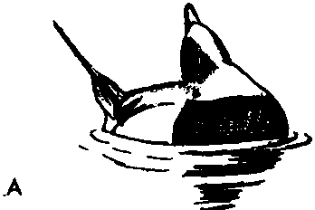D w
'

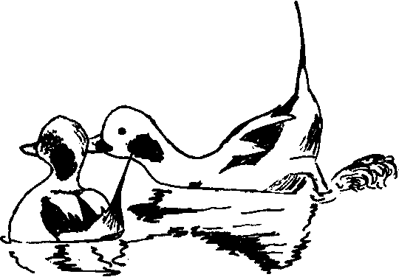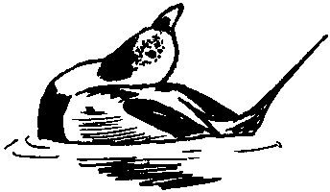

8

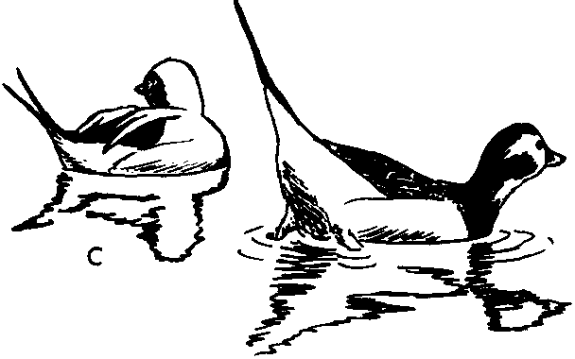
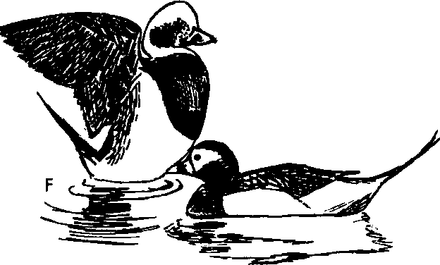Figure 77. Long-tailed Duck
A, B. Two views of Bill-toss by male long-tailed duck while uttering the
Ah-har-lik call.
C. Turning-the-back-of-the-head by one male (left) as the other performs the Rear-end display.
D. Turning-the-back-of-the-head by one male to another (apparently a homosexual pair), combined with Neck-stretching.
E. Rear-end display by male just assuming winter plumage. Note white cheeks.
F. Wing-Happing (possibly a display) by male in full winter plumage. The
male on the right is just molting out of its summer plumage.

were no postcopulatory Rotations, and no other special postcopulatory behavior was observed.

Black Scoter (Melanitta nigra)

The black seater diverges from the other two species of Melanitta in several respects. The downy young are rather eiderlike in that they are predominantly dark brown with no dorsal spotting and with only an indistinct cheek patch. Juvenile males resemble females, which have a two-tone head plumage unlike the other scoters but otherwise are uniformly brownish in color. Adult males are almost entirely black except for a variably enlarged yellow bill protuberance. The wing is unpatterned and has a very narrow outer primary that produces a whistling noise when the wings are Aapped. There is no obvious eclipse plumage. The tracheal structure of the male is extremely simple, with a tracheal tube of uniform diameter and a small, sym­ metrical syrinx. The bronchi, however, are much enlarged (illus­ trated in Johnsgard, 196lc). The species has a broad range in the holarctic region and is sympatric with both of the other species of scoters. No hybrids have been reported involving this species.
General behavior. Like the other scoters, black seaters are essen­ tially salt-water birds, coming inland only during the breeding season. They dive well, normally opening their wings when so doing, but this appears to be rather variable, at least in captivity. Like most other sea ducks, the black scoter indicates its intention to Ay by swimming in an alert, neck-stretched attitude and occasionally performing lateral Head-shakes.
Agonistic and sexual behavior: female. Neither I nor others have
observed any calls or movements which obviously function as Inciting, although Myres (l959a) has observed a slight chin-lifting which may be such a display. At times the female calls in unison with the male when he utters the courtship whistle, and the female's call is a similar, frequently repeated, whistling note that is grating rather than mellow, and reminds one of the swinging of a door with rusty hinges. It is uttered from an erect posture like the calling posture of males. One obvious female display consists of Preening-behind-the-wing (Fig.
79B, E) toward a male as he utters the courtship whistle, and this
preen appears to be a frequent stimulus for the male to perform the Low Rush. Myres (l959a) mentions the Tail Snap and Low Rush as being performed by females. I have not seen these displays, but

lateral Head-shaking, the Upward-stretch, Wing-Happing, and various preening movements are all frequent and may have signal function.
Agonistic and sexual behavior: male. Male courtship displays have
been described by Gunn (1927), Humphrey (1957), McKinney (1959), and Myres (1959a). My observations on the European race compare very closely with those of McKinney on the American race. It is extremely difficult to separate true display from ordinary comfort movements in this species, for most displays are only slightly modified versions of such movements. Thus the Upward-stretch (the "Shake" of McKinney), Wing-Happing, lateral Head-shaking, and preening in various places all occur frequently during display and appear to have signal function. McKinney (1959) has named the major displays, which include the Low Rush (Fig. 79C, F), the Tail-snap (Fig. 79A, D), the Short Flight, and Steaming toward the female. The Tail-snap is almost always followed by the Low Rush, but the latter display is sometimes performed independently. In its complete form the male display sequence involves a complex series of movements. In the order of their usual performance, these are as follows: Courtship whistle in Erect posture (Fig. 78A), Tail-snap, Low Rush, Water­ Hick (Fig. 78C), Breast-preen (Fig. 78D), Forward-stretch (Fig.
78E), Upward-stretch (Fig. 78F), and lateral Head-shake (Fig. 78B). The Tail-snap and the Low Rush are fairly often omitted from the sequence, and in its simplest form the display consists of the courtship whistle followed by lateral Head-shaking (Fig. 78A, B). I have not observed the display that Humphrey (1957) termed "Bowing," but Myres (1959a) considered it to be the courtship call posture ("Neck­ stretching").
Copulatory behavior. My observations on copulation agree with those of McKinney (1959) and Myres (1959a). Unlike most other sea ducks, the female does not remain in the Prone or soliciting posture for long, but assumes it just before the male mounts, after both sexes have Preened in various places. The male performs an Upward-stretch when the female goes Prone, then mounts im­ mediately (compare Steller's eider). The male does not Flick-the­ wings while mounted, and he releases the female as soon as copula­ tion is completed, then swims away from her while calling in the usual Neck-stretching posture. The female begins to bathe im­ mediately. Myres (1959a) observed the Tail-snap, Low Rush, and Upward-stretch sequence after one copulation.

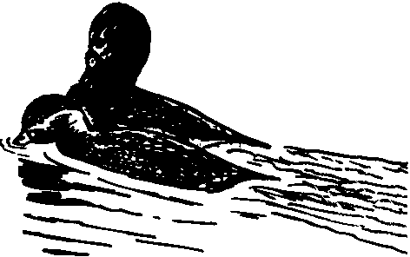
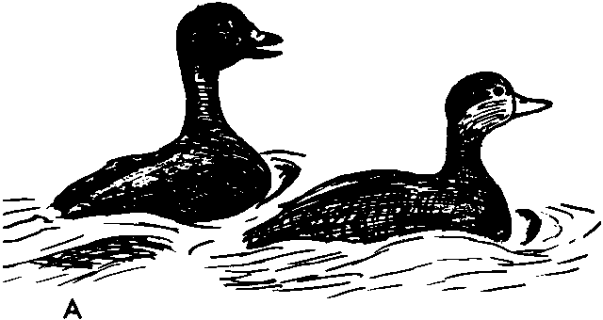D

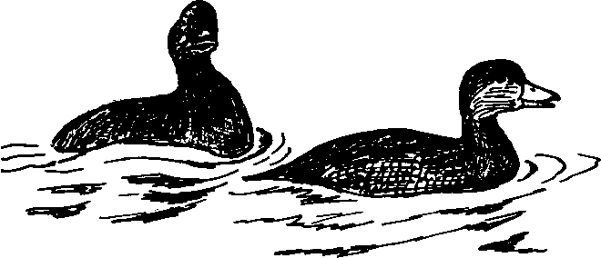 , '

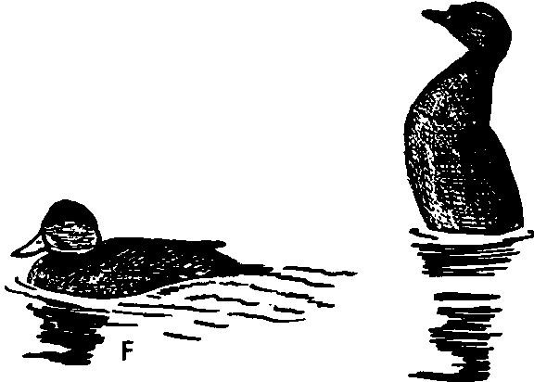B E

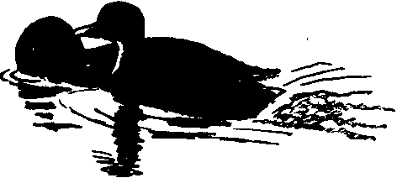c

Figure 78. European Black Scoter
A. Male scoter (left) uttering courtship whistle in Neck-stretching posture.
B. Lateral Head-shake performed by male scoter after courtship whistle;
female calling.
C-F. Water-flick-Breast-preen-Forward-stretch-Upward-stretch sequence. C. Water-flick.
D. Breast-preen.
E. Forward-stretch (female preening breast). F. Upward-stretch.

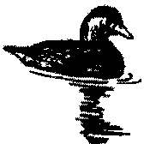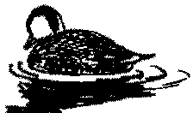A D •

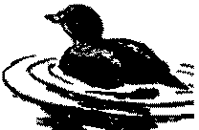B E

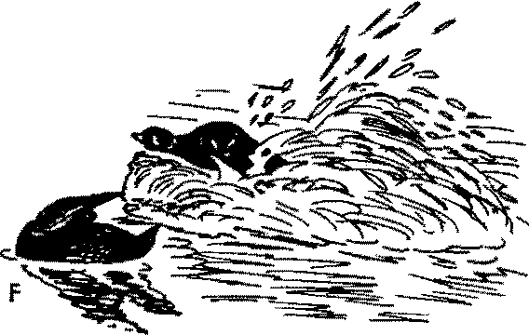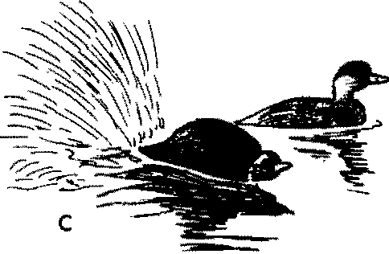

Figure 79. European Black Sooter
A. Tail-snap by male scoter following courtship whistle.
B. Female scoter (right) Preening-behind-the-wing to male. C. Low-rush by male.
D-F. Another Tail-snap-Low-rush sequence. D. Tail-snap
E. Female Preening-behind-the-wing as male lowers tail. F. Low-rush by male.

Subfamily Anatinae 281

Surf Scoter (Melanitta perspicillata)

Although prol;>ably more closely related to the white-winged scoter than to the black scoter, the surf scoter exhibits a few similarities to other species, including Steller's eider. The downy young closely resemble those of the black scoter, but they have a more contrasting pattern which approaches the black and white pattern of the white­ winged scoter. First year males and females have a brown·and-white­ spotted head pattern which closely resembles that of the white-winged scoter. Adult males resemble the black scoter in their lack of a white wing-speculum, but in their sexually dimorphic white iris coloration they are like the white-winged scoter. In their orange leg and foot coloration they also approach the white-winged scoter. Bill and head coloration in this species is the most elaborate of all the scoters and, as in the other species, there is no distinct eclipse plumage. The trachea of the male has a swelling near the anterior end of the tube and a mid-tracheal swelling which apparently varies in size in dif­ ferent individuals. The species is restricted to North America and is sympatric with both of the other scoters. Hybridization with the white­ winged scoter has been reported.
General behavior. The surf scoter seems slightly heavier-bodied
and less agile than the black scoter and lacks the markedly elongated tail of that species. Males also lack the extreme narrowing of the outer primary of that species, but their wings do nevertheless whistle slightly when Happed. Preflight movements have not been observed.
Agonistic and sexual behavior: female. I have not observed display
in this species, but Myres (1959a) has presented a full account. Chin­ lifting, accompanied by a "crow-like" call, is directed toward a spe­ cific male, and presumably it is very similar to the marked chin­ lifting and harsh calling during Inciting by Steller's eiders. Females also perform several of the male courtship displays, according to Myres.
Agonistic and sexual behavior: male. The "Threat" and
"Crouched" aggressive postures of this species are much like those of the white-winged scoter, according to Myres, and, as in that species and the goldeneyes, underwater chases are frequent. The "Sentinel" posture described by Myres is apparently equivalent to "Neck­ stretching" in the black scoter and the "Neck-erect-forwards" of the white-winged scoter. In this posture "Breast Scooping" occurs, which

is apparently a combination of lateral Head-shaking and breast preen· ing movements, and is accompanied by a "liquid gurgling call" (Myres, 1959a). A display not found in the other scoters is "Chest­ lifting," which is a rapid throwing back of the head and raising of the front of the body out of the water in a manner very similar to the Rearing display of male Steller's eiders (Myres, pers. comm.). There is a "Fly-away" display similar to the Short Flights of black scoters, Steller's eiders, and Bucephala, and as the bird lands the wings are momentarily raised into the "Upward-wings-raised" posture as in Bucephala (Myres, 1959a). There is also a "Tail-raised and Head­ Turning" display which is perhaps homologous to the Tail-snap of black scoters and the lateral Head-turning of eiders and goldeneyes.
Copulatory behavior. Myres (1959a, 1959b) has provided the
only account of copulation in this species. The female remains in a Prone posture for a longer period (up to two minutes) than in the other scoters. No preceding mutual behavior was noted. While the female was Prone, the male performed the Water-twitch (dipping the bill while shaking the head laterally) and Preening-behind-the­ wing. Ritualized Drinking was observed in four out of eight pre­ copulatory sequences. The male mounted slowly, and in most cases Flicked-the-wings once during treading. In seven out of the eight cases the male performed a Chest-lifting movement as he dismounted, but no other displays were seen. The female usually Happed her wings after copulation.

White-winged Scoter (Melanitta fusca)

The white-winged, or velvet, scoter appears to be the most spe­ cialized species of scoter, and approaches in several respects the genus Bucephala. The downy young are strongly patterned with black and white, and are very similar to goldeneye downies. First-year males and females have a brown plumage and a spotted head-pattern like that of the surf scoter. Adult males have white irises as in the surf scoter, which are emphasized by a white eye-stripe. The body is otherwise dark except for a large white patch on the secondaries and their coverts. There is no eclipse plumage. The trachea of the male has two distinct enlargements in the tracheal tube and an almost bilaterally symmetrical bulla (see illustration in Johnsgard, 196Ic). The species ranges widely across the arctic and is sympatric with both of the other species of scoters. Hybrids with the surf scoter have

been reported, and hybrids with the common goldeneye have also been alleged.
General behavior. White-winged scoters usually open their wings when diving, and keep them open when under water, and it has been alleged that the wings are used for steering when the birds are sub­ merged. Like the other scoters, this species is primarily a saltwater bird, although during the breeding season it moves great distances from any ocean, into the central part of North America.
Agonistic and sexual behavior: female. To judge from Myres' ac­
count (1959a), Chin-lifting appears to be the primary female dis­ play. It is similar in form to the preflight Chin-lifting of the lesser scaup and is accompanied by a "very thin whistle." It is directed to a favored male or occurs in a Triumph Ceremony situation; thus it is clearly equivalent to true Inciting. Ritualized Drinking is also per­ formed by females.
Agonistic and sexual behavior: male. Besides Myres' account (1959a), Koskimies and Routamo (1953) have described the displays of this species in detail. Threat display is much like that of the surf scoter and the goldeneyes, and underwater attacks often occur. The "Neck-erect-forward" (Myres, 1959a) is assumed during rapid swim­ ming. Males also frequently perform ritualized Drinking in an exag­ gerated fashion much like that of the common goldeneye. Although Drinking is frequent during courtship, it, Water-twitching, and ritualized Preening are probably primarily precopulatory displays. Males also utter a whistling note during display, but it is not certain whether this occurs during special posturing. As in the other scoters, the Upward-stretch and Wing-flapping are frequent during display and are almost certainly ritualized. Myres (1959a) mentions a pos­ ture observed in a male during apparent pair formation, when he held his bill downward, with a very "swollen" head and neck.
Copulatory behavior. Myres (1959a, 1959b) has observed copu­
lation on several occasions. As in the black scoter, the female assumes the Prone posture only shortly before the male mounts. Before this the pair usually performs mutual Drinking, and the male performs Water-twitching and Preening-behind-the-wing. This latter display can occur independently, but when Water-twitching is performed it is usually followed immediately by Preening-behind-the"wing. Preen­ ing is not restricted to the wing (where it exposes the white specu­ lum), but also occurs dorsally and on the sides and shoulder. Ap-

parently no particular display occurs just before mounting. When mounted, the male sometimes (once or twice out of five times) per­ forms a double Flick-of-the-wings, and upon dismounting he some­ times momentarily retains his hold of the female's nape, producing a slight rotary movement by the two birds. The male then releases the female and swims slowly away, rearranging his wings. The female does the same and may also Hap her wings (Myres, l959a, l959b).

BufHehead (Bucephala albeola)

Of the three species in the genus Bucephala, the bufHehead ap­ pears to be the least specialized. Myres (l959a) suggested that the goldeneyes might be related to the seater group through the bufHe­ head, and that possibly the latter should be placed in a monotypic genus. Although I agree that the bufHehead is a probable link be­ tween Melanitta and Bucephala, I do not believe that generic separa­ tion is warranted. The downy pattern of the bufHehead is exactly like that of the goldeneyes, and juvenile males and females are very similar to those of goldeneyes except for the white head-markings and dark-colored eyes. Males in nuptial plumage differ from the goldeneyes only in having a dark iris, pink rather than yellow feet, and slightly different head patterning. There is a complete eclipse plumage which closely resembles the female plumage. The trachea of the male lacks any swellings, and the bulla is fairly small and simple in form, approaching the simple seater type of bulla. BufHeheads are restricted to North America and are sympatric with both species of goldeneyes. No hybrids have been reported.
General behavior. As is true of the other species of Bucephala,
bufHeheads differ from seaters in that they are primarily fresh-water birds and cavity-nesters rather than ground-nesters. In correlation with this the females are grayish rather than brown, and possess white rather than dark gray nesting-down. Unlike the preceding sea ducks, all species of Bucephala dive with their wings closed. Pre­ flight movements have not been noted.
Agonistic and sexual behavior: female. As in the goldeneyes, there
is a great deal of aggressive behavior in both sexes, and postures de­ rived from or related to threat displays are conspicuous features of display. The female apparently has two major displays. The first of these is the "Head Display" (Myres, l959a), which is similar to the

Crest-erection of males and apparently stimulates males to display sexually. The second is "Following," in which the female follows a male (presumably a preferred individual), calling and alternately stretching and withdrawing her neck (Myres, 1959a). This display is at least functionally equivalent to Inciting, although it is entirely different from the lateral Inciting of goldeneyes or the chin-lifting form of Inciting in seaters and eiders. It resembles somewhat the Inciting of female smews.
Agonistic and sexual behavior: male. Male displays are largely derived from attack and escape behavior. They include the aggres­ sive "Head-forward" posture (Myres, 1959a), which is exactly like the Crouch posture of seaters and the Laying-the-neck-on-the-water posture of goldeneyes. A similar posture, but with the bill held well out of the water, is assumed during the commonest male display. Myres (1959a) calls this posture Head-bobbing, but I believe it is homologous to the Bowsprit-pumping and Rotary Pumping of the common goldeneye and Barrow's goldeneye, though it is performed in a much more rapid and jerky fashion (Fig. 80A). This posture, which might be called Oblique-pumping, is sometimes momentarily interrupted by a sudden lifting of the folded wings, retraction of the head, and down-tilting of the tail (Fig. 80B), after which the male usually resumes his Oblique-pumping. I have not heard any male vocalizations. Lateral Head-turning movements are sometimes also performed, and are similar to but more rapid than those of golden­ eyes. Other sexual displays of males include Crest-erection and "Leading" (Myres, 1959a) a particular female (who Follows him), with or without Head-turning. This Leading and Following com­ bination is no doubt functionally equivalent to the Turning-the-back­ of-the-head and Inciting combination of dabbling ducks, pochards, and some other sea ducks. Frequently the male will make rapid Bill­ pointing movements back toward the female behind him (Fig. 80C). Ritualized "Short Flights" are frequent, during which a male takes off, flies toward a female, and lands near her, immediately after which he Wing-flaps, ending with a resounding slap of the wings and some­ times raising the folded wings high over the body. On one occasion I observed what I believe was a display corresponding to the Bowsprit of the common goldeneye. It was performed in almost exactly the same manner as the Bowsprit is performed in that species. I have also observed a vertical head-pumping of uncertain significance.

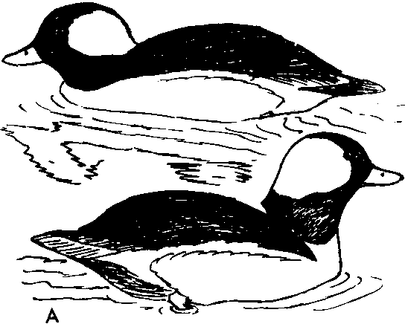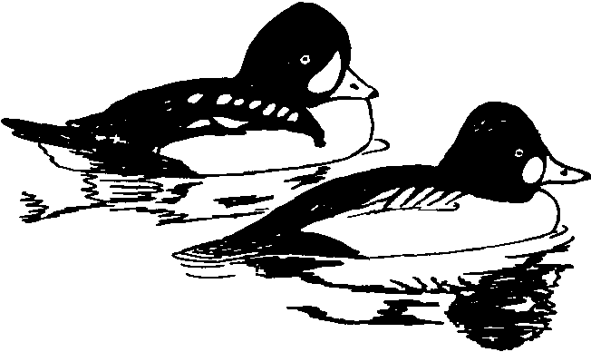D

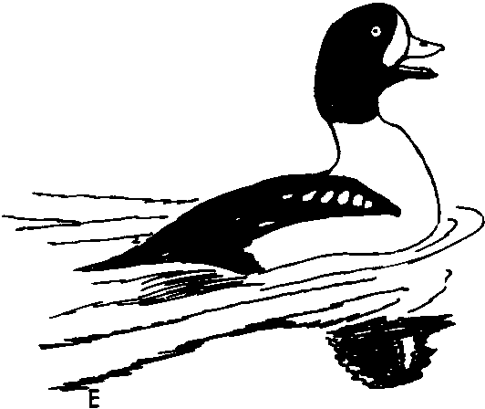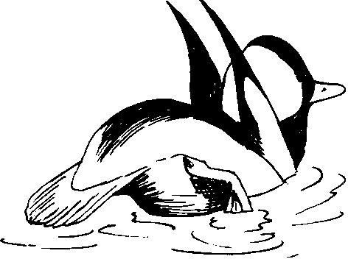
8

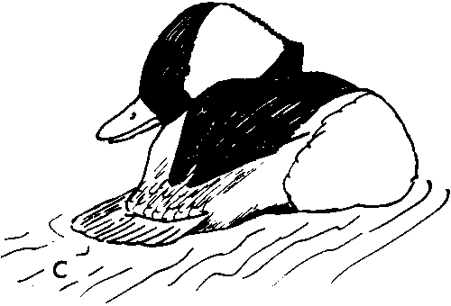
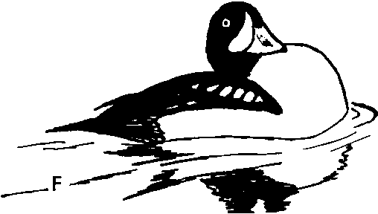Figure 80. Buffiehead, Barrow's Goldeneye
A. Two phases of Oblique-pumping by male buffieheads.
B. Folded-wings-lifted posture of male buffiehead.
C. Male buffiehead performing Bill-pointing to female behind him.
D. Comparison of male plumages of Barrow's goldeneye (left) and common goldeneye (right).
E, F. Neck-withdrawing by male Barrow's goldeneye.

Copulatory behavior. Myres (l959a, 1959b) has described in de­ tail the copulatory behavior, which differs from that of goldeneyes in several important respects. The female is in a Prone posture for a variable period, but never for more than a few minutes. The male repeatedly performs two movements-the Water-twitch (lateral bill­ shaking in the water, as in scoters and goldeneyes) and, less com­ monly, Preening-dorsally, which sometimes follows the Water-twitch. Ritualized Drinking was apparently not observed by Myres, nor was the Wing-and-leg-stretch, although these are the two most common goldeneye precopulatory displays. The male suddenly mounts the female without any special preceding movements, and a Flick-of-the­ wings was seen by Myres on three out of eight occasions. The male retains hold of the female's nape after completing copulation, and the two birds "Rotate" (Myres, 1959a) from one to several full turns. The male then releases her and either immediately "Plunges" under the water or begins to "Splash-bathe." The female bathes and then Haps her wings. In one copulation I observed, the male swam rapidly away from the female while performing Head-turning movements after he emerged from his dive.

Barrow's Goldeneye (Bucephala islandica)

In nearly every respect Barrow's goldeneye is almost identical with the common goldeneye. It is virtually impossible to distinguish the downy young of the two species, and the juvenile males and females of the two species differ only slightly in bill shape and head shape. Females from the western United States apparently have all­ yellow bills during the breeding season, while those from the eastern population have little or no yellow on their bills. This may be related to the fact that the western breeding population is sympatric with the common goldeneye, whereas the eastern population apparently is not. Males in nuptial plumage differ from those of the common golden­ eye in their head shape and plumage, and in the pattern of the wings and scapulars. There is an eclipse plumage which is essentially identical to the female plumage. The male trachea has a bulla almost exactly like that of the common goldeneye, although the tracheal tube has a gradual rather than abrupt enlargement near the middle. The species occurs in western and eastern North America, Green­ land, and Iceland, and is sympatric with both species of Bucephala

and several mergansers. Hybrids have been reported only with the common goldeneye.
General behavior. Goldeneyes are found both on salt and fresh
water, often in fairly large Hocks. They are excellent divers, and feed primarily on animal materials. Preflight movements consist of lateral Head-shaking while holding the head erect and facing into the wind.
Agonistic and sexual behavior: female. Although similar in ap­ pearance to the female common goldeneye, the female Barrow's presents some interesting behavioral differences. The head-pumping movements take a rotary form ("Rotary Pumping" of Myres, 1959a) rather than an elliptical one as in the common goldeneye. The "Head-up" posture (Myres, 1959a) is like that of the common goldeneye, but Inciting (the "Jiving" of Myres, 1959a), which is much more frequent in this species (Fig. 81D), consists of alternate side-to-side pointing movements, silently performed. On the other hand, the "Neck-dip" of the female common goldeneye is either lacking altogether or performed very rarely. Ritualized Drinking is frequent in both species, and is the usual prelude to copulation. In addition, females of both species assume the aggressive postures of the males, and sometimes will attack other birds from under water.
Agonistic and sexual behavior: male. In his aggressive displays, the male Barrow's goldeneye is exactly like the male common golden­ eye, and the Laying-the-neck-on-the-water posture (Fig. 81A) usually precedes underwater attack. Rotary Pumping is the most frequent display and consists of rotary movements of the bill and head. It is no doubt homologous to the Bowsprit Pumping of the common goldeneye, but differs from it in that the bill is held almost level. It is directed to males, females, and even to downy young. The "Crouch" posture (Myres, 1959a) (Fig. 81B) is frequent during sexual display and there is an associated clicking sound uttered with the bill open. The Crouch does not occur in the common goldeneye, but in this species it is a frequent prelude to the Head-throw-kick display (Fig.
81C), which is a rapid toss back of the head and a simultaneous kick with both feet. The bill is turned slightly to the side nearest the female, and a weak, grunting ka-kaa' call is uttered at the same time. Similar, but softer, grunting sounds are also uttered during Rotary Pumping. The usual male response to female Inciting is to swim ahead of her with neck erect while lateral Head-turning (Fig. 81D), or to stretch the neck vertically while opening and closing the bill

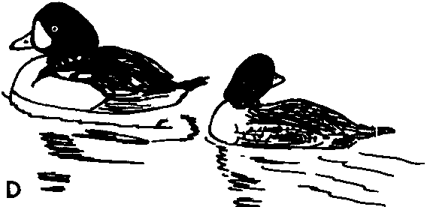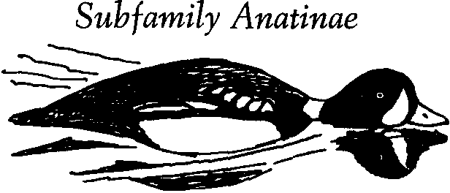 289

A

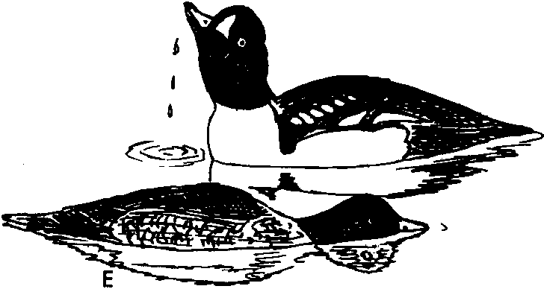

8

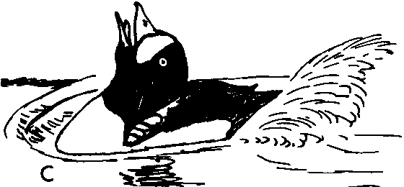
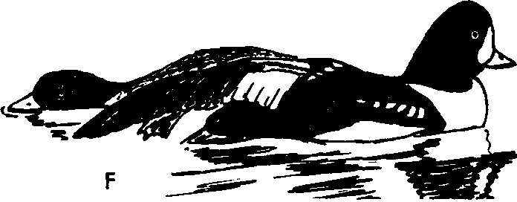Figure 81. Barrow's Goldeneye
A. Male Barrow's goldeneye in Laying-the-neck-on-the-water aggressive posture.
B. Crouched posture of male Barrow's goldeneye. Compare with A.
C. Head-throw-kick display of male Barrow's goldeneye.
D. Inciting by female Barrow's goldeneye and lateral Head-turning by male. E. Female Prone, male performing display Drinking.
F. Precopulatory Wing-and-leg-stretching by male Barrow's goldeneye.

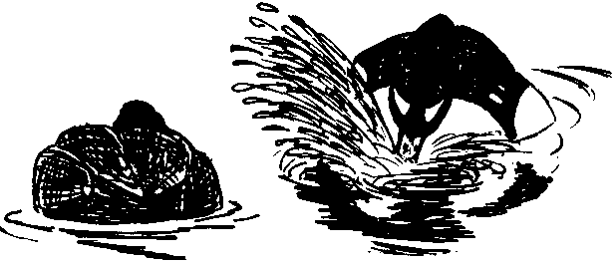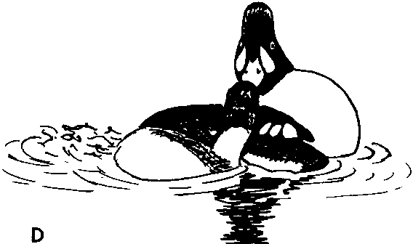A

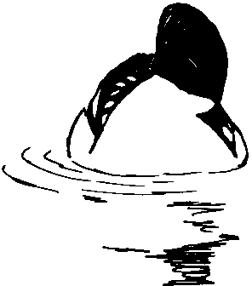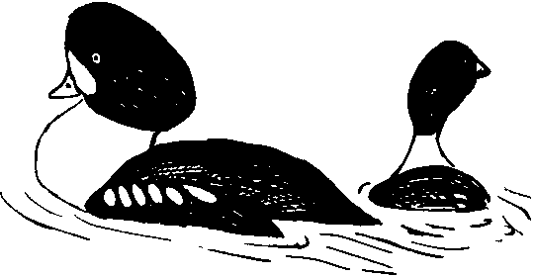

8

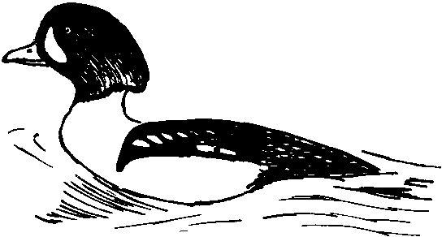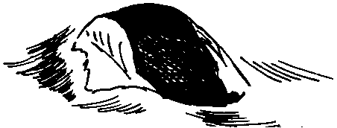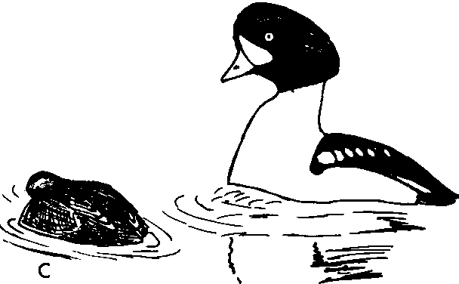
Figure 82. Barrow's Goldeneye, Common Goldeneye
A-E. Copulatory behavior, Barrow's goldeneye.
A. Jabbing by male Barrow's goldeneye.
B. Preening-behind-the-wing.
C. Precopulatory Steaming to female. D. Rotations terminating copulation. E. Postcopulatory Steaming.
F. Male common goldeneye attacking male Barrow's goldeneye underwater.

with a clicking sound, and periodically drawing the head down and back on the shoulders in a display that Myres (l959a) calls "Neck­ withdrawing" (Fig. 80E, F). Short Flights toward the female are common, as also are the Upward-stretch and Wing-Happing, all of which are apparently ritualized. There are no displays which cor­ respond to the common goldeneye's Masthead, Bowsprit, or simple Head-throw.
Copulatory behavior. The usual precopulatory behavior is mutual Drinking (Fig. 81E), which in this species is not so exaggerated as in the common goldeneye, and is interspersed with Wing-and-leg­ stretching (Fig. 81F). Water-twitching is infrequent, however, and is often replaced with Bathing movements (which suggests that Water-twitching is a low-intensity form of Bathing). Rarely, both wings are stretched over the back. Vigorous Water-twitching, or "Jabbing," (Fig. 82A) occurs only during the stage just prior to mounting, which is very much like that of the common goldeneye. As in that species this stage consists of a series of rapid sideways shakes that splash the water high in the air. These shakes are sud­ denly terminated as the male Preens-dorsally once on the side toward the female (Fig. 82B), then rapidly Steams at her with his bill pointed down toward her. Then he immediately mounts the female, who has assumed the Prone position (Fig. 82C), and he always per­ forms one or more Flick-of-the-wings while treading. When treading is completed the male retains hold of the female's nape for several seconds as the birds Rotate in the water (Fig. 82D). He then releases her and Steams rapidly away with head erect (Fig. 82E), performing lateral Head-turning and uttering repeated grunting sounds. This post­ copulatory behavior is identical to that of the common goldeneye.

Common Goldeneye (Bucephala clangula)

The common goldeneye has a much broader range than Barrow's goldeneye, extending over most of the temperate, wooded portions of the Northern Hemisphere. The downy young of the two species are identical except, possibly, for a slight difference in foot colora­ tion, and juvenile males and females differ from those of Barrow's goldeneye mainly in having a more pointed head. Adult males in nuptial plumage have a high, pointed, greenish head set off with a rounded white mark in front of the eye, and the scapulars are pri­ marily white, with black border stripes running diagonally parallel

above the wings. The upper wing-surface is also more extensively white than in Barrow's goldeneye. The male trachea has a bulla shaped almost identically like that of Barrow's goldeneye, but the tracheal tube has an enlargement that tapers abruptly posteriorly and gradually anteriorly. This allows for a "telescoping" of the tube that is probably functionally related to the extreme head-throw displays (Johnsgard, 196lc). The common goldeneye is sympatric with the other two species of Bucephala and with five species of mergansers. Wild hybrids have been reported involving Barrow's goldeneye, the smew, the hooded merganser, the goosander, and the white-winged scoter.
General behavior. While Barrow's goldeneyes are mainly birds of the mountains and coniferous woodlands, the common goldeneye occurs more broadly over the hardwood forests and prairies. In winter they occur both on salt water and far inland. Preflight movements consist of the usual lateral Head-shaking while facing into the wind and holding the head erect in an alert posture.
Agonistic and sexual behavior: female. Much has been written
on the behavior of goldeneyes, the most recent contributions being those of Myres (1957, 1959a), Dane et al. (1959), and Lind (1959). Since Myres has also studied the bufflehead and Barrow's goldeneye, his terminology is the most useful for naming the numerous and elaborate displays. The most common female display is Head-pump­ ing (also called Nodding and the Oblique display), which is a silent, diagonal pumping movement (Fig. 85B, C). The "Head-up" is a posture indicating general excitement, and it occurs frequently during display. It is a silent display, in which the neck is extended and the head feathers usually depressed. Dane et al. (1959) have observed the Bowsprit display in females, but I have not seen this. Perhaps the most purely sexual display of females is Neck-dipping (Fig. 83A) (called the Dip by Dane et al., and considered part of Inciting by Lind). In this the head is brought forward as the neck is submerged and the tail cocked downward, a weak screeching cry is uttered, and the head is lifted out of the water. This display re­ sembles rather strongly the Curtsy of the male red-breasted mergan­ ser, and is usually directed toward a particular (the favored) male. A weak kick may accompany the display. The last major female dis­ play, and a very important one, is Inciting (the "Jiving" of Myres,
1957; the "Head-forward" of Dane et al.). In this display two males

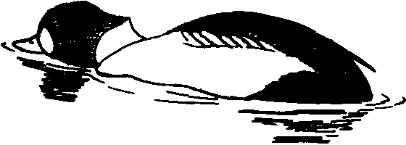
D

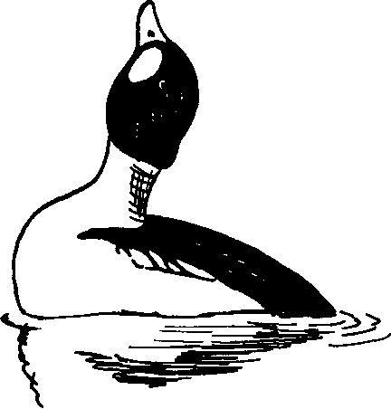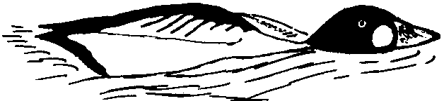
B

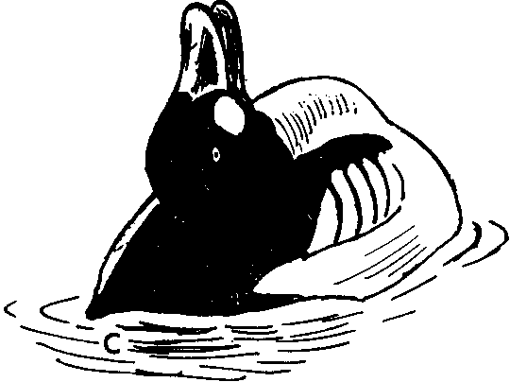
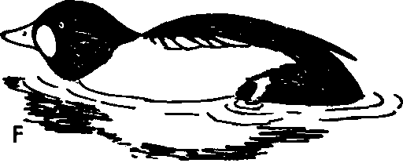Figure 83. Common Goldeneye
A Neck-dipping by female common goldeneye.
B. Aggressive Laying-the-neck-on-the-water posture of common goldeneye.
C. Common goldeneye male performing the Head-throw.
D-F. Stages in the performance of the Masthead display. Note depressed head feathers and downward tilting of the tail.

are typically involved, the favored male and an intruder. The female silently swims behind the favored male, turning her head first over one shoulder and then the other toward the second male behind. Sometimes Neck-dipping occurs during Inciting, and this produces intermediate behavior patterns.
Agonistic and sexual behavior: male. The bewildering number of male goldeneye displays warrant a much more detailed discussion than can here be given, and the reader is referred to the papers of Myres, Lind, and Dane et al. mentioned above. Perhaps the most frequent male display is Bowsprit-pumping, which corresponds to and is often done during female Head-pumping. This display (called Nodding by Dane et al.) is a silent movement with the neck being repeatedly extended diagonally and then withdrawn to the normal position. Often several males perform the display together, and it gives the impression of being primarily a hostile display. This same diagonal neck posture is assumed during the Bowsprit display (Fig.
85B, C) (called the Oblique posture by Lind), in which the neck
and head are first extended along the water, then rapidly and rigidly brought up to the diagonal position as a soft rrrrrrt is uttered. Lind has clearly shown that this display has hostile motivation. The pre­ liminary part of this display, Laying-the-neck-on-the-water (Fig.
83B), is a highly aggressive posture that is often assumed by rival males. It may precede direct attack, which often occurs under-water (Fig. 82F). A final and very frequent male display that probably has important significance is lateral Head-turning (called Ticking by Dane et al.). In this display, which is often performed by a favored male as he swims ahead of an Inciting female, the neck is extended upward, the bill is held horizontally, and the head is mechanically turned from side to side as the head feathers are puffed out. As in Barrow's goldeneye, Neck-withdrawing movements sometimes occur during this display, but these are not nearly so conspicuous as in that species.
The most common of the "head-throw" displays is the simple Head-throw (Fig. 83C), in which the head is tossed rapidly back to the rump and held there while a rattling rrrrt is uttered. Two kinds of head-throws, which differ in the rapidity of performance, are as­ sociated with kicks. The Fast Head-throw-kick (Lind's Kick-throw I) lasts about one second, and is the more frequent of the two (Figs.
84E, F; 85A). The head is thrown back rapidly, both feet are kicked,

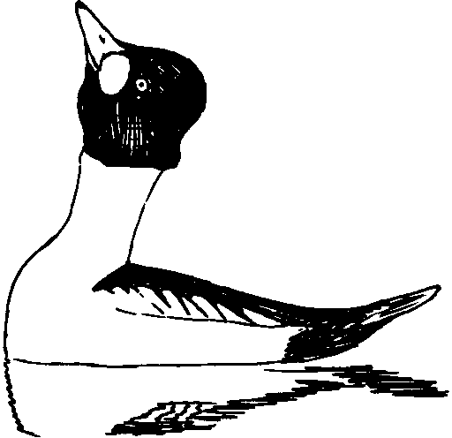
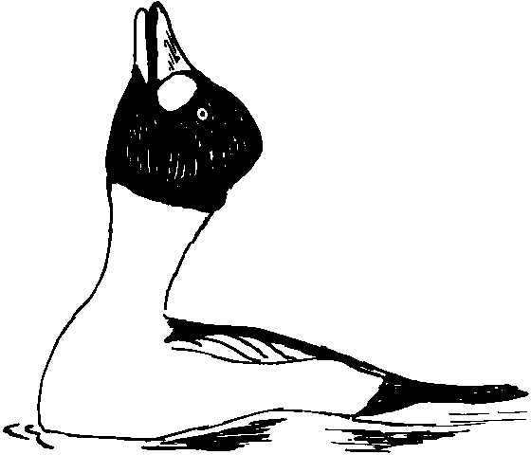A D

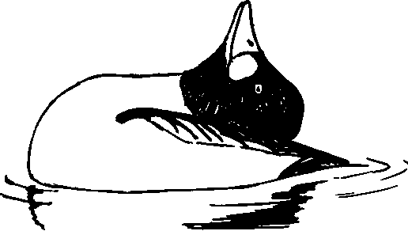8 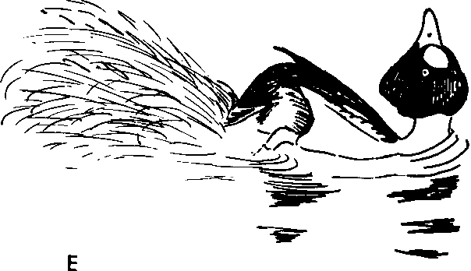

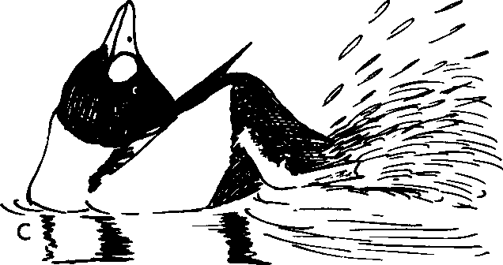

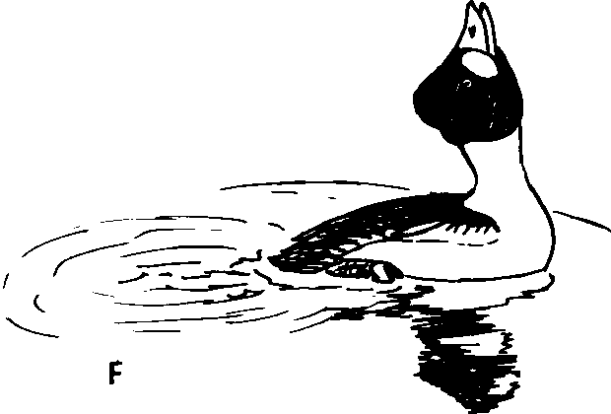Figure 84. Common Goldeneye
A-D. Stages in the performance of the Slow Head-throw-kick of the male common goldeneye.
E, F. Stages in the performance of the Fast Head-throw-kick of the male common goldeneye.

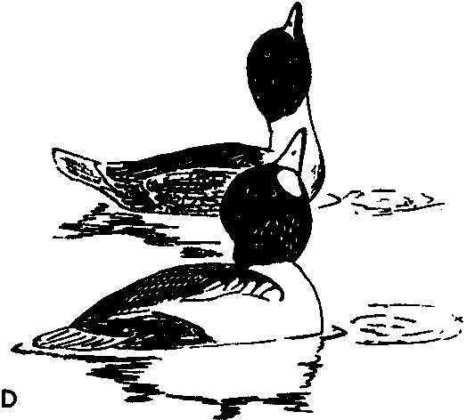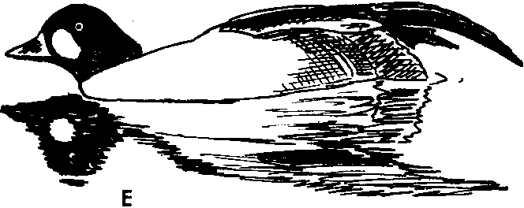

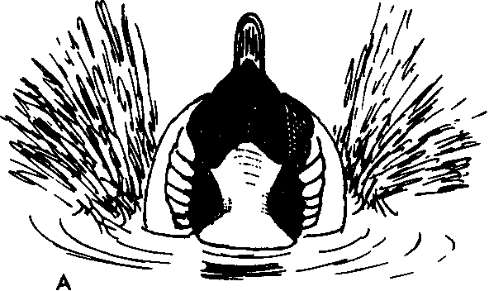

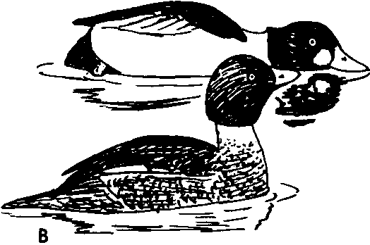

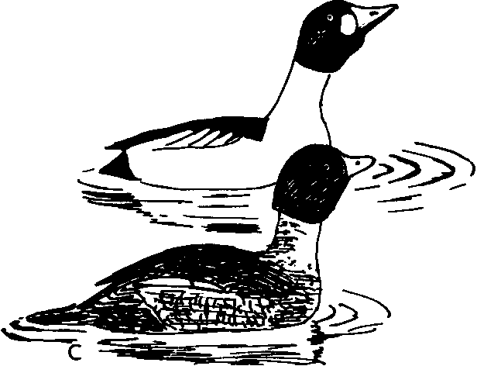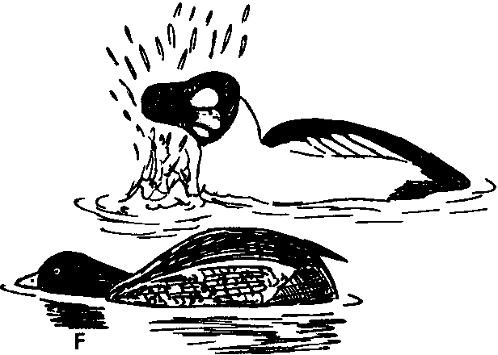Figure 85. Common Goldeneye
A. Front view of the Fast Head-throw-kick display of the common goldeneye.
B, C. Stages in the performance of the Bowsprit display of male common goldeneye. The female is performing Head-pumping.
D-F. Precopulatory behavior.
D. Mutual display Drinking.
E. Wing-and-leg-stretching.
F. Jabbing by male, female Prone.

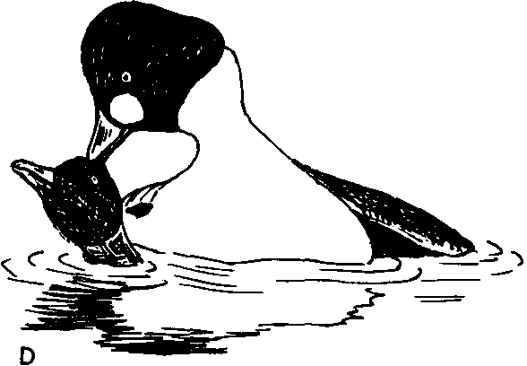- - .._ ,....._
-

A

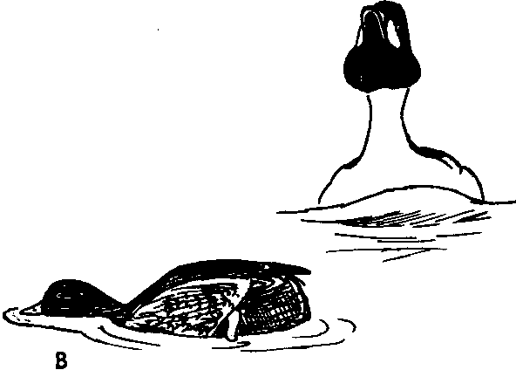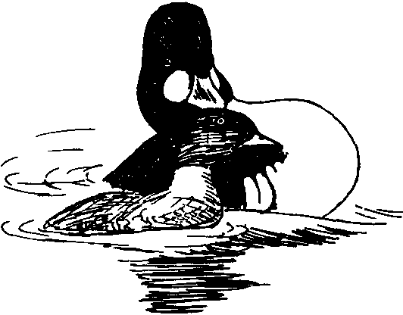E

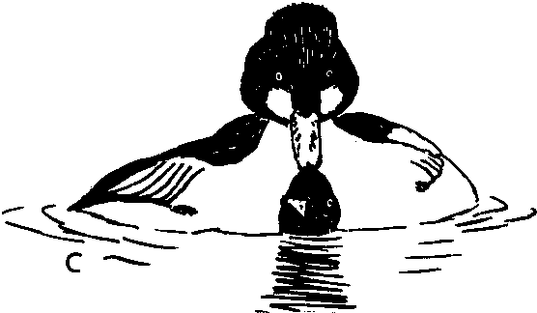
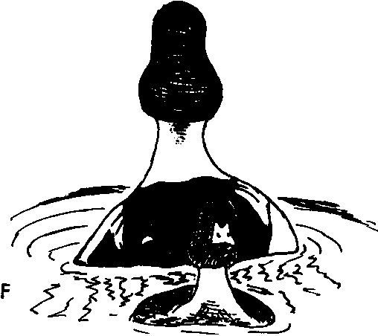Figure 86. Common Goldeneye
A-F. Copulatory behavior.
A. Preening-behind-the-wing following Jabbing.
B. Precopulatory Steaming to the female. C. Copulation.
D, E. Rotations terminating copulation.
F. Postcopulatory Steaming. Note extreme feather erection of the male's head.

298 Handbook of W ate.rfowl Behavior

and a loud zeee-zeee' is uttered. In the Slow Head-throw-kick (Lind's Kick-throw II) the head is thrown back much more slowly after a rapid start which brings the bill to the vertical, the back is strongly arched, and the same type of call is uttered (Fig. 84A-D). Finally, the last major display is the Masthead (also called the Crouched-up­ down). This display starts in the same manner as the Bowsprit, with the head and neck low over the water. The bird brings his head rapidly to a vertical position and immediately returns it to the start­ ing position, without bending his extended neck (Fig. 83D-F). The call is a soft rrrrt as in the Bowsprit, and both displays appear to be aggressive. Males also frequently perform Short Flights toward fe­ males, and, as in Barrow's goldeneye, the Upward-stretch and Wing­ flapping occur frequently but are not obviously ritualized.
Copulatory behavior. Copulatory behavior is initiated by either
sex, through ritualized Drinking toward the other bird (Fig. 85D). The female then fairly rapidly assumes the Prone posture and re­ mains in it, although she may perform rudimentary Drinking move­ ments in response to male Drinking while in this posture. The male then performs two major precopulatory displays, ritualized Drinking (also called the Water-flip) and the Wing-and-leg-stretch (also called the Wing Display) (Fig. SSE). The male also, but less frequently, performs Bathing, Water-twitching, and rolling the cheeks on the shoulders. Water-twitching is at first interspersed with other displays, but eventually, in exaggerated form (Jabbing), it alone is performed (Fig. 85F). After a series of rapid Jabs the male suddenly reaches back and Preens-dorsally on the side toward the female (Fig. 86A), then rapidly Steams toward her, bill tilted upward, uttering a faint bzzzzt call (Fig. 86B). He immediately mounts, and while treading
,always Flicks-the-wing one or more times. After treading is completed,
m oo
the two birds Rotate in circles (Fig. 86D, E). The male then releases
her and Steams rapidly away while performing lateral Head-turning and emitting low grunts (uig uig-uig ...). Finally, both birds bathe and flap their wings.

MERGANSERS

Although the mergansers have traditionally been placed in a dis­ tinct subfamily on the basis of their bill structure, the fallacy of this division has been repeatedly pointed out by several authors, and is

entirely analogous to the unjustified separation of the shovelerlike ducks from the other species of Anas. The goldeneyes grade into the mergansers in the same way as the typical Anas species grade into the shovelers, and there is even some evidence that the merganser with the least specialized bill shape (the smew) is not as closely re­ lated to Bucephala as is one species with a typical Mergus bill (the hooded merganser). In no anatomical or behavioral respect do the mergansers deserve more than a generic separation from the golden­ eyes.

Hooded Merganser (Mergus cucullatus)

The hooded merganser provides an almost perfect link between Bucephala and Mergus. The downy young are similar to those of goldeneyes except that they have a brownish tone on the upper parts which suffuses the white cheeks. There is no cheek stripe as is typical of most other mergansers. Juvenile males and females generally re­ semble female goldeneyes except for their different head and bill shape. As in the goldeneyes and the other mergansers, the wings have a black and white speculum pattern on the secondaries. The male in nuptial plumage has a unique erectable white crest and vermiculated brown flanks, but is otherwise not very different in patterning from male goldeneyes. There is an eclipse plumage which is very female­ like. The tracheal tube of the male is slightly enlarged near the pos­ terior end, and the bulla is relatively larger, with membranaceous fenestrae, and very similar in shape to those of goldeneyes (see the illustration in Johnsgard, I96Ic). The species is restricted to North America, and is sympatric with the three species of Bucephala and with the red-breasted merganser and the goosander. Wild hybrids have been reported with the common goldeneye.
General behavior. The hooded merganser is primarily a freshwater
bird, and tends especially to frequent woodland ponds and swamps. Although it has a typical merganser-type bill, it consumes fairly large quantities of animal material other than fish. Preflight move­ ments have not been noted.
Agonistic and sexual behavior: female. The female hooded mer­
ganser does not take a very active part in sexual display, and seems to lack special calls or movements for eliciting male displays. The only definite sexual display I have observed is a form of Inciting. This differs from the lateral pointing type of goldeneye Inciting, and

is more like the "Bobbing" of female smews. It consists of a rapid lateral pointing movement toward another female or unfavored male, immediately followed by a jerky upward and forward movement of the head, with crest depressed, at the same time as a hoarse gak is uttered (Fig. 87A). Except for the preliminary lateral pointing move­ ment (which is sometimes lacking), it is almost exactly like the Bobbing type of smew Inciting. Ritualized Drinking is primarily a precopulatory display in the female. Females also perform a Pumping movement exactly like that of the male.
Agonistic and sexual display: male. Male hooded mergansers
have numerous displays, which are described more fully elsewhere
(Johnsgard, 196Id). The major displays include a Crest-raising (Fig.
87C), which is very frequent. After raising the crest, the male per­ forms several Head-shaking movements (Fig. 87D), raising the front of the body slightly each time, and after three or four such move­ ments a Head-throw usually follows (Fig. 87E). This display, per­ formed without such extreme neck-stretching as the Head-throws of the common goldeneye, is accompanied by a rolling, froglike crrrroooo note as the head is brought forward. As the head is returned to its normal position, the male Turns-the-back-of-the-head toward the courted female. Sometimes, after several Head-shakes, the male sim­ ply opens his bill and utters a hollow pop. At other times he performs a silent Pumping movement (Fig. 87B). A diagonal Tail-cocking is also frequent, and is usually associated with swimming ahead of the female and Turning-the-back-of-the-head with crest depressed (Fig.
87A). The ornamental tertials are also sometimes repeatedly lifted
and lowered, although this may not constitute a true display. The Upward-stretch and Wing-Happing are also commonly performed during courtship, usually with the crest erected.
Copulatory behavior. In its copulatory behavior the hooded
merganser exhibits clear affinities with the goldeneye group. Copula­ tion is initiated by mutual Drinking (Fig. 87F), and soon the fe­ male assumes a Prone posture with her head and tail both near the water surface. The male immediately begins to swim about with his crest erect, performing rather jerky head movements that are similar to the "Pouting" movements of male smews. The male performs the Upward-stretch and also Drinks, but I have not seen the Wing-and­ leg-stretch (typical of goldeneyes) or independent Preening-dorsally (typical of the other mergansers). The male soon replaces the ritual-

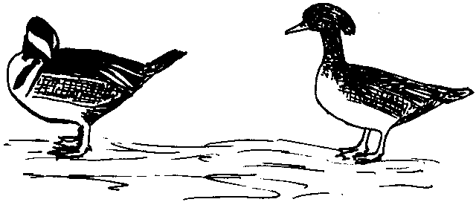

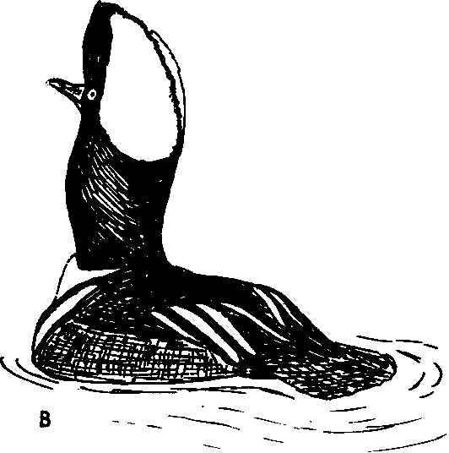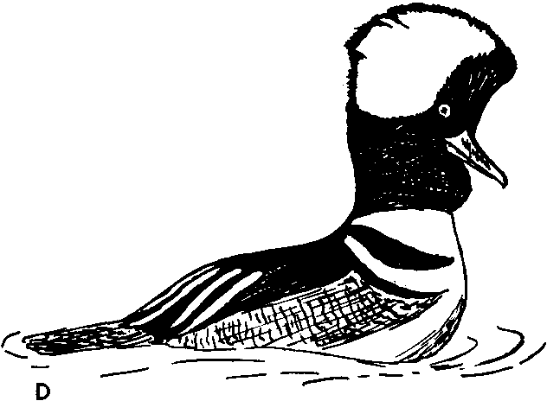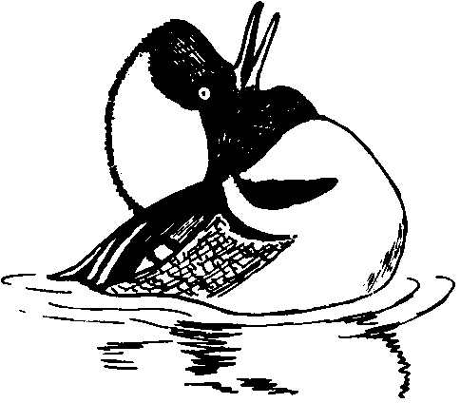A

E

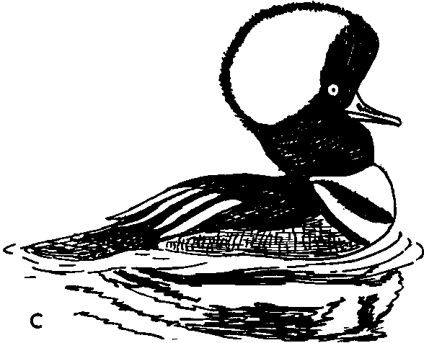
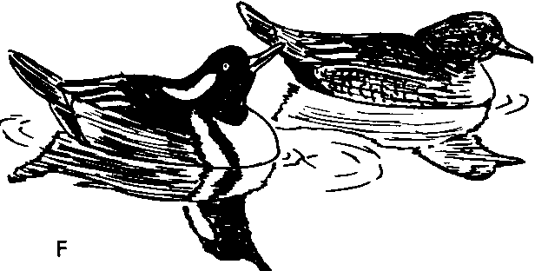Figure 87. Hooded Merganser
A. Male Turning-the-back-of-the-head to female, who is performing low­
intensity Inciting movements.
B. Pumping posture of male hooded merganser. Note how the neck appears to be swollen.
C. Crest-raising.
D. Head-shaking preceding the Head-throw. E. Head-throw.
F. Precopulatory Drinking display.

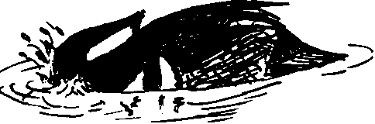
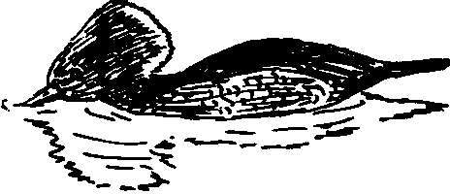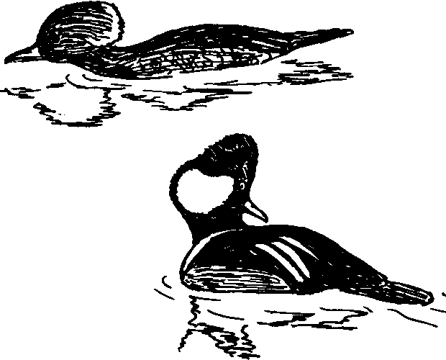A D

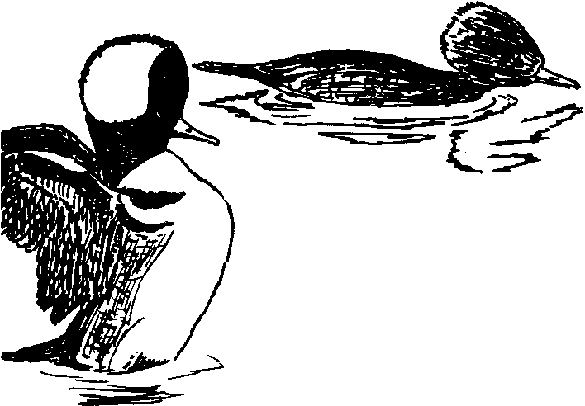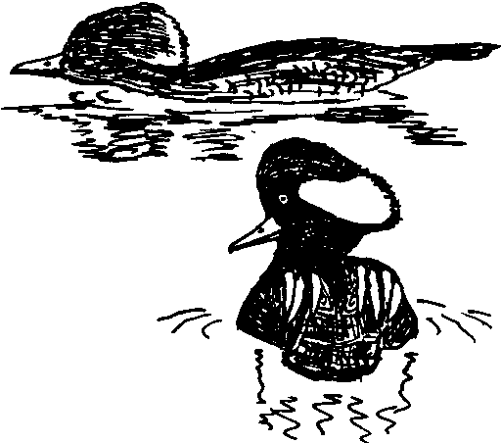
8 E

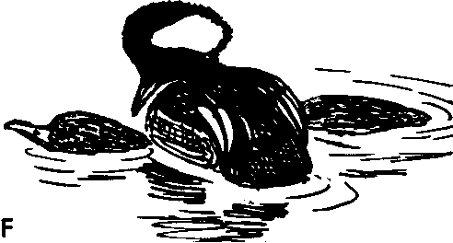c
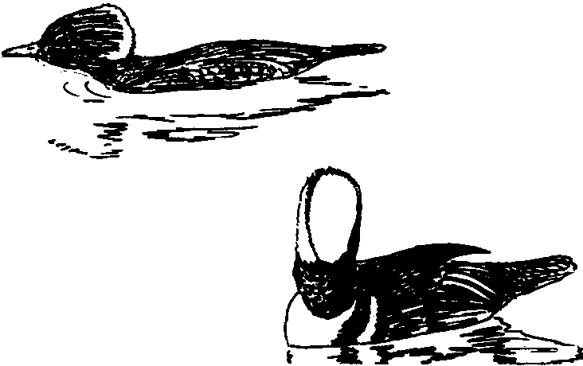Figure 88. Hooded Merganser
A-F. Copulatory Behavior.
A. Precopulatory Water-twitching (or Jabbing) by male, female in Prone posture. Compare with Fig. 85F.
B. Wing-flapping. Note fully expanded crest and lateral orientation to female.
C. Preening-behind-the-wing (or behind the slightly raised wing). Compare
Fig. 86C.
D, E. Tacking toward the female. Note turning of alternate sides of crest to female's view.
F. Mounting.

ized Drinking with energetic Water-twitching (or Jabbing) move­ ments (Fig. 88A), such as are performed by goldeneyes. After sev­ eral such Jabs, the male stops, performs an Upward-stretch or a Wing­ Hap (Fig. 88B), then settles back in the water and makes a rapid Preening movement (probably dorsally or behind the slightly raised wing) on the side toward the female (Fig. 88C). Precopulatory Steaming in this species differs from that of the goldeneyes in that the male approaches the female in a "Tacking" route (Fig. 88D, E), still performing the head-jerking movements and alternately present­ ing the two sides of his crest to her view. The male mounts the fe­ male as soon as he reaches her; then he raises his crest fully and Flicks-the-wing while treading. After treading he retains hold of the female's nape and the two birds Rotate nearly a complete circle. The male then releases the female and Steams away from her in a Crest­ raised posture. In one of the two cases seen, the male Steamed away for about 25 feet before beginning to bathe, and in the other case he Plunged under the surface after swimming about five feet. The post­ copulatory Steaming was like that of goldeneyes except that no lat­ eral Head-turning could be definitely seen, although the distances from the birds were considerable.

Smew (Mergus albellus)

The smew is certainly, with the hooded merganser, a link be­ tween Bucephala and Mergus, and the pattern of the downy young is clearly more like that of Bucephala than like that of the typical Mergus downies. Juvenile males and females are distinct both from the other mergansers and from the goldeneyes, although an extension of the brown head over the white cheeks and throat would produce a very goldeneye-like effect. The male nuptial plumage, which is mostly black and white, is also Bucephala-like. The male eclipse plumage is like the female plumage. The tracheal tube of the male is of only slightly varying diameter, and the bulla is more similar in shape to that of the goosander and red-breasted merganser than to that of the hooded merganser and the goldeneyes. Smews range widely over Europe and Asia, and are sympatric with the common goldeneye, the goosander, the red-breasted merganser, and the Chinese merganser. Hybrids with the common goldeneye have been reported.
General behavior. Smews feed on fish to a relatively small degree;
they tend, rather, to consume aquatic insects and larvae, as do golden-

eyes. This no doubt explains why the two species often associate in the wild. Like the goldeneyes and most of the other mergansers, smews are tree-nesters.
Agonistic and sexual behavior: female. The female smew takes an active part in courtship, and smew display is a very energetic affair. The female Inciting call is a harsh, rattling krrrrr, krrrrrr, emitted at low intensities without special head movements, but this is usually followed by a louder version, associated with violent up­ ward and forward body lunges, the bill being pointed sharply down­ ward with each movement forward (Fig. 89A, B). Hollom (1937) termed this display, which is clearly a form of Inciting, Bobbing, but this does not express well the energetic nature of the movements. There is little if any lateral pointing involved in this display, and it is certainly a very highly ritualized type of Inciting.
Agonistic and sexual behavior: male. The descriptions of Hollom (1937) and Lebret (1958b) are fairly complete, and Hollom's termi­ nology is followed here. The most frequent male display, except per­ haps for the Upward-stretch or Wing-flapping, is "Pouting:" This is a smooth Bridling-like movement of the head back along the back, with the bill remaining level (Fig. 87F). This may be performed while the bird is standing on land, but more often it is done while he is swimming. The associated call is a soft mechanical rattle which Lebret described as the noise made by the winding of a wristwatch. During Pouting the feathers of the forehead are erected to form a shaggy crest, but the black V-pattern of the nape is never erected in any way. During display the males often assume a Neck-stretching posture, which is accompanied by the same rattling call as during Pouting (Fig. 89C). The most elaborate male display is the Head­ fling (Fig. 90A, B). This occurs unexpectedly during Pouting, and perhaps is an exaggerated version of it, except that the head is sud­ denly flung back over the back, raising the body axis about 45 de­ grees. The head does not touch the back, but stops short of it, and is just as rapidly brought back in a manner very much like the Bobbing movement of females, with the bill pointed sharply downward, so that the black V-pattern of the nape is visible to a person in front of the displaying bird. There is no obvious kick associated with this display, although Lebret (1958b) reported seeing water splashed up behind. The call is like that uttered during Pouting, but somewhat louder. Males Turn-the-back-of-the-head to females very often, especially

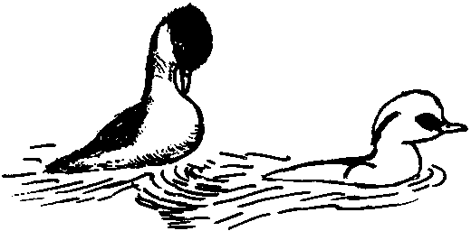A 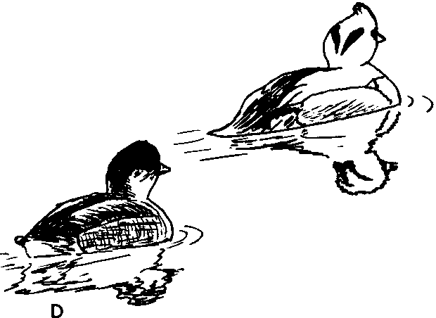

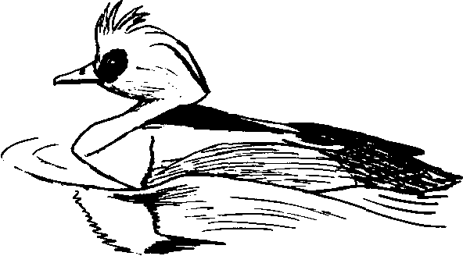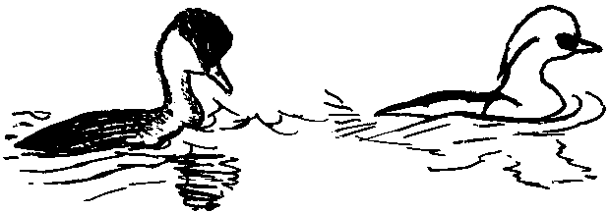

8 E

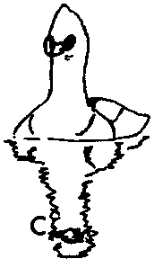
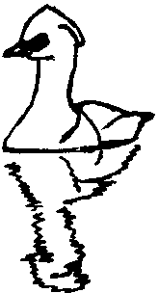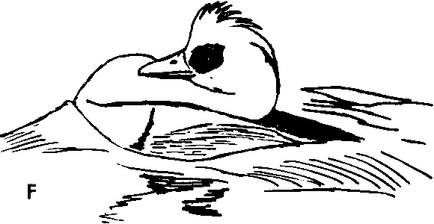Figure 89. Smew
A, B. Inciting (Bobbing) by female smew, as the male Turns-the-back-of- the-head.
C. Neck-stretching in male smews.
D. Turning-the-back-of-the-head by male smew. E. Crest-raising by male smew.
F. Pouting by male smew; alternated with posture in E.

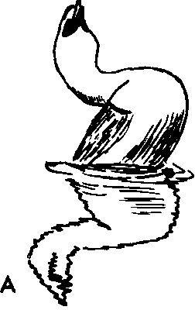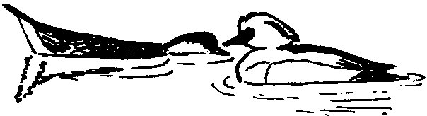

D

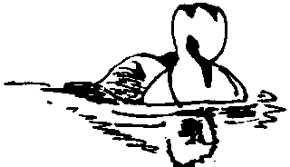

8 E

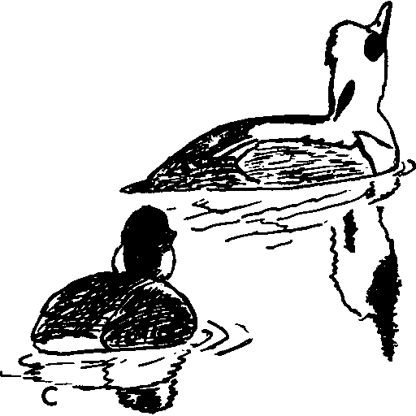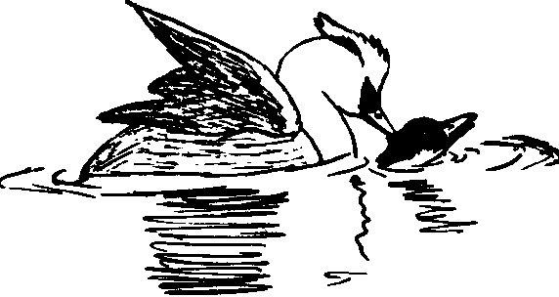F

Figure 90. Smew
A, B. Stages in the Head-fling display of male smew. Note asymmetrical position of the head.
C-F. Copulatory behavior.
C. Precopulatory Drinking by male smew.
D. Prone posture of female. Note tilted tail, which is shaken frequently. E. Preening-dorsally by male.
F. Flick-of-the-wing during treading.

when they are being followed by an Inciting (Bobbing) remale. Ritualized Drinking is sometimes seen during courtship, but prob­ ably should be considered as an invitation to copulation. Mr. Vincent Weir (pers. comm.) has observed males attack one another under water, but this is not done so frequently as by goldeneyes.
Copulatory behavior. Both sexes typically perform ritualized
Drinking (Fig. 90C) before the female goes Prone, or the female may assume the Prone posture after Bobbing a few times toward the preferred male. The Prone posture in this species differs from that of other mergansers in that the head is held near the water and the tail is held up at about a 30-degree angle and quivered frequently (Fig. 90D). The male makes repeated Drinking movements, together with Upward-stretches, Preening-dorsally (Fig. 90E) and, possibly, Preening-behind-the-wing. He repeatedly approaches and retreats from the female, who often suddenly erects herself, Bobs a few times, then goes Prone again. I have not observed any Water-twitching, and the single instance of Preening-behind-the-wing observed ap­ peared to be normal preening. When the male finally succeeds in mounting the female he Flicks-the-wings from two to five times (Fig.
90F). After treading is completed the male releases the female im­ mediately and performs a Head-fling; then he swims rapidly away from the female while Turning-the-back-of-the-head toward her. Whether this postcopulatory swim should be considered Steaming is doubtful, for it lacks the stereotyped appearance of such Steaming in the goldeneyes, eiders, and the hooded merganser. The female either bathes or follows closely behind the male, Bobbing in the usual fashion.

Brazilian Merganser (Mergus octosetaceus)

The Brazilian merganser apparently does not represent an iso­ lated derivative of one of the northern mergansers, but rather must have had an earlier origin and has developed several unusual fea­ tures. The downy young have the incomplete breast band and streaked cheeks found in the large, northern mergansers, but they lack the brownish head coloration typical of all merganser downies except those of the smew. As adults, the sexes are colored alike, and both have metallic-green heads with long, narrow crests. The rest of the body is rather uniformly gray and brown, and the wings have the usual type of white speculum on the secondaries. The male

trachea has been described by Humphrey (1955) as being very simi­ lar to that of the red-breasted merganser, and also as having some affinities with that of the hooded merganser. The species is restricted to southeastern South America and is not sympatric with any near relatives.
General behavior. According to Partridge (1956) this species is rare and very shy, and is a river and stream dweller. Partridge has given a good account of feeding and nesting behavior. Like the goosander, this species is a tree-hole nester.
Agonistic and sexual behavior: male and female. Partridge (1956)
has observed what he believes was courtship display. His observa­ tions, and those of Giai (1950), suggest that circular swimming, while paddling with the wings, is one of the courtship displays. This behavior is altogether unlike the displays of any of the other mer­ gansers known to me, and it is probable that other displays are present which are still undescribed.
Copulatory behavior. Partridge (1956) observed one copulation.
The female assumed the Prone posture after bathing. She was Prone for only a few seconds before the male mounted, and both birds were then totally submerged. After treading, the female "uttered a long cry," and both birds then bathed. This is also quite different from copulatory behavior in the other species of mergansers which have been studied.

Red-breasted Merganser (Mergus serrator)

The red-breasted merganser is probably a close relative of the Chinese merganser. Red-breasted downy young are somewhat darker than Chinese downies; the downy young of the two species are other­ wise almost identical. Red-breasted juveniles and adult females have a darker and less contrasting body plumage than do those of the Chinese species, but males of both species are similar in head pattern and wing-speculum patterns. Red-breasted males are unique in their reddish-brown breast and their shoulder patterns. The trachea of the male has one gradual enlargement and a very large bulla that is ap­ proximately equally inflated on the left and right sides (see illustra­ tion in Johnsgard, 196lc). The red-breasted merganser is widely dis­ tributed throughout the Northern Hemisphere, and is sympatric with all the northern species of Mergus as well as Bucephala. No definite hybrids are known, but mixed pairs of red-breasted mergansers and

goosanders have frequently occurred at the Wildfowl Trust, and some young have hatched and lived several weeks which were thought to represent this cross.
General behavior. In its distribution and ecology the red-breasted merganser is similar to the goosander, but whereas the goosander is a hole-nester, the red-breasted merganser usually nests on the ground and has dark-colored down. Preflight movements consist of swimming with neck outstretched and bill tilted slightly upward, with frequent lateral Head-shaking.
Agonistic and sexual behavior: female. Females tend to be rather aggressive toward males, and they do not take a very active part in courtship displays. Curth (1954) and Ringleben (1951) have men­ tioned head-nodding displays, but I have not observed any such movements. The female has a harsh krrrr-krrrr call, which can be uttered without special head movements, and the same call is emitted during a type of Inciting similar to the Bobbing movement of female smews. From a normal swimming position the female suddenly lurches forward and upward with her head, but with the bill pointed downward. This may be repeated once or twice; but unlike the smew's Bobbing, it is apparently never continued in a longer se­ quence. I have only observed this Inciting a few times, but it is probably not so rare as these few observations suggest. No obvious sideways pointing movements were seen, although such movements may possibly be a typical part of the display, as it is often lacking in the Inciting of female hooded mergansers.
Agonistic and sexual behavior: male. Male threat display con­ sists of a Crouched posture, somewhat like that of goldeneyes. I have observed one underwater attack, and Armstrong (1947) also reports such behavior. Males often rush over the water surface in a closed-wing "Sprint" (Fig. 92E) that sometimes serves as an overt attack, but more often brings the male close to the female or simply attracts the female's attention. Besides the Sprint, the major male sexual display is an extremely complex and variable sequence collec­ tively termed the "Knicks" (German for "bending"). This consists basically of two postures, the Salute and the following Curtsy. The simplest form of this occurs in early winter, when from a normal swimming position the male suddenly jerks his head out diagonally, so that the bill, head, and neck form a straight line (the Salute) and a second jerk pulls the neck slightly downward as a soft and catlike

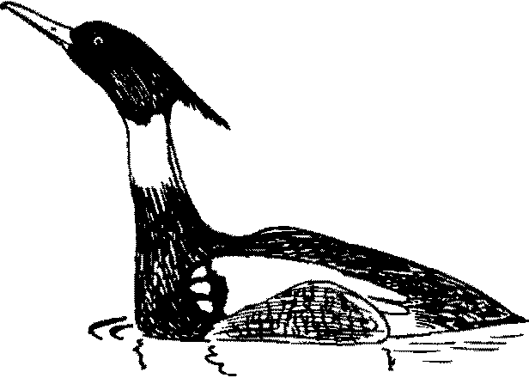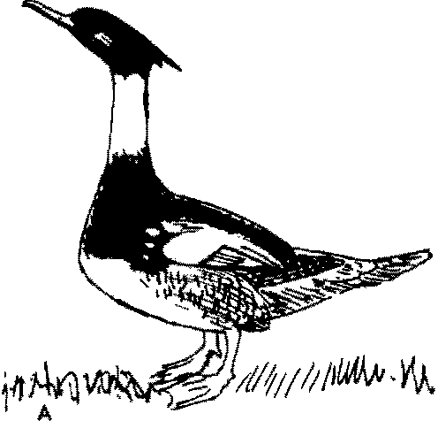 D

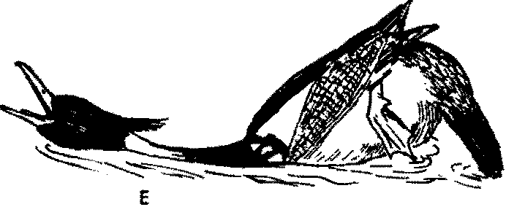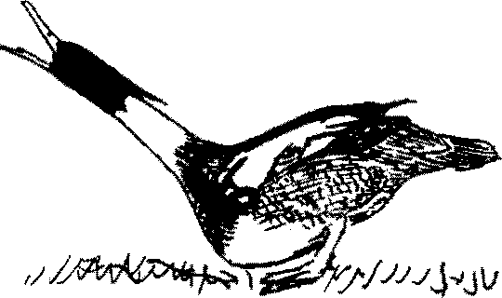
B

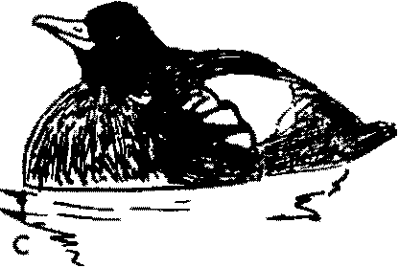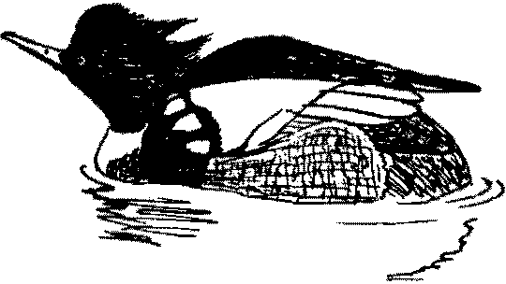e:-­ F

Figure 91. Red-breasted Merganser
A, B. Male performing Salute (A) followed by Curtsy (B) on land.
C-F. Knicks sequence, side view.
C. Starring posture. Note lowered crest.
D. Salute posture.
E. Curtsy.
F. Finishing position, with neck withdrawn, tail bent down, and crest
raised.

yeow is uttered (Fig. 91A, B). Later, when the males begin to swim in a characteristic "ready" posture, the complete display may be seen. In this posture (Figs. 91C, 92A) the head is withdrawn into the shoulders, the crest is erected, and the bill is tilted slightly up­ ward. As the display begins, the crest is suddenly depressed, and within about a second the neck is suddenly extended diagonally up­ ward and forward. The head is momentarily "left behind," but it quickly swings up into line with the neck to form the Salute, which is generally performed at "profile view" to a female (Figs. 91D, 92B). This phase, marked by a yeaw call, is held for an instant, then the neck, as if weighted at the base, is brought down into the water, and simultaneously the tail is pointed downward. As the head is brought down into the Curtsy phase the crest is raised, the bill is opened and pointed toward the courted female (or another male), and the second of two faint yeaw notes is uttered (Figs. 91E, 92C). The display can end in a partially extended neck posture (Fig. 92D), or the head may be strongly withdrawn into the shoulders while the tail is still pointed downward and the feet back-paddle slightly (Fig. 91F). Very often males Turn-the-back-of-the-head to the courted female as a finale to this display sequence. This display is one of the most bizarre of all waterfowl displays and is completely different from the sexual displays of the other Mergus species studied to date. Males often perform the display in synchrony or near-synchrony. Males swim ahead of Inciting females, probably Turning-the-back-of-the­ head to them, although this is not certain. Males also sometimes swim with their tails slightly cocked, which possibly represents a display, and the Upward-stretch and Wing-Happing are frequent during court­ ship and are very likely ritualized.
Copulatory behavior. Copulatory behavior has been only inade­ quately observed, but the general form of display is evident. As in the other mergansers, both sexes perform ritualized Drinking, and the female soon assumes a Prone posture like that of the goosander, with both the head and tail Hat on the water. The male then re­ peatedly Drinks, Preens-dorsally, Wing-Haps, and does the Upward­ stretch, though in no particular sequence. In addition, the male fre­ quently does a rudimentary form of the Knicks, and apparently al­ ways mounts the female immediately after the Knicks, approaching her in a manner similar to the Tacking of the hooded merganser. It is not known whether there is a Flick-of-the-wings during treading,

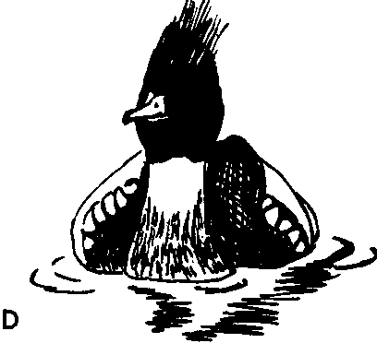
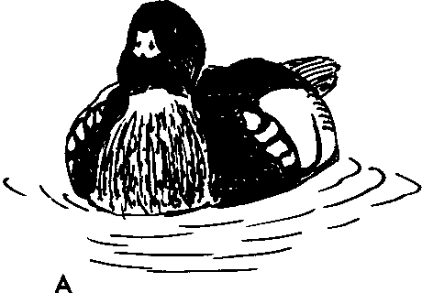

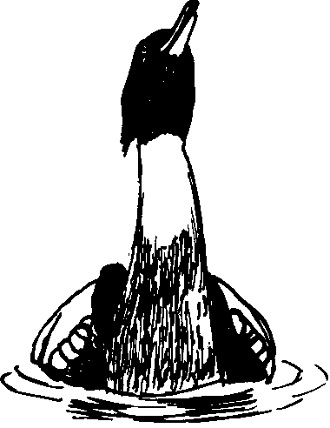
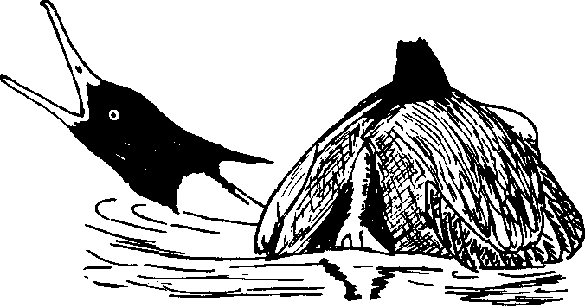B E

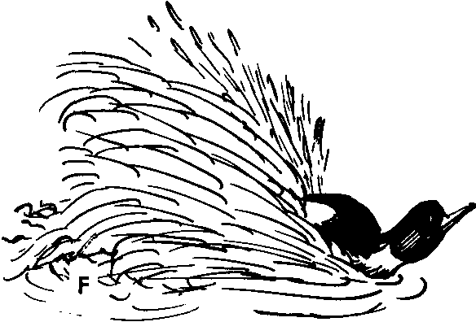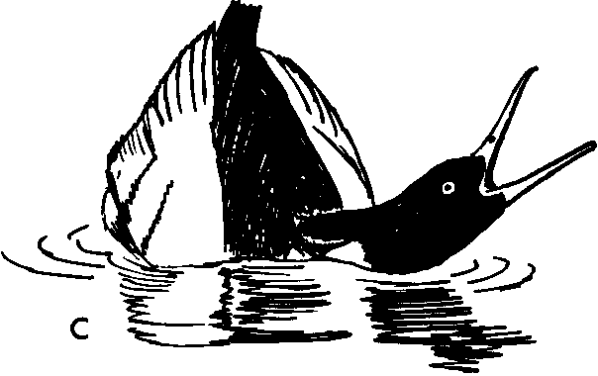
Figure 92. Red-breasted Merganser
A-D. Knicks sequence, front view.
A. Starting posture.
B. Salute. C. Curtsy.
D. Finishing position.
E. Curtsy, rear view. Note raised hindquarters, bent tail. F. Sprint, male red-breasted merganser.

or whether postcopulatory Rotations are present. After treading, how­ ever, the male evidently performs a variation of the Knicks, then bathes or Sprints some distance over the water and finally Plunges under the surface (Adams, 1947).

Chinese Merganser (Mergus squamatus)

Very little is known of the Chinese merganser, but it appears to occupy a position roughly between the goosander and the red­ breasted merganser. The downy young seem to be somewhat more like those of the red-breasted merganser, but juveniles and adult fe­ males have plumages closely resembling the corresponding plumages of the goosander. The male in nuptial plumage has a crested head much like that of the red-breasted merganser, but the body plumage is rather more similar to that of the goosander. The wing coverts are gray rather than white as in these two species, although the speculum pattern is almost the same in all three. The male has a female-like eclipse plumage, and the male trachea is very similar to that of the goosander (Humphrey, 1955). The species has a restricted range in China and is no doubt sympatric with both the red-breasted merganser and the goosander. No hybrids have been reported.
General and sexual behavior. Aside from the fact that it is a hole­
nester like the goosander, virtually nothing is known of the behavior of the Chinese merganser. In view of the great differences in the sexual behavior of the goosander and the red-breasted merganser, it would be of special interest to obtain information on the courtship and copulatory behavior of this species.

Goosander (Mergus merganser)

The goosander is the largest and perhaps the most specialized of the mergansers. The downy young are very similar to those of the two preceding species, having incomplete breast bands, streaked cheeks, and brownish heads. Juvenile males and females are very similar to those of the Chinese merganser. Males in nuptial plumage have an entirely green head and a predominantly white body. The breast and Hanks of breeding males have a salmon-tinted "bloom" such as occurs in the Chinese merganser. There is a female-like eclipse plumage. The male trachea has a major anterior enlargement followed by a smaller one, and the bulla is extremely large and rather triangular in shape, with large membranceous fenestrae (illustrated

in Johnsgard, l96lc). The goosander is widespread over the North­ ern Hemisphere and is sympatric with all the Northern Hemisphere species of Bucephala and Mergus. Hybrids have been reported with the common goldeneye and hybridization with the hooded merganser has also been alleged. Three races are currently recognized.
General behavior. The goosander is found on both salt and fresh water, and frequents large deep-water areas. Unlike the red-breasted merganser, the goosander tends to nest in holes or crevices, and its down is white. Preflight movements are lateral Head-shakes, per­ formed in an alert posture with head feathers depressed and neck extended.
Agonistic and sexual behavior: female. Females are highly aggres­ sive toward courting males, and often jab at them with their bills. Their call is a loud, harsh karrr, karrr, which serves as a warning note as well as for Inciting. Inciting in this species is not highly ritualized, and consists of a quick sideways pointing movement toward an unfavored bird followed immediately by a spurt forward and upward as the call is uttered, but without a marked down-tilting of the bill. This is not usually repeated more than once or twice and, as is also true of the other mergansers, preferred males always respond to it by swimming rapidly ahead of the Inciting bird, usually Turning­ the-back-of-the-head toward her (Fig. 93B).
Agonistic and sexual behavior: male. Courtship among male goosanders is marked by a great deal of activity and frequent overt attacks, which usually occur above water as the males race toward one another. Such surface chasing is apparently not equivalent to the Sprinting of red-breasted mergansers, although it is similar in form. Underwater attacks apparently occur (Peter Scott, pers. comm.), but I have not observed them. The most frequent male dis­ play involves extending the neck, erecting the head feathers, and re­ peatedly uttering a rather faint uig-a note reminiscent of the twang­ ing of a guitar string (Fig. 93A). The throat enlarges slightly with each call. The only elaborate display I have seen is the Salute, which is probably, but not definitely, homologous to the Salute of the red­ breasted merganser. From either a normal resting posture or the courtship call position the head is suddenly lifted vertically upward until the neck is stretched to the utmost. The posture is held for a fraction of a second with the bill pointed toward the zenith as a faint, high-pitched, bell-like note is uttered (Fig. 93C); then the head is

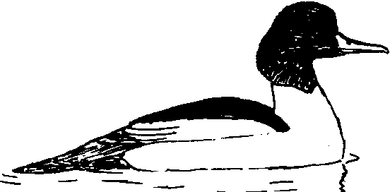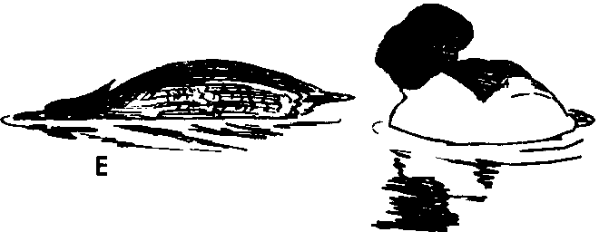A D 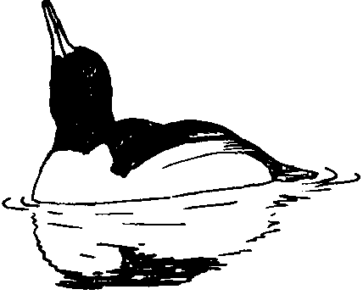

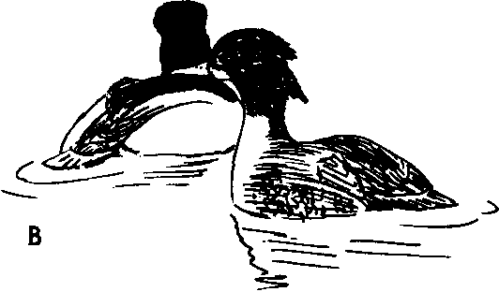

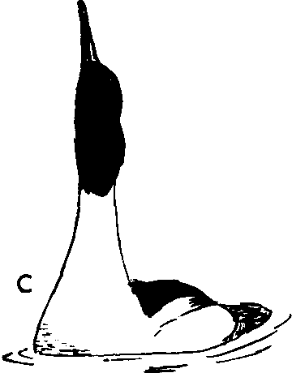
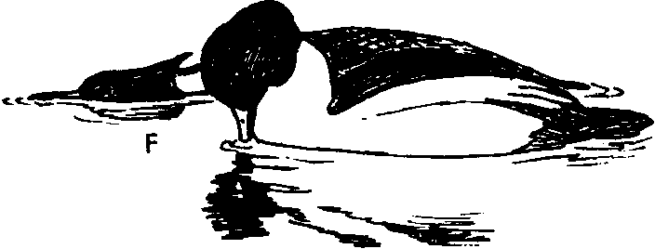Figure 93. Goosander
A. Courtship call of male. Note bulge in throat.
B. Turning-the-back-of-the-head by male to female. Note shape of male's head formed by feather erection.
C. Salute posture of male. Compare with display Drinking below.
D. Precopulatory Drinking.
E. Male Preening-dorsally, female in Prone posture. F. Male Water-twitching.

316 Handbook of W ate.rfowl Behavior

rapidly returned to the starting position. The display is reminiscent of the common goldeneye's Masthead display and, like it, is prob­ ably rather aggressive in motivation. Males Turn-the-back-of-the-head to females, especially Inciting females, and also perform a diagonal Tail-cocking. The Upward-stretch and Wing-Happing occur fre­ quently during display and are no doubt ritualized. I have not ob­ served a Kick display in this species, but it has been frequently re­ ported in the literature, and Vincent Weir (pers. comm.) has ob­ served it. He informs me that there is no associated head movement or call, and that the jet of water is thrown hack much farther than in the common goldeneye's Head-throw-kick.
Copulatory behavior. Copulatory behavior is initiated by either
sex through ritualized Drinking. The pair Drink mutually several times (Fig. 93D), and each time the female lifts her bill as she pumps her head forward, outward, and finally downward, with her crest depressed. Soon she assumes a Prone posture, stretched out completely on the water (Fig. 93E). If the male does-not respond she may become erect, Drink, and again go Prone. At times. I have observed a Prone female hunch her head into the shoulders, then back-paddle, in a movement reminiscent of the Neck-dip of common goldeneyes. The male repeatedly Drinks with head feathers depressed, interspersing this with Preening-dorsally (Fig. 93E), and sometimes also with Preening-behind-the-wing. He also performs the Upward­ stretch frequently, and I have observed Bill-dipping and probable sideways shaking movements of the bill in the water, as in the Water­ twitch of the hooded merganser and the goldeneyes (Fig. 93F). The male apparently lacks a ritualized approach to the female, and there is no Flick-of-the-wings during copulation. There are also no postcopulatory Rotations, and after releasing the female the male swims rapidly away from her, Turning-the-back-of-the-head toward her and repeatedly uttering his courtship call with erected head feathers. The female immediately bathes.

Auckland Island Merganser (Mergus australis)

Practically nothing is known about this species, which is now almost certainly extinct. Unlike the Brazilian merganser, it does seem to represent an island population derived from one of the northern mergansers which has secondarily lost its sexual dimorphism and bright male plumage. The downy young are of the typical Mergus

type, juveniles resemble adults, and the sexes of adults do not differ in plumage. The adult plumage pattern is similar to that of the female red-breasted merganser, and the speculum pattern is of the typical Mergus type, but there is little white on the upper-wing coverts. Humphrey (1955) has described the male trachea, which is very similar to those of the goosander and the Chinese merganser. The species, if it survives, is restricted to the Auckland Islands and is not sympatric with any near relatives.

TRIBE OXYURINI (STIFF-TAILED DUCKS)

The stifF-tailed ducks constitute a unique section of the Anatidae that is possibly the most isolated of all the tribes with the exception of the Anseranatini. There are eight species which almost certainly belong in the group, plus one more that is only very tentatively in­ cluded. The tribe is of worldwide occurrence. Seven of the species have long, narrow, and stiffened tail feathers that function as rud­ ders in underwater swimming, at which all species are very adept. These species also have a dense and shiny body plumage much like that of grebes, but lack metallic coloration altogether. The typical species have short, thick necks with loose-fitting skin that can be ex­ panded through the inflation of the esophagus or special air sacs. All species have large feet and their legs are placed well toward the rear, which results in a poor walking ability. All species but the most aber­ rant one (the white-backed duck) exhibit sexual dimorphism. Vocali­ zations are extremely variable, and male calls are often produced by extra-tracheal structures. Sexual maturity is probably reached in the first year in all but one of the species (the musk duck), and pairs are probably renewed yearly in most and quite possibly all species. Male displays are generally elaborate and tend to produce sound. Nests are generally built over the water surface and the eggs are generally chalky white and relatively large, the young being very precocial at hatching.
Affinities with other tribes are uncertain. No definite intertribal
hybrids are known, although an alleged hybrid of the greater scaup and the North American ruddy duck has been mentioned (Sibley
1938). One species, the black-headed duck, appears to be the least specialized of the group and in its downy plumage, female plumage, and tail structure resembles the dabbling duck group. It also has an unlobed hallux and a bill which rather resembles that of a typical

