AT-SEA DISTRIBUTION OF SPECTACLED EIDERS: A 120-YEAR-OLD MYSTERY RESOLVED

MARGARET R. PETERSEN/·3 WILLIAM W. LARNED/ AND DAVID C. 00UGLAS1
1U.S. Geological Survey, Biological Resources Division, Alaska Biological Science Center, 1011 East Tudor Road, Anchorage, Alaska 99503, USA; and
2 U.S. Fish and Wildlife Service, Migratory Bird Management, Soldotna, Alaska 99669, USA

ABSTRACT.-The at-sea distribution of the threatened Spectacled Eider (Somateria fischeri) has remained largely undocumented. We identified migration corridors, staging and molting areas, and wintering areas of adult Spectacled Eiders using implanted satellite transmitters in birds from each of the three extant breeding grounds (North Slope and Yukon-Kuskokwim Delta in Alaska and arctic Russia). Based on transmitter locations, we conducted aerial sur­ veys to provide visual confirmation of eider flocks and to estimate numbers of birds. We identified two principal molting and staging areas off coastal Alaska (Ledyard Bay and east­ ern Norton Sound) and two off coastal Russia (Mechigmenskiy Bay on the eastern Chukotka Peninsula, and the area between the Indigirka and Kolyma deltas in the Republic of Sakha). We estimated that >10,000 birds molt and stage in monospecific flocks at Mechigmenskiy and Ledyard bays, and several thousand molt and stage in eastern Norton Sound. We further identified eastern Norton Sound as the principal molting and staging area for females nest­ ing on the Yukon-Kuskokwim Delta, and Ledyard Bay and Mechigmenskiy Bay as the prin­ cipal molting and staging areas for females nesting on the North Slope. Males marked at all three breeding grounds molt and stage in Mechigmenskiy Bay, Ledyard Bay, and the Indi­ girka-Kolyma delta region. Males from the Yukon-Kuskokwim Delta molt and stage mainly at Mechigmenskiy Bay. Equal numbers of males from the North Slope molt and stage at all three areas, and most males from arctic Russia molt and stage at the Indigirka-Kolyma delta region. Postbreeding migration corridors were offshore in the Bering, Chukchi, and Beaufort seas. In winter, eiders were in the Bering Sea south of St. Lawrence Island. Our estimates from surveys in late winter and early spring suggest that at least 333,000 birds winter in single-species flocks in the pack ice in the Bering Sea. Received 14 August 1998, accepted 10
February 1999.

THE DISTRIBUTION and ecology of many ma­ rine birds at sea are poorly known because of the large distances birds travel and the great expense of such studies. Seaducks (tribe Mer­ gini) may spend one to four months on land during the nesting period and the remainder of the year at sea. In general, these marine locales are in northern latitudes where sea ice is com­ mon. The at-sea molting and wintering areas of the Spectacled Eider ( Somateria fischeri) have re­ mained largely undocumented since the dis­ covery of the species. One speculation was that Spectacled Eiders wintered somewhere in the Bering Sea, probably along the ice edge (Con­ over 1926, Dement'ev and Gladkov 1952). Dau and Kistchinski (1977) also speculated that this species molted in the Bering Strait and win­ tered in polynyas south of the Chukotka Pen­ insula and south of St. Lawrence, Nunivak, and

3 E-mail: margareLpetersen@usgs.gov
St. Matthew islands. These speculations re­ mained unconfirmed because of high costs and safety issues associated with conducting sur­ veys in the Bering Sea.
The need for better information about the species became urgent when analyses of pop­ ulation trends suggested that the population of Spectacled Eiders nesting on the Yukon-Kus­ kokwim Delta (Y-K Delta) in Alaska declined by 96% from the 1970s to the early 1990s (Stehn et al. 1993, Ely et al. 1994). In addition, no data were available from other Alaskan and Russian breeding grounds, but anecdotal information suggested that the species had declined in those areas as well (U.S. Fish and Wildlife Ser­ vice 1996). Consequently, all Spectacled Eider breeding populations were listed as threatened in 1993. Because it was thought that little change had occurred on the nesting grounds in the Sakha Republic and northern Magadan Re­ gion (arctic Russia), the North Slope of Alaska, and the Y-K Delta, environmental changes on

1009

TABLE 1. Year, location, and number of satellite transmitters deployed on Spectacled Eiders.

Paired Failed Females with
Year males females broods
Arctic Russia
1995 10' 0 0
North Slope, Alaska
1995 | 0 | 0 | 10
1996 | 12 | 2b | 8'
Yukon-Kuskokwim Delta, Alaska
1993 | 5' | 5 | 4
1994 | 11 | 11' | 0
1995 | 0 | 2 | 8'
"Includes one bird shot on the nesting area by a local hunter (no location data).
b Includes one bird whose death on the nesting grounds was com­
plicated by lead poisoning (no location data).
c Includes one bird with no location data.

the molting and wintering grounds were sus­ pected in contributing to the decline (U.S. Fish and Wildlife Service 1996). The locations of principal molting and wintering areas of Spec­ tacled Eiders were unknown, so no assessment could be made of habitat conditions and threats to the species while at sea.
Here, we describe the distribution of Spec­
tacled Eiders during the migration, staging, molting, and wintering periods derived from locations of birds that were implanted with sat­ ellite transmitters in each of the three major breeding areas. We describe migration patterns between sexes and among breeding locations as well as variations in the use of principal molting and wintering areas. In addition, we provide estimates of abundance of birds in principal molting, staging, and wintering areas based on aerial surveys.

METHODS

Satellite tracking.-All birds were marked with sat­ ellite platform transmitting terminal (PTT) transmit­ ters (Telemetry 2000, Columbia, Maryland). Each transmitter weighed 36 g and measured 3.6 X 5.6 X
0.8 em exclusive of the external antenna. Transmit­
ters were programmed to transmit with a 60-s pulse rate for 6 h every 72 h (n = 86) or for 6 h every 120 h (n = 2) and were designed to last 6 to 8 months (Petersen eta!. 1995).
Transmitters were deployed using an implant technique developed by Korschgen et al. (1996). Cap­ turing and handling procedures were described in Petersen et al. (1995). We marked 88 adult breeders between 1993 and 1996 (Table 1) from each of the
three major nesting areas: arctic Russia (Indigirka River Delta, Sakha Republic), North Slope (Prudhoe Bay region, Alaska), and Y-K Delta (Kashunuk or Manokinak rivers, Alaska). Males were considered paired if captured while flying with a female, flying in a flock with an equal sex ratio, or attempting to chase another pair from a wetland. Adult females were captured in spring when paired with adult males, during egg laying, within the first 10 days of incubation, or with a brood of ducklings about 30 days of age. Failed-breeding females abandoned nests after surgery, failed to hatch eggs, or joined flocks of females during the breeding season. Fe­ males with broods rejoined their brood after surgery and probably remained with their brood through the remainder of the 45-to-55 day brood-rearing season. Data from 82 of the 88 transmitters were received through the Argos Data Collection and Location Sys­ tem in Landover, Maryland. From a total of 6,595 sat­ ellite overpass events that collected one or more PTT transmissions, 3,888 locations were calculated for 82 individuals whose transmitters provided location data on a regular basis (Table 1). Both standard and auxiliary location processing services (Service Argos
1996) were used in this study. Only 1,165 (30.0%) lo­
cations were accepted for analysis as independent and biologically plausible using decision criteria de­ tailed in Petersen et al. (1995). Multiple locations re­ corded within a single 6-h transmission period were not considered independent, so one location was se­ lected for each individual during each transmission period to describe the location of that individual. Among multiple locations, the location with the highest Argos precision index was selected. If several locations with similar precision occurred, the cen­ tral-most location was selected. Single locations dur­ ing a transmission period that were indexed with poor precision were rejected if not corroborated by locations on previous or subsequent days. For loca­ tions at sea, offshore distances were calculated to the nearest land mass represented in a 1:1,000,000-scale digital chart of the world using ARC/INFO geo­ graphic information system software. No transmitter provided acceptable location data every three days throughout the lifetime of its batteries. Thus, sample sizes vary for estimates of arrival and departure times and numbers of birds at molting areas. Seven transmitters malfunctioned without providing loca­ tions beyond the breeding grounds. In addition, three birds on the Y-K Delta died 16 to 34 days after surgery. This is consistent with the level of mortality from lead poisoning in the population at that time (Franson et al. 1995, Flint and Grand 1997, Flint eta!.
1997, Franson et a!. 1998); however, the cause of death of each individual was not determined.
Data were pooled among years within locations. Departure dates among years for males and females were consistent with those observed during other years on the Y-K Delta (P. Flint pers. comm.) and

with those from birds marked with conventional transmitters during the same years birds were marked with PTTs on the North Slope (D. Troy pers. comm.). However, sample sizes often were insuffi­ cient for annual comparisons of departure and arriv­ al dates (Table 1).
Aerial surveys.-Transect lines for aerial surveys were established based on the most recent PTT lo­ cations for that region. The survey was centered on those locations and then expanded in all directions in an attempt to find other flocks. Survey design was similar to that described by Pihl and Frikke (1992) for open-water areas. Two observers recorded species, flock size, and sex ratio of flocks. Data were then in­ tegrated with position coordinates derived using GPSTRAK (Anthony and Stehn 1994) to provide lo­ cation information for each flock. Aerial photographs were taken of a nonrandom sample of flocks to de­ termine sex ratios after the survey was completed. During some surveys, all flocks in the survey area were photographed and the abundance estimate de­ termined from a count of individuals in all flocks.
Mavement data.-A bird was considered migrating when it remained in an area less than one week and sequential locations indicated movement in a single direction. Birds were identified as molting if they re­ mained within a restricted area and moved less than
1.5 km/h for up to three weeks. Staging areas were identified from clusters of locations from several in­ dividuals. A bird was considered staging if it re­ mained in an area for at least 10 days or with move­ ments exceeding 1.5 km/h during the period from 1
June to 1 November. Wintering areas were identified
from clusters of locations from several individuals during the period 1 October to 20 November (early winter), 21 November to 31 January (mid-winter), and 1 February to 31 March (late winter).
Because locations of individuals were calculated at
three-day intervals, the precise date that an individ­ ualleft an area or arrived at an area could not be de­ termined. An individual migrating to an area was re­ corded as arriving by the first date that a location was determined; an individual leaving an area was considered to have departed on the date of the last location from the area.
Statistical analysis.-Differences among arrival and
departure dates and among distances birds were off­ shore were analyzed using Kruskal-Wallis tests on ranked data. For the purposes of these analyses, all locations from individuals offshore were pooled and treated as independent samples. However, if all lo­ cations for a particular analysis were from a single individual, samples were considered insufficient for statistical comparisons with other birds. Data on dates and distances offshore are presented as medi­ ans, interquartile ranges, and numbers of locations. We used Bonferroni tests of ranked data to determine similarities and differences among groups when Kruskal-Wallis tests were significant.
Methods of estimating abundance varied among surveys. Abundance estimates from 11 of 15 (73.3%) surveys were based on uncorrected ocular estimates of the number of birds in flocks. Because ocular es­ timates of dense flocks with large numbers of birds may be low (Follestad eta!. 1988), our abundance es­ timates should be considered minimal. All flocks lo­ cated on the water during two late-winter surveys (1995 and 1997) and two surveys of eastern Norton Sound were photographed. An estimate for each sur­ vey was calculated from counting the number of males in all photographs and multiplying by the mean ratio of total birds per male derived from a subsample of slides. To each of those products we added our ocular estimate of the number of birds in flying flocks, which gave us the annual point esti­ mate for the survey.
Methods of estimating sex ratios also varied among the 15 surveys. No sex-ratio data were col­ lected on four surveys, ocular estimates were made on six, and counts of birds in photos on five. In the five surveys with photographs of flocks, a sex ratio was calculated for each flock. Variance of this ratio was calculated following Cochran (1977) for cluster sampling of proportions, with each slide treated as a sampling unit. Photographs taken for estimating sex ratios were a nonrandom sample of flocks, because most photographs were taken of large flocks that ap­ peared to contain the highest concentration of birds.

RESULTS

Timing of postbreeding dispersal.-Adult males left the breeding grounds in June, but depar­ ture dates varied significantly (X2 = 14.10, df =
2, P = 0.001), with males departing from arctic
Russia and the North Slope almost three weeks later than from the Y-K Delta (Table 2). The de­ parture of females varied according to nesting area and the outcome of the breeding attempt. Females that raised broods departed the breed­
ing grounds about the same time (P > 0.05) in
late August (Table 2). Females whose breeding attempts failed left the Y-K Delta almost seven weeks before successful females (x2 = 10.73, df
= 1, P = 0.001; Table 2). Furthermore, among
failed females on the Y-K Delta, departure dates differed (x2 = 27.0, df = 2, P < 0.001) be­ tween females whose eggs failed to hatch (me­ dian = 10 July; interquartile range 3 to 17 July, n = 10) and those who lost their broods soon
after hatching (median = 2 August, interquar­
tile range 28 July to 7 August, n = 5).
Molting areas.-We identified four main molt­ ing areas for Spectacled Eiders (Fig. 1). Arrival dates to molting areas varied significantly only

TABLE 2. Departure dates of Spectacled Eiders from nesting areas. Values are median date and interquartile range of dates, with n in parentheses.

Paired males Failed females
Arctic Russia
Females with broods

25 Jun, 19-30 Jun (8)

22 Jun, 19-29 Jun (12)

3 June, 28 May-15 Jun (12)
No data
North Slope, Alaska
21 Jul (1)
Yukon-Kuskokwim Delta, Alaska
12 Jul, 30 Jun-31 Jul (15)
No data

30 Aug, 26 Aug-4 Sep (15)

29 Aug, 18 Aug-1 Sep (5)

for females that bred successfully (X2 = 7.14, df
= 2, P = 0.03). Successful females arrived later at Mechigmenskiy Bay (P = 0.02) than at east­ ern Norton Sound and Ledyard Bay, which had similar arrival dates (P = 1.00; Table 3). One successful female that nested on the North Slope arrived off eastern St. Lawrence Island on 21 September. Unsuccessful females from the Y-K Delta arrived in eastern Norton Sound in early August (Table 3). Arrival dates of males at molting areas did not differ significantly (Ta­ ble 3) among breeding areas (x2 = 1.44, df = 2, P > 0.05) or among molting areas (x2 = 1.36, df
= 2, p > 0.05).
Departure dates from molting areas differed among males, successful females, and unsuc­ cessful females (x2 = 11.65, df = 2, P = 0.003). Males left molting areas the earliest, followed by failed females and then successful females (Table 3). Arrival dates to the wintering area also differed in a similar pattern (X2 = 9.65, df
= 2, P = 0.008), with males and unsuccessful
females arriving first (P > 0.05), followed by
successful females (P < 0.001).
Birds en route from breeding areas to molt­ ing areas and from molting areas to wintering areas remained primarily offshore (Fig. 1}, ex­ cept for two adult males from the North Slope

St. Mathew Is'-

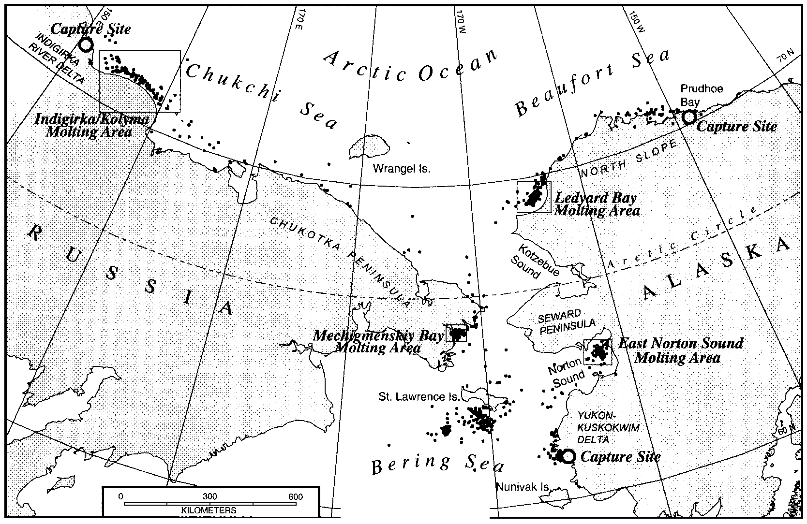FIG. 1. At-sea distribution of Spectacled Eiders, with all years and locations combined. Molting areas: Indigirka/Kolyma river delta, Ledyard Bay, Mechigmenskiy Bay, and eastern Norton Sound.

TABLE 3. Arrival and departure dates of Spectacled Eiders. Values are median date and interquartile range of dates, with n in parentheses.

Location

lndigirka-Kolyma Ledyard Bay Norton Sound
Mechigmenskiy Bay

Indigirka-Kolyma Ledyard Bay Norton Sound
Mechigmenskiy Bay

St. Lawrence I.

Paired males Failed females
Arrival dates to molting areas
17 Jul, 6-24 Jul (9) None
6 Jul, 25 Jun-26 Jul (6) None
None 3 Aug, 20 Jul-10 Aug (13)
25 Jul, 12 Jul-10 Aug (14) None
Departure dates from molting areas
5 Oct, 21 Sep-11 Oct (5) None
19 Sep, 26 Aug-19 Oct (4) None
None 28 Sep, 17 Sep-10 Oct (5)
5 Oct, 25 Sep-12 Oct (8) None
Arrival dates to wintering area
22 Oct, 28 Sep-2 Nov (8) 17 Oct, 12-22 Oct (4)
Females with broods

None
8 Sep, 7-11 Sep (9)
8 Sep, 4-16 Sep (5)
21 Sep, 17-21 Sep (4)

None
18 Oct, 6-25 Oct (9)
21 Oct, 2-29 Oct (5)
1 Nov (2)

7 Nov, 1-11 Nov (9)

that went onshore at Teshekpuk Lake, Alaska. When migrating through the Beaufort Sea, males flew almost 10 km closer to shore than did females (X2 = 8.94, df = 1, P = 0.003); how­ ever, the tendency to migrate offshore did not
differ between the sexes when moving along the Chukchi or Bering Sea coasts (P > 0.05; Ta­
ble 4).
Males and females used different molting ar­ eas (x2 = 35.31, df = 3, P < 0.001). At least one male from each breeding area molted and I or staged at each of three locations: Mechigmen­ skiy Bay, Indigirka I Kolyma river delta, and Ledyard Bay (Fig. 2A). Females nesting on the Y-K Delta were found molting only in eastern Norton Sound. Females nesting on the North Slope molted at Ledyard Bay (n = 10), Mechig­ menskiy Bay (n = 3), near Bukhoto Puoten (n
= 1), and off eastern St. Lawrence Island (n =
1). No marked females from Y-K Delta or North Slope went to the IndigirkaiKolyma River del­ ta region (Fig. 2B).
The distances that females molted and staged offshore varied among locations (X2 =
63.66, df = 1, P < 0.001). Females were more
than 10 km closer to shore at eastern Norton
Sound than at Ledyard Bay (Table 4). The num­ bers of locations for females at other sites were too small for meaningful statistical compari­ sons.
The distances that males molted and staged offshore at their three main molting areas (Led­ yard Bay, Mechigmenskiy Bay, and Indigirkal Kolyma river deltas) also varied (X2 = 162.09, df = 2, P < 0.001). Males were recorded far­ thest offshore at Ledyard Bay (P < 0.001), clos­ er to shore in the IndigirkaiKolyma river delta (P < 0.001), and closest to shore at Mechigmen-

TABLE 4. Distances (km) Spectacled Eiders were offshore when at sea. Values are median distance and in­
terquartile range of distances, with n in parentheses.

Location

Beaufort Sea Chukchi Sea Bering Sea
Males Females
Molt migration
6.6, 2.7-13.8 (24) 16.5, 8.4-24.8 (24)
34.7, 23.1-48.2 (69) 59.6, 21.2-93.4 (4)
12.6, 9.3-38.8 (55) 26.2, 14.4-44.4 (31)
Molting areas
Both sexes

34.9, 20.8-48.9 (73)
15.3, 0.1-30.6 (86)

Indigirka-Kolyma Ledyard Bay Norton Sound
Mechigmenskiy Bay
16.9, 10.5-23.3 (103)
34.5, 30.9-38.1 (75)

6.9, 4.3-9.6 (122)

37.9, 33.8-42.0 (93)
26.7, 21.7-30.9 (107)
9.3, 5.8-12.7 (6)

7.1, 4.9-12.5 (128)

Early winter
Mid-winter
Winter (St. Lawrence Island)

52.0, 32.1-71.9 (119)
108.2, 90.8-125.5 (19)

1014 PETERSEN, LARNED, AND DOUGLAS [Auk, Vol. 116

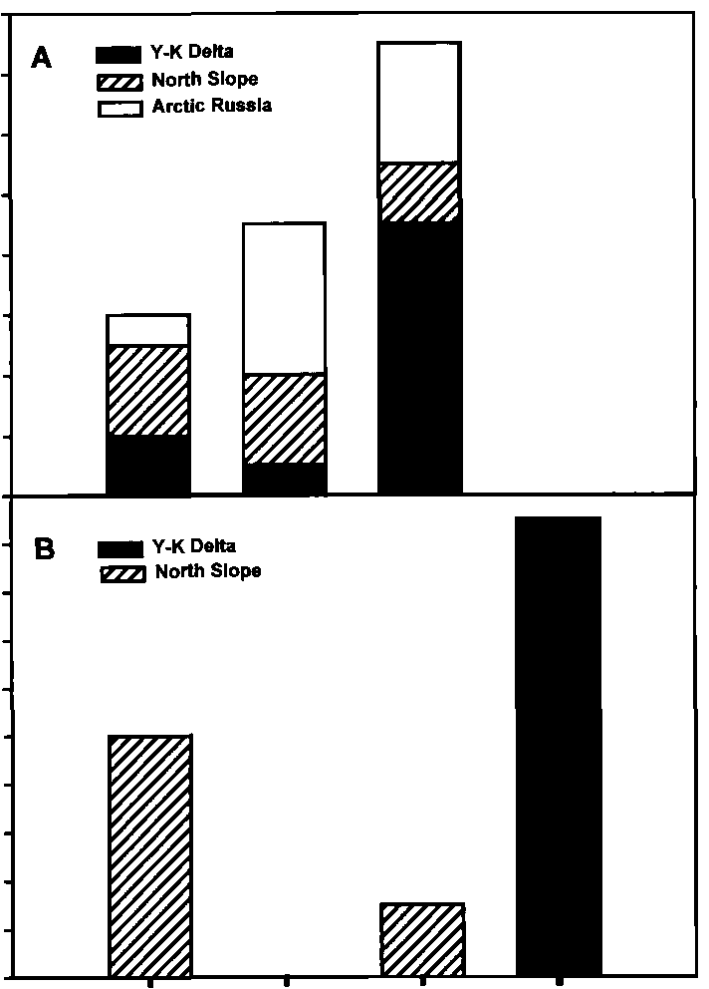16
A -Y-KDetta
14 EZZl North Slope
c:::::J Arctic Russia
Observations of birds during aerial surveys at Mechigmenskiy Bay (Fig. 3A), eastern Nor­ ton Sound (Fig. 3B), and Ledyard Bay (Fig. 3C)

U)
12
Cll
'iii
E 10
0.. 8
.Ccll
E 6
z 4

2

18
U) 16
,CII
'iii 14
E
J!! 12
0 10
.lcii 8
E
z 6
4
2

LB 1/K EC ENS

FIG. 2. Molting areas used by marked adult Spec­ tacled Eiders. LB = Ledyard Bay; 1/K = Indigirka/ Kolyma coast; EC = eastern Chukotka Peninsula (in­ cluding Mechigmenskiy Bay and Bukhoto Puoten); ENS = eastern Norton Sound. (A) Molting areas used by males; (B) molting areas used by females.

skiy Bay (P < 0.001; Table 4). Both males and females marked with PTTs molted in Ledyard Bay and Mechigmenskiy Bay. However, only at Ledyard Bay were samples for males and fe­ males sufficient for meaningful comparisons. The distance that birds were offshore at Led­ yard Bay differed between males and females (x2 = 6.23, df = 1, P = 0.01; Table 4).
suggested that PTT locations provided accurate data on the location and extent of molting and staging areas used by eiders.
Winter locations.-All marked eiders win­
tered south and southwest of St. Lawrence Is­ land (Figs. 4A-D). Areas used by eiders ap­ peared to change from early to mid-winter, but use of these areas was similar among years. An aerial survey conducted in March 1996 corrob­ orated evidence from PTT locations suggesting that eiders were absent from the portion of the area that they used in early winter (Fig. 4C).
Aerial surveys conducted in late winter I early
spring suggested that in spring some areas were used repeatedly (Figs. 4C and 4D), where­ as others were used only periodically (Figs. 4B and 4C).
The distances that birds were located off­
shore varied between early winter and mid­ winter (X2 = 13.91, df = 1, P < 0.001). By mid­ winter, the median distance from shore was twice that of early winter (Table 4). The maxi­
mum distance eiders were found offshore in winter was 206 km.
Abundance.-Our largest estimate of Specta­
cled Eider numbers (ca. 363,000 birds; 95% CI
333,526 to 392,532) came from aerial surveys of the Bering Sea in late winter 1996-1997 (Table
5). Estimates of the number of birds in each molting area varied among and within years. We found males and females at all molting and wintering areas surveyed (Table 5). Our survey data indicate that fewer eiders used eastern Norton Sound than Ledyard Bay and Mechig­ menskiy Bay. Our best estimates of the number

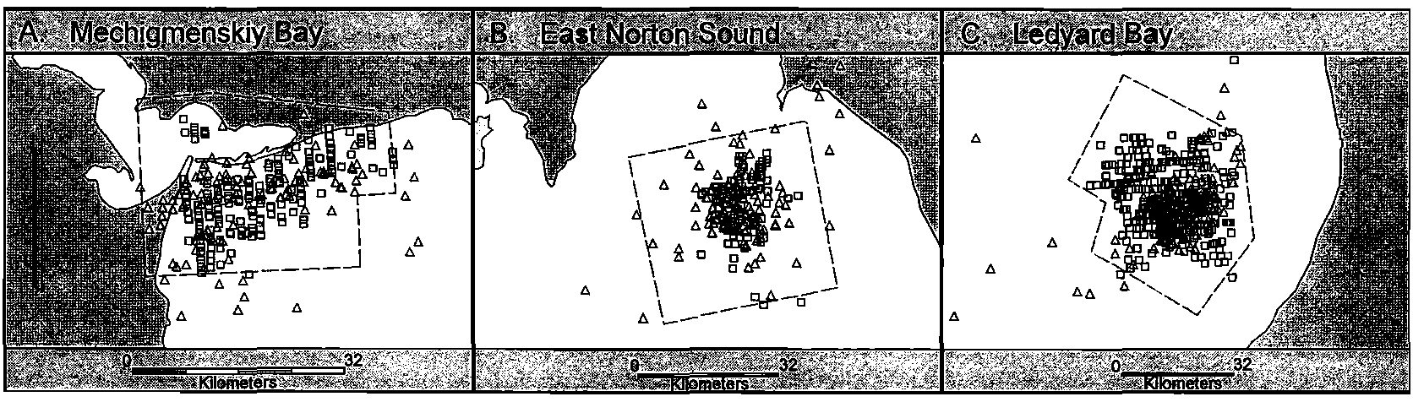
FIG. 3. PTT locations and survey areas of Spectacled Eiders on staging and molting areas at (A) Mechig­ menskiy Bay, (B) eastern Norton Sound, and (C) Ledyard Bay. Squares = locations of flocks recorded during aerial surveys and triangles = PTT locations. Aerial survey areas are delineated by dashed lines.

174'W 172'

A) WINTER 1993-94

B) WINTER 1994-95

..=-: -. :_. - .. -.

•

" " ""t;"£;-" • "
J%, );, 0:' ,&

63'N +
" " " " +

"" t;,pf!fA•A
•
•
62'N + + +

KILOMETERS

174'W 170'W

C) WINTER 1995-96

62'N
+
+ +

6APR1995
[ ]
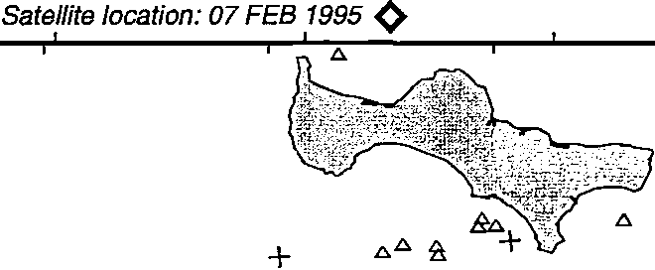Aerial Survey

D) WINTER 1996-97

/'-... .....
"-r/ )-"',
"
'A ,!t; '"\" "
' aa 1 a

+
• •
A"--

Aerial Survey

/....
. ...,
/ .t:::..

+ + / ba /
G
.0. A

26MAR 1996
" {I' t f1f. "
Art
6.0..o, A

••
A 1 _
+

._,
...
I
---/23 MAR 1996
Aerial Survey
• +
7-8 MAR 1997
Aerial Survey
+ + +

I+ I
I I
I I
: :22 MAR 1996
: : Aerial Survey
I I I I L----.J

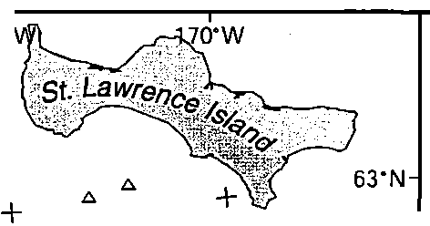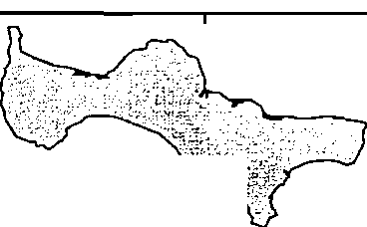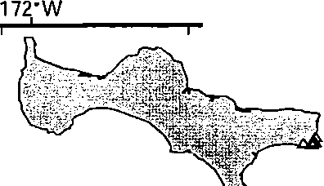FIG. 4. PTT locations and survey areas of Spectacled Eiders in the Bering Sea during (A) winter 1993-
1994, (B) winter 1994-1995, (C) winter 1995-1996, and (D) winter 1996-1997. Triangles= locations of marked birds from 1 October to 20 November, circles= locations of marked birds from 21 November to 31 December, and diamond is the location of a marked bird on 7 February 1995. Survey areas are delineated by solid lines. Reconnaissance areas (no birds located) are marked by dashed lines. See Table 5 for survey totals corre­ sponding to survey dates.

of birds in each area, however, varied substan­ tially among years. Survey conditions varied among years, and timing of surveys often was suboptimal owing to extended bad weather; thus, the number of birds likely was underes­ timated during some surveys. Because no sur­ veys were conducted in the Indigirka/Kolyma delta area, near Bukhoto Puoten, or in eastern St. Lawrence Island, the relative importance of these areas for molting and staging birds re­ mains undetermined.

DISCUSSION

The at-sea distribution of Spectacled Eiders in winter, as proposed by Conover (1926), De-
ment'ev and Gladkov (1967), and Dau and Kistchinski (1977), was partly substantiated by our satellite telemetry data. The molting areas, however, were more restricted in location than envisioned by Dau and Kistchinski (1977) and were in near-shore waters. It is understandable that the relatively small and localized molting areas were previously undocumented because birds generally were too far offshore to be seen during incidental flights or aircraft surveys along the coast. In addition, most birds mi­ grated far enough offshore that ground-based observers would have been unable to detect large numbers of birds moving from breeding areas to molting areas.
Distribution.-Eastern Norton Sound was the

TABLE 5. Estimated numbers of Spectacled Eiders at molting and winter locations.

Location Survey date

Norton Sound 31 Aug 1993
23 Aug 1994
6 Sep 1994
18 Aug 1996
28 Sep 1996
Estimate
Molting areas
551"
1,460b
4,030b
3,303d
2,793d
Proportion male•

10.7 :±: 3.2 (8 flocks') No data
16.0 :±: 1.3 (23 flocks')
No data
14.4 :±: 4.3 (6 photos)

Ledyard Bay

Mechigmenskiy Bay

Early winter
18 Aug 1994
21 Sep 1995
1 Oct 1996
21 Aug 1994
22 Aug 1994
5 Sep 1995

10-13 Nov 1994

Bering Sea
202<
33,192b
14,116<
37,397b
41,209b
55,731"

32,698 '
0 (2 flocks, 100 F, 1 F)
85.3 :±: 2.5 (28 photos)
62.0 :±: 2.7 (212 flocks')
No data
49.8 :±: 4.0 (8 flocks<)
28.4 :±: 9.1 (11 photos)

56.7 :±: 1.7 (70 flocks')

Late winter

Spring
26 Mar 1996
7-8 Mar 1997
6 Apr 1995
226,810b
363,030•
148,059•
No data
54.4 :±: 2.3 (13 photos)
56.7 :±: 3.6 (15 photos)

• "Females" may include hatching year males and subadult females of all ages and unknown proportions; values are i :!: SE.
b Ocular estimate of all birds in survey area.
c Ocular estimate of percent in male plumage.
d Photo estimates.
e Ocular estimate extrapolated to include area between survey lines.
1 Incomplete survey.
g Ocular and photo estimates combined.

primary molting area for females that nested on the Y-K Delta. Our maximum estimate of fe­ males in eastern Norton Sound (3,385) corre­ sponds relatively well with the recent estimate of 3,000 or fewer nesting females on the Y-K Delta (U.S. Fish and Wildlife Service 1996). If females from other breeding areas currently molt in eastern Norton Sound, they are proba­ bly few in number.
Based on the large numbers of eiders esti­
mated during aerial surveys at Ledyard and Mechigmenskiy bays, we conclude that these are important molting areas for females that breed on the North Slope and for males from all areas. Our data suggest that the area off­ shore from the Indigirka I Kolyma deltas is an important molting area for males, because a high proportion of males from the Indigirka Delta molted there, as did some males from the Y-K Delta and the North Slope breeding areas. However, the numbers and sex ratios of birds molting offshore from the Indigirka/Kolyma river deltas were not determined because aerial surveys in the area could not be conducted. Fe­ males from arctic Russia may molt there. It is unlikely, however, that the area off the Indigir­ ka-Kolyma river deltas is consistently used by large numbers of successfully breeding females
as a molting area because the area can be half­ covered to completely covered with ice by Oc­ tober (Gloersen et al. 1992).
Differences in the distances birds were off­ shore among the different molting areas per­ haps reflects the biotic and abiotic variability among these areas. For instance, the widths of the relatively shallow shelves of the Ledyard Bay, Mechigmenskiy Bay, and Indigirka-Koly­ ma delta areas appear to vary, and distance from shore and depths are probably highly cor­ related. Thus, if molting birds are limited by factors correlated with water depth (such as preferred foods), the distance from shore they are found will differ among molting areas. Sim­ ilarly, the distance ice is from shore along the Beaufort Sea during molt migration may be correlated with difference distances that males and successful females were found offshore in the Beaufort Sea.
Postbreeding dispersal.-The differences in timing of molt migration between male and fe­ male Spectacled Eiders in our study are consis­ tent with those found in other species of sea ducks (Weller 1964) and with previous obser­ vations of Spectacled Eiders (Johnsgard 1964, Kistchinski and Flint 1974, Dau and Kistchinski
1977). Similarly, it was not surprising that

males in the two northernmost nesting grounds (North Slope and arctic Russia) departed the nesting grounds later than males from the more southern Y-K Delta, because nesting chro­ nology is later at the more northern areas (North Slope median nest initiation 15 June [D. Troy pers. comm.]; arctic Russia nest initiation
17 June to 2 July [Kondratev and Zadorina
1992]) than at the Y-K Delta (median nest ini­ tiation 27 May [Grand and Flint 1997]). This conclusion differs from Dau and Kistchinski (1977), who suggested that departure dates were similar from Y-K Delta and Indigirka Del­ ta (arctic Russia), but is consistent with John­ son and Herter (1989) for the Beaufort Sea coast. The tendency for males from all nesting areas to arrive at molting areas at about the same time suggests that molt is synchronous among males. The date a male leaves the breed­ ing area may be a consequence of timing and nesting success of the female with which he is paired. However, migration may be either pro­ longed or relatively rapid such that most males arrive at molting areas and begin to molt at about the same time.
Failed and nonbreeding females have been reported to leave the Indigirka Delta by 30 July (Kistchinski and Flint 1974), which is within the range of dates that unsuccessful females left the Y-K Delta in our study (26 June to 9 Au­ gust). Our data for females on the Y-K Delta suggest that the timing of reproductive failure further influences timing of molt migration. This is likely true for females nesting in arctic Russia and the North Slope, but too few unsuc­ cessful females at the North Slope were marked.
Our observations of eiders migrating off­ shore when leaving the nesting grounds are similar to previous observations (Dau and Kistchinski 1977, Johnson and Herter 1989). Males began postbreeding migration in sum­ mer (June to July) and staged or migrated in offshore waters. Subadult and unsuccessful fe­ males left their nesting areas later in the sum­ mer. Our observations, as well as those sum­ marized by Dau and Kistchinski (1977), showed that successful females left the nesting grounds in late August to September and moved to offshore waters. None of the females we captured with broods was flightless or had recently undergone molt of body or wing feath­ ers. This is contrary to Nelson's suggestion (in
Bent 1925) that successful females molt in sum­ mer on the breeding grounds while raising their broods.
Except for the two males located at Teshek­ puk Lake, Alaska, molt migration and fall mi­ gration occurred in offshore waters. This is consistent with incidental observations report­ ed in Palmer (1976), Dau and Kistchinski (1977), and Johnson and Herter (1989). We found no evidence that eiders nesting on the North Slope migrated over the coastal plain or near the Brooks Range, as suggested in Johnson and Herter (1989).
Our observation that males often took several
weeks to migrate through the Beaufort, Chuk­ chi, and Bering seas suggests that these areas are important staging and I or feeding areas during molt migration. However, the physio­ logical condition of birds when they depart the breeding grounds and arrive at molting areas is unknown, as are the type, quality, and quan­ tity of foods available to eiders during molt mi­
gration and staging. The importance of these areas relative to the timing of molt, survival during the molting period, and condition after molting is unknown. However, the availability and quality of key resources in those areas dur­ ing the prolonged migration period ultimately may influence the survival of Spectacled Ei­ ders.
Winter range.-The wintering area south of
St. Lawrence Island that we identified for Spec­ tacled Eiders includes some of the waters pro­ posed by Dau and Kistchinski (1977) as a pos­ sible wintering area. We found, however, that Spectacled Eiders were not restricted to polyn­ yas, but instead used areas that may, in some years, have >60% ice coverage, especially in late winter and early spring (Gloersen et al.
1992). Because we surveyed only the areas
where marked birds were located, we did not consider other potential wintering areas. No surveys were conducted in areas identified by Dau and Kistchinski (1977), such as south of St. Matthew and Nunivak islands and Chukotka Peninsula, or in areas identified by Alexei Mik­ hailovich Trukhin (F. H. Fay pers. comm.) in the northern Kurils and southeast Kamchatka. Observers conducting aerial surveys for large marine mammals in the Bering Sea in spring have reported "eiders" and "large ducks" among the sea ice (J. Brueggeman and G. Garner pers. comm.), but the identity of the

species was unknown. At 62°00'N, 176°26'W in the Bering Sea aboard the U.S. Coast Guard cutter Polar Star, F. H. Fay (pers. comm.) noted flocks of Spectacled Eiders flying eastward on
17 May 1980 over the ice "at which time they
were just about on a straight-line course be­
tween Cape Navarin and the Yukon Delta."
Abundance.-Aerial survey data provided minimum estimates of birds that used three of the four main molting areas. Breeding males and females arrived at and molted in these ar­ eas at different times of the year. Males arrived at molting areas almost two months earlier than successful females and began leaving the molting areas as successful females arrived. Thus, a comprehensive estimate of the number of males and females molting in each area would require at least two surveys, one each for males and females. We do not know what pro­ portion of subadult Spectacled Eiders molts in these areas, or whether they molt primarily in other areas. Thus, a worldwide population es­ timate from surveys of the molting grounds would be difficult to obtain. Except for perhaps Y-K Delta birds in eastern Norton Sound, it is unlikely that estimates of molting birds in oth­ er areas would provide a breeding-population estimate for arctic Russia or the North Slope of Alaska.
Our minimum population estimate of about
333,000 birds in 1997 suggests that the number of Spectacled Eiders has increased since 1977, when Dau and Kistchinski (1977) proposed a world population of 200,000 breeding birds. Dau and Kistchinski's (1977) estimate was ex­ trapolated from provisional estimates based on small portions of the breeding area (C. Dau pers. comm.). In addition, their estimate did not include nonbreeding or subadult birds. Thus, the total population size can only be con­ sidered not to have changed dramatically dur­ ing the period of rapid decline (a 96% decrease; Stehn et al. 1993) of the Y-K Delta breeding population. Based on data from aerial surveys, a substantial population increase appears to have occurred between 1995 and 1997 (Table 5). Aerial surveys at sea in winter were limited by short daylight periods, chronically bad weath­ er, and fuel restrictions of survey aircraft. Sur­ veys rarely were continued beyond areas where birds were no longer seen. Thus, survey esti­ mates represent the best minimum estimates for the conditions during a particular survey,
but no trend data can be inferred with so few years of data.
Conclusions.-Here, we provide a basis to be­
gin more comprehensive studies of eider dis­ tribution relative to physical and biological characteristics and potential population effects due to changes in human use of the Beaufort, Chukchi, and Bering seas. With the identifica­ tion of eastern Norton Sound, Ledyard Bay, Mechimeginskiy Bay, and the Indigirka-Koly­ ma deltas as important molting areas, studies can be designed that focus on the ecology of Spectacled Eiders during molt. The delineation of the wintering area south of St. Lawrence Is­ land provides a basis to initiate more detailed studies of population dynamics and ecology of wintering birds. Biotic and abiotic factors that probably influence the distribution of Specta­ cled Eiders within and among winters include sea ice conditions, benthic invertebrate com­ munities, ocean depth, and behavioral charac­ teristics of eiders. Once the wintering area is defined more clearly, hypotheses regarding factors that occur in winter that may limit re­ covery of the population can be addressed.
The tendency for Spectacled Eiders to clump into discrete areas during molting (and per­ haps in winter) leaves them vulnerable to nat­ ural and human-caused environmental pertur­ bations. During molt, eiders are particularly vulnerable to contact with petroleum products and to becoming entangled in fishing gear or other floating objects. Because they cannot fly during molt, hazing them away from such ar­ eas would be difficult. There is strong evidence that most female Spectacled Eiders nesting on the Yukon-Kuskokwim Delta use eastern Nor­ ton Sound as their principal molting area. Thus, perturbations such as new trawl fisher­ ies, fuel spills, or other disruptions to birds and/ or their habitat could have a major effect on this breeding population, which has already experienced a major decline. Similarly, winter­ ing Spectacled Eiders appear to use a relatively restricted area in the Bering Sea. Major disrup­ tions of food resources, other habitat changes, or direct threats to birds could have major in­ fluences on the worldwide population.
Postbreeding migration routes of Spectacled Eiders tend to be offshore where birds normal­ ly would not be at risk to death or injury. How­ ever, because petroleum development occurs in these offshore areas, eiders may have an in-

October 1999] Spectacled Eiders at Sea 1019

creased risk of flying into fixed structures or supply vessels and being exposed to petroleum products that may spill or accumulate in areas of open water.
A more comprehensive analysis to statisti­
cally define high-use areas and habitat charac­
teristics that may help identify critical habitats for molting, migrating, and wintering eiders is needed. This analysis will be important for evaluating proposed activities such as a ship­ ping port for petroleum products in Ledyard Bay; exploration, development, and shipping of petroleum products in the Beaufort Sea; and expanded fisheries in eastern Norton Sound.

AcKNOWLEDGMENTS

This project would not have been possible without the surgical expertise of Dan Mulcahy, Kathy Burek, and Pam Tuomi. Many people assisted with the sur­ gery, particularly Mark Cunningham, Kim Mills, Todd O'Hare, Abby Parks, and John Pearce. Kevin Kenow and Carl Korschgen taught us the surgical technique. Declan Troy, Paul Flint, Barry Grand, Joel Schmutz, John Pearce, and Andre Degteyerev al­ lowed us to mark birds on their study areas, and they and their crews were instrumental in capturing birds. Paul Howey was particularly responsive to our phone calls from the field to modify the implant transmitter. Gregory Balogh, Bill Eldridge, Jack Hodges, Karen Laing, Brian McCaffery, Robert Platte, and Tim Tiplady assisted with aerial surveys. J. Brueggeman, F. H. Fay, Paul Flint, Gerald Garner, and Declan Troy allowed us to use their unpublished data. In-kind support was provided by British Petro­ leum-Exploration (AK) Inc. on behalf of Prudhoe Bay Unit owners, North Slope Borough, Yakutsk Institute of Biology, and Yukon Delta National Wildlife Ref­ uge. This project was funded by the U.S. National Bi­ ological Service, Alaska Science Center (now U.S. Geological Survey, Biological Resources Division, Alaska Biological Science Center); U.S. Fish and Wildlife Service, Region 7, Migratory Bird Manage­ ment; and U.S. Fish and Wildlife Service, Region 7, Ecological Services. We thank T. W. Arnold, D. V. Derksen, D. Esler, J. B. Grand, R. E. Gill, Jr., R. Oates, C. Smith, and two anonymous reviewers for com­ ments on various drafts of the manuscript.

LITERATURE CiTED

ANTHONY, R. M., AND R. A. STEHN. 1994. Navigating aerial transects with a laptop computer. Wildlife Society Bulletin 22:125-129.
BENT, A. C. 1925. Life histories of North American wild fowl. Part 2. Smithsonian Institution. Unit­ ed States National Museum Bulletin No.126.
CocHRAN, W. G. 1977. Sampling techniques. John
Wiley and Sons, New York.
CoNOVER, H. B. 1926. Game birds of the Hooper Bay
Region, Alaska. Auk 42:162-180, 303-318.
DAU, C. P., AND S. A. KISTCHINSKI. 1977. Seasonal movements and distribution of the Spectacled Eider. Wildfowl 28:65-75.
DEMENT'EV, G. P., AND N. A. GLADKOV. 1952. Birds
of the Soviet Union. Vol. 4. Israel Program for
Scientific Translations, Jerusalem.
ELY, C. R., C. P. DAU, AND C. A. BABCOCK. 1994. De­ cline in a population of Spectacled Eiders nest­ ing on the Yukon-Kuskokwim Delta, Alaska. Northwestern Naturalist 75:81-87.
FLINT, P. L., AND J. B. GRAND. 1997. Survival of Spec­
tacled Eider adult females and ducklings during brood rearing. Journal of Wildlife Management
61:217-221.
FLINT, P. L., M. R. PETERSEN, AND J. B. GRAND. 1997.
Exposure of Spectacled Eiders and other diving ducks to lead in western Alaska. Canadian Jour­ nal of Zoology 75:439-443.
FOLLESTAD, A., B. H. LARSEN, T. NYGARD, AND N.
R0v. 1988. Estimating numbers of moulting ei­ ders Somateria mollissima with different flock size and flock structure. Fauna Norvegica Series C Cinclus 11:97-99.
FRANSON, J. C., M. R. PETERSEN, L. H. CREEKMORE, P.
L. FLINT, AND M. R. SMITH. 1998. Blood lead con­ centrations of Spectacled Eiders near the Kashu­ nuk River, Yukon Delta National Wildlife Ref­ uge, Alaska. Ecotoxicology 7:175-181.
FRANSON, J. C., M. R. PETERSEN, C. U. METEYER, AND
M. R. SMITH. 1995. Lead poisoning of Spectacled Eiders (Somateria fischeri) and of a Common Ei­ der (Somateria mollissima) in Alaska. Journal of Wildlife Diseases 31:268-271.
GLOERSEN, P., W. J. CAMPBELL, D. J. CAVALIERI, J. C.
COMISO, C. L. PARKINSON, AND J. J. ZWALLY.
1992. Arctic and antarctic sea ice, 1978-1987: Satellite passive-microwave observations and analysis. National Aeronautics and Space Ad­ ministration, Washington, D.C.
GRAND, J. B., AND P. L. FLINT. 1997. Productivity of
nesting Spectacled Eiders on the lower Kashu­
nuk River, Alaska. Condor 99:926-932. JoHNSGARD, P. A. 1964. Observations on the biology
of the Spectacled Eider. Wildfowl15:104-107.
JOHNSON, S. R., AND D. R. HERTER. 1989. The birds of the Beaufort Sea. BP Exploration (Alaska) Inc., Anchorage, Alaska.
KISTCHINSKI, A. A., AND V. E. FLINT. 1974. On the bi­
ology of the Spectacled Eider. Wildfowl25:5-15. KONDRATEV, A. V., AND L. V. ZADORINA. 1992. Com­ parative ecology of the King Eider (Somateria spectabilis) and the Spectacled Eider (S. fischeri)
on the Chaun Tundra. Zoological Journal71:99-
108.
KORSCHGEN, C. E., K. P. KENOW, A. GENDRON-FITZ-

PATRICK, W. L. GREEN, AND F. J. DEIN. 1996. Im­ planting intra-abdominal radiotransmitters with external whip antennas in ducks. Journal of Wildlife Management 60:132-137.
PALMER, R. S. (Ed.). 1976. Handbook of North Amer­
ican birds. Vol. 3. Yale University Press, New Ha­
ven, Connecticut.
PETERSEN, M. R., D. C. DOUGLAS, AND D. M. MUL­ CAHY. 1995. Use of implanted satellite transmit­ ters to locate Spectacled Eiders at-sea. Condor
97:276-278.
PIHL, S., AND J. FRIKKE. 1992. Counting birds from aeroplane. Pages 8-23 in Manual for aeroplane and ship surveys of waterfowl and seabirds (J.
Komdeur, J. Bartelsen, and G. Cracknell, Eds.). IWRB Special Publication No. 19.
SERVICE ARGOS. 1996. User's manual. Service Argos, Inc., Landover, Maryland.
STEHN, R. A., C. P. DAU, B. CONANT, AND W. I. BUT­
LER, JR. 1993. Decline of Spectacled Eiders nest­
ing in Western Alaska. Arctic 46:264-277. UNITED STATES FISH AND WILDLIFE SERVICE. 1996.
Spectacled Eider recovery plan. Anchorage, Alaska.
WELLER, M. W. 1964. General habits. Pages 15-34 in
The waterfowl of the world. Vol. 4 (J. Delacour, Ed.). Country Life Limited, London.
Associate Editor: T. W Arnold

